DES’S NAVINCHANDRA MEHTA INSTITUTE OF TECHNOLOGY AND DEVELOPMENT,
MUMBAI – 400028

SUMMER INTERNSHIP REPORT ON
“ FUNDAMENTAL ANALYSIS OF THE FMCG SECTOR “
(With Internship Exposure to Equity Dealing, the Futures and Options Market and Trading Terminals at Rosy Blue Securities Pvt. Ltd.)
Submitted in partial fulfilment for the award of the degree of
MASTER OF MANAGEMENT STUDIES
FINANCE
UNIVERSITY OF MUMBAI
Submitted by
Nikhil [ADD: full name as per institute records]
ROLL NO :- [ADD: roll number]
2025-2027
Under The Guidance of
DR. RAHUL N. WADEKAR
CERTIFICATE
This is to certify that the summer internship report titled “Fundamental Analysis of the FMCG Sector” submitted in partial fulfilment for the MMS Degree Examination by Nikhil [ADD: full name], Roll No. [ADD: roll number], is a record of research work carried out by the student during the period from [ADD: internship start date] to [ADD: internship end date] under my guidance, and has been found satisfactory. This project work is original and not submitted earlier for the award of any degree, diploma or associateship of any other University/Institute.

------------------------- -------------------------
Dr. Rasika Mallya Dr. Rahul Wadekar
DIRECTOR PROJECT GUIDE

EXTERNAL EXAMINER
DECLARATION
I, Nikhil [ADD: full name], Roll No. [ADD: roll number], a student of the Master of Management Studies (Finance) programme of the University of Mumbai, hereby declare that this project report submitted by me to the partial fulfilment of the requirement for the award of Master of Management Studies (MMS) of the University of Mumbai is a bonafide work undertaken by me and it is not submitted to any other University or Institute for the award of any degree, diploma or certificate, or published at any time before.
The report is based on my own learning and observation during the summer internship undertaken at Rosy Blue Securities Pvt. Ltd. in the capacity of an Equity Dealer, together with information drawn from publicly available documents of the stock exchanges, the Securities and Exchange Board of India, the Reserve Bank of India and the annual reports of the companies analysed. Confidential information of the firm, including client names, client codes, permanent account numbers, unique client codes, terminal identifiers and the firm’s internal financial data, has not been disclosed. All trading examples given in this report are illustrative and are identified as such. The fundamental analysis of the FMCG sector has been carried out for academic purposes only and does not constitute investment advice.

Name : Nikhil [ADD: full name] Signature
Roll No. [ADD: roll number] (Nikhil [ADD: full name])
ACKNOWLEDGEMENT
This project has been a valuable learning experience, and I am grateful to everyone who supported me through it. I extend my sincere thanks to our Director, Dr. Rasika Mallya, and to my internal project guide, Dr. Rahul N. Wadekar, whose guidance, patient review and constructive suggestions shaped this report. The insistence that every figure be traced to a verifiable source, and that every table be followed by an interpretation rather than a restatement, has improved both the discipline and the usefulness of this work.
I am grateful to my parents and to my friends for their encouragement and patience during the internship and the writing of this report. Their support made it possible to combine the demands of a live dealing desk, which begins well before the market opens, with the requirements of academic study.
I thank the management of Rosy Blue Securities Pvt. Ltd. for granting me the opportunity to work in the equity dealing function, and the seniors on the dealing desk, the risk management team and the back-office staff who explained processes, corrected my errors and allowed me to observe live operations. I also thank the faculty members of the Finance specialisation and the library staff of DES’s NMITD for the academic and infrastructural support extended during the programme.
Finally, I am grateful to everyone who contributed indirectly to this project. Any error that remains in this report is my own.

Nikhil [ADD: full name]
EXECUTIVE SUMMARY
Summer training is an important part of management education because it places the student inside the activity being studied rather than outside it. This report combines the two components required of the internship: a record of the work performed on the equity dealing desk of Rosy Blue Securities Pvt. Ltd. in the capacity of an Equity Dealer, and a fundamental analysis of the Indian fast-moving consumer goods sector with a comparative study of three listed companies.
The operational component of the report documents the dealing function as it operates on a stock broker’s desk. It covers the structure of the Indian secondary market, the trading mechanism on the exchange-provided terminal and on the member’s Computer-to-Computer Link facility, the margining framework in the cash and equity derivatives segments, the settlement cycle, and the ladder of statutory charges that applies to every executed trade. The report records the working day of a dealer, the order types used in practice, the pre-trade risk checks applied before an order leaves the member’s server, and the post-trade reconciliation performed at the close of the session. Six worked examples convert this description into computed evidence: a cost-of-carry valuation of an illustrative futures contract, a five-day mark-to-market settlement sequence, a Black-Scholes valuation of an illustrative option with its sensitivities, a margin build-up and shortfall scenario, and the charge computation on illustrative delivery and intraday round trips.
The analytical component applies fundamental analysis to the Indian FMCG sector. The sector is the fourth largest in the Indian economy, employs around three million people and is valued at approximately Rs. 25 lakh crore, with household and personal care contributing half of all sales. Three companies with a March financial year end were selected for comparative study: Hindustan Unilever Ltd., Britannia Industries Ltd. and Dabur India Ltd. Their financial statements for FY2023-24, FY2024-25 and FY2025-26 were analysed using thirteen ratios covering profitability, returns, liquidity, leverage, efficiency and market valuation, and the three were ranked on those ratios in a factor analysis.
The analysis finds that Britannia Industries is the strongest performer on profitability and capital efficiency, recording a net profit margin of 13.25 per cent, a return on capital employed of 52.63 per cent and a return on equity of 49.68 per cent in FY2025-26. Hindustan Unilever has the most conservative financial structure, being effectively debt free, with the lowest operating ratio and the highest interest coverage in the group, but its underlying earnings were almost flat in FY2025-26 once the one-time gain of Rs. 4,611 crore from the demerger of its ice cream undertaking is excluded. Dabur India has the strongest short-term liquidity position and the lowest market valuation, but its revenue and profit growth over the three years has been the slowest and its earnings per share has grown at 1.34 per cent a year. On the composite ranking of thirteen ratios, Hindustan Unilever scores 120 points, Britannia 117 and Dabur 114, a narrow spread that reflects the trade-off between financial safety and growth rather than a clear overall winner.
The report concludes that fundamental analysis identifies differences in the quality of performance rather than a single superior company, and that on a dealing desk the same security is assessed on an entirely different set of attributes, principally price band, liquidity and volatility. The main learning of the internship is that the analytical and operational views are complementary and must be held together. The analysis in this report is academic and does not constitute investment advice.
INDEX
CHAPTER  NO. | CHAPTER TITLE / SUB-SECTION | PAGE NO.
 | TITLE PAGE | 1
 | CERTIFICATION | 2
 | DECLARATION | 3
 | ACKNOWLEDGEMENT | 4
 | EXECUTIVE SUMMARY | 6
 | TABLE OF CONTENTS | 7-8
CHAPTER 1 | INTRODUCTION | 9-10
 | 1.1 Need of the Study | 9
 | 1.2 Objectives of the Study | 9
 | 1.3 Scope of the Study | 10
CHAPTER 2 | ORGANIZATIONAL BACKGROUND | 11-31
 | 2.1 Organisational Introduction (Rosy Blue Securities Pvt. Ltd.) | 11
 | 2.2 Directors and Key Management Personnel | 12
 | 2.3 Array of Services | 12
 | 2.4 Vision | 13
 | 2.5 Mission | 13
 | 2.6 Departments | 13
 | 2.7 Job Description | 14
 | 2.8 Learning Activities from Organisation | 16
CHAPTER 3 | FUNDAMENTAL ANALYSIS (FMCG SECTOR OVERVIEW) | 32-37
 | 3.1 Importance of the FMCG Sector | 32
 | 3.2 Industry-Wide Advantages & Disadvantages | 33
 | 3.3 Sector Challenges | 34
 | 3.4 Top 10 Indian FMCG Companies Overview | 35
CHAPTER 4 | RESEARCH METHODOLOGY | 38-40
 | 4.1 Research Design & Objectives | 38
 | 4.2 Scope and Sources of Data | 38
 | 4.3 Sample Selection and Period of Study | 39
CHAPTER 5 | EIC FRAMEWORK (ECONOMIC, INDUSTRY & COMPANY ANALYSIS) | 41-64
 | 5.1 Economic Analysis (Macroeconomic Factors & Current Indian Economy) | 41
 | 5.2 Industry Analysis (FMCG Industry Drivers and Trends) | 45
 | 5.3 Company Analysis – HINDUSTAN UNILEVER LTD. | 47
 | 5.4 Company Analysis – BRITANNIA INDUSTRIES LTD. | 53
 | 5.5 Company Analysis – DABUR INDIA LTD. | 59
CHAPTER 6 | COMPARATIVE RATIO ANALYSIS & INTERPRETATION | 65-84
 | Factor Analysis | 82
CHAPTER 7 | CONCLUSION, FINDINGS & SUGGESTIONS | 85-90
 | REFERENCES & BIBLIOGRAPHY | 91-92
APPENDICES | HINDUSTAN UNILEVER LTD. – COMPANY RESEARCH REPORT | 93-113
CHAPTER 1 :- INTRODUCTION
1.1 NEED OF THE STUDY
• To gain exposure to the corporate world and to the working of a live stock broking operation, in which a client instruction becomes a settled transaction within a fixed cycle of time.
• To understand the Indian secondary market from the inside, covering the trading mechanism, the two trading technologies used on a dealing desk, the margining framework and the settlement cycle, rather than only from a textbook description.
• To understand the futures and options segment, which now accounts for the larger part of turnover on Indian exchanges but receives limited practical attention in the classroom, and to compute for myself the quantities that govern a derivative transaction: contract value, margin, daily settlement, option premium and option sensitivities.
• To understand the fast-moving consumer goods sector fundamentally, including its importance to the economy, its growth drivers, its structural advantages and its challenges, and to relate the sector to current macroeconomic conditions in India.
• To apply financial statement analysis and ratio analysis to selected FMCG companies of the Indian listed universe and to interpret the results rather than merely compute them.
• To study how economic changes, inflation, interest rates and regulatory decisions affect a defensive consumption sector and the companies within it.
• To compare the financial performance of three leading FMCG companies over three financial years and to identify the company that performs relatively better on the selected ratios.
• To develop the discipline of sourcing every figure to a verifiable document and of separating reported figures from computed figures.
1.2 OBJECTIVES OF THE STUDY
The objectives of the study are stated below.
• To study the changes that the organisation has undergone or initiated in the recent past, and to understand the organisational context in which the internship was undertaken.
• To study the structure of the Indian capital market, the principal exchanges, the market participants and the regulatory framework administered by the Securities and Exchange Board of India.
• To study the equity trading mechanism, the order life cycle, the clearing and settlement process and the role of the depositories.
• To study the futures and options market, including contract specification, pricing by cost of carry, daily mark-to-market settlement, option payoff, premium decomposition and the computation of option sensitivities.
• To study the trading terminals used on a dealing desk, comprising the exchange-provided terminal and the member’s Computer-to-Computer Link facility, together with the pre-trade risk controls and audit obligations attaching to each.
• To study risk management on a dealing desk, including margin computation in both segments, client-wise limits, margin-shortfall identification and square-off discipline.
• To carry out a fundamental analysis of the Indian FMCG sector and a comparative financial analysis of three selected FMCG companies for the three financial years from FY2023-24 to FY2025-26.
1.3 SCOPE OF THE STUDY
This project will allow investors and students to refer to the performance of FMCG companies, their relative growth and their relative valuation, and to decide whether the sector deserves a place in a portfolio. The project is limited to the fundamental analysis of the selected FMCG companies for a given period; technical analysis, portfolio construction and other sectors of the Indian market are not considered.
The analytical scope covers the Indian FMCG sector as it stood in October 2026 and three listed companies — Hindustan Unilever Ltd., Britannia Industries Ltd. and Dabur India Ltd. — for the financial years FY2023-24, FY2024-25 and FY2025-26. The study uses consolidated financial statements so that the figures of the three companies are on a comparable basis, and it relies entirely on secondary data drawn from annual reports, exchange filings, regulatory publications and published financial information.
The operational scope of the internship, which forms the second part of the report, covers the cash and equity derivatives segments of the Indian secondary market as they operated during the internship period. Functionally it is the dealing desk and the processes immediately adjacent to it, namely risk management, back-office settlement and compliance. The currency, commodity and debt segments are outside the scope, as are portfolio management and investment advisory. Every firm-specific detail has been generalised in accordance with the confidentiality undertaking referred to in Chapter 4, and every trading example in this report is illustrative.
CHAPTER 2 :- ORGANIZATIONAL BACKGROUND
2.1 ORGANISATIONAL INTRODUCTION
About the Firm
Rosy Blue Securities Pvt. Ltd. is the organisation at which the summer internship was undertaken. The firm operates as a stock broker in the Indian securities market, which means that it is registered with the Securities and Exchange Board of India, holds membership of a recognised stock exchange and executes transactions in securities on behalf of clients for a brokerage commission. The firm is a private limited company incorporated under the Companies Act.
A broking firm of this type performs four functions that are separated for regulatory and control reasons. The dealing function receives and executes client orders. The risk management function sets and monitors client-wise exposure against collateral. The back-office function computes obligations, issues contract notes and reconciles the firm’s records against those of the exchange and the depositories. The compliance function maintains client registration documents, unique client code mappings and regulatory filings. The intern was attached to the dealing function but interacted with the other three daily, because an instruction that fails a risk check, or a trade that is not reconciled at the close of the day, becomes an immediate problem for the desk.
The corporate particulars of the firm are a matter of public record with the Registrar of Companies, the Securities and Exchange Board of India and the exchanges. They have been left for completion from the firm’s own certificates rather than reconstructed, because no identifier in the table below has been assumed by the author.
Table 2.1: Registration and corporate particulars of the firm
Particular | Entry to be confirmed from the firm’s records
Name of the entity | Rosy Blue Securities Pvt. Ltd.
Constitution | Private limited company incorporated under the Companies Act,  2013
Year of incorporation | [ADD: year of incorporation]
Registered office | [ADD: registered office address]
SEBI stock-broker registration | [ADD: SEBI registration number, INZ format]
Other SEBI registrations | [ADD: research analyst / investment adviser / depository participant,  if held]
Exchange membership — NSE | [ADD: member code and segments, if a member]
Exchange membership — BSE | [ADD: member code and segments, if a member]
Segments dealt in | [ADD: cash / equity derivatives / currency / commodity]
Clearing arrangement | [ADD: self-clearing or through a named clearing member]
Depository participation | [ADD: CDSL / NSDL registration, or ‘not a depository participant’]
Investor grievance channel | [ADD: e-mail address and SCORES registration details]
The registration and membership profile determines the boundary of everything a dealer may lawfully do. A member registered only in the cash segment cannot accept a derivatives order however insistent the client; a firm that is not a depository participant must route demat instructions through a separate entity, which lengthens the settlement chain; and a firm that clears through another member rather than self-clearing faces an additional layer in the margin and collateral process. The table is therefore not an administrative formality but the first thing a new dealer should read, because it defines the permissible universe of instructions.
2.2 DIRECTORS AND KEY MANAGEMENT PERSONNEL
The management of a broking firm is organised around the separation of business development from risk acceptance. The board determines the risk appetite of the firm, the compliance officer is responsible for registration, reporting and surveillance, and the heads of the dealing, risk management and back-office functions are accountable for the daily operation of that framework. The particulars of the individuals holding these offices at Rosy Blue Securities Pvt. Ltd. are to be reproduced from the firm’s records and from its annual filings.
Table 2.2: Directors and key management personnel of the firm
Designation | Name and particulars
Director | [ADD: name of director]
Director | [ADD: name of director]
Chief Executive Officer or Managing  Director | [ADD: name and designation]
Compliance Officer | [ADD: name, qualification and SEBI registration, if any]
Head of Dealing | [ADD: name and designation of the reporting senior for the  dealing desk]
Head of Risk Management | [ADD: name and designation]
Head of Back Office and Settlement | [ADD: name and designation]
The intern reported to the head of the dealing function and worked under the supervision of a registered dealer. No names have been assumed in this chapter: every entry that is not a matter of public record has been marked for completion from the firm’s own documents.
2.3 ARRAY OF SERVICES
The service range of a retail-facing broking firm is set out below. The entries marked for confirmation should be verified against the firm’s own service brochure and its exchange membership certificates before submission. [ADD: confirm the list of services actually offered by the firm and delete any that are not offered.]
Secondary Market Broking
Execution of buy and sell orders in the equity cash segment on behalf of registered clients, against brokerage charged on turnover or on a per-order basis, with contract notes issued for every executed trade and settlement through the clearing corporation.
Derivatives Broking
Execution in equity futures and options, subject to the client having completed the additional documentation required for the segment, having been assigned a unique client code valid for derivatives, and having placed the margin required for the position.
Depository Services
Holding of client securities in dematerialised form where the firm is a depository participant, together with pledge and re-pledge instructions for collateral, delivery instructions and corporate action processing.
Research and Advisory
Dissemination of research output and advisory communication, which may be undertaken only to the extent permitted by the firm’s registration as a research analyst or investment adviser under the regulations of the Securities and Exchange Board of India.
Client Servicing and Support
Client registration and know-your-customer verification, ledger and holding statements, funds pay-in and pay-out, queries relating to contract notes and charges, and grievance redressal through the exchange and SEBI SCORES platform.
2.4 VISION
[ADD: reproduce the firm’s published vision statement here. If the firm does not publish one, delete this section and renumber the sections that follow, together with the corresponding entry in the index.]
2.5 MISSION
[ADD: reproduce the firm’s published mission statement here, on the same basis as the preceding section.]
2.6 DEPARTMENTS
The functional departments of a broking firm and the way each of them touches the dealing desk are set out in Table 2.3. The table is written from the point of view of the desk, which is the reason the last column records the interaction rather than the internal hierarchy of the department concerned.
Table 2.3: Departments of a broking firm and their principal functions
Department | Principal functions | Interaction with the dealing desk
Dealing desk | Receives client instructions, enters and  modifies orders, confirms executions and  communicates fills to clients | The function itself
Risk management | Sets client-wise limits, monitors margin  utilisation, raises shortfall alerts and  authorises square-off | Releases or blocks limits in real  time during market hours
Back office and  settlement | Computes obligations, generates contract  notes, maintains client ledgers, handles  pay-in and pay-out | Supplies opening ledger balances  and resolves trade mismatches
Compliance | Client registration, unique client code  mapping, surveillance responses, regulatory  filings and reporting | Confirms that a client code is  active and permitted in a segment
Information  technology | Terminal provisioning, connectivity, user  and terminal identifiers, business continuity  arrangements | Restores terminal access and  connectivity when a session fails
Accounts and  treasury | Client fund transfers, bank reconciliation,  settlement funding and collateral placement | Confirms receipt of client funds  that release additional limit
The separation of the dealing function from the risk management function is the single most important control in this structure, because it prevents the person with an incentive to execute from also being the person who decides whether execution is affordable. A dealer therefore cannot increase a client’s limit, and an instruction that exceeds it must be refused at the desk and escalated to risk management. During the internship this separation was the most frequent source of friction with clients and at the same time the most frequent source of protection for the firm.
2.7 JOB DESCRIPTION
The intern was attached to the equity dealing desk in the capacity of an Equity Dealer for the period [ADD: internship start date] to [ADD: internship end date], working [ADD: working hours] and reporting to the head of the dealing function. The segments handled were [ADD: cash / equity derivatives / both] and the client categories dealt with were [ADD: retail / high net-worth / sub-broker — categories only]. All order entry was carried out under the supervision of a registered dealer, and no instruction was executed without a recorded client instruction and a confirmed limit.
The principal duties performed were the following.
• Receiving client instructions by telephone, confirming the security, quantity, price and validity of each instruction, and recording the instruction before entry.
• Entering, modifying and cancelling orders on the exchange-provided trading terminal and on the member’s Computer-to-Computer Link facility.
• Verifying the tradable limit available to each client against the collateral and margin recorded by the risk management system before releasing an order.
• Monitoring open orders and executed positions during the session, and informing clients of the status of their instructions.
• Responding to margin-shortfall alerts by informing the client, recording the communication and escalating the matter to risk management for further action.
• Following the firm’s intraday square-off discipline for positions that cannot be carried forward under the client’s available limit.
• Verifying the day’s executions against the trade book after the close of the session, and reconciling discrepancies with the back office the same evening.
• Checking contract notes and charge computations, and answering client queries on brokerage, statutory charges and settlement obligations.
• Maintaining the desk’s daily records in the form required by the firm’s compliance policy, including the record of instructions received by telephone.
The responsibilities fell into three time bands, corresponding to the periods before, during and after the continuous trading session, and are set out in Table 2.4.
Table 2.4: Indicative working day of an equity dealer
Time | Activity | Purpose
08:45 – 09:00 | Review of overnight news, corporate actions,  the exchange ban list and pending client  instructions | To identify scrips that require special  handling before the session opens
09:00 – 09:07 | Verification of client-wise limits and  collateral uploaded by the risk management  system | To confirm the tradable limit  available to each client for the day
09:07 – 09:15 | Observation of the pre-open session and the  indicative equilibrium price | To assess the likely opening level and  to prepare the order queue
09:15 – 12:30 | Continuous trading: order entry, modification  and cancellation; confirmation of fills to  clients | Execution of client instructions  within the limits available
12:30 – 14:30 | Mid-session monitoring, response to risk  alerts and follow-up on margin top-ups | To prevent a margin shortfall from  becoming a forced square-off
14:30 – 15:30 | Intraday square-off discipline, closing  instructions and end-of-session order review | To close positions that cannot be  carried forward under the client’s  limit
15:30 – 17:30 | Verification of the day’s executions against  the trade book, reconciliation with the back  office and contract-note review | To ensure that the client’s records  and the firm’s records agree
The shape of the day shows that only about six of the nine working hours fall inside the continuous trading session, and that much of a dealer’s effort is expended before the market opens and after it closes. The pre-market block determines how much can safely be executed; the post-market block determines whether what was executed has been recorded correctly. Order entry is thus the visible part of a process that is predominantly preparation and verification.
The principal tools used during the internship were the following.
• The exchange-provided trading terminal: used for the market watch, order entry, and review of the order book and the trade book.
• The member’s Computer-to-Computer Link terminal: used for order routing through the firm’s own server, with pre-trade risk controls applied before the order reaches the exchange. [ADD: name of the Computer-to-Computer Link software used by the firm.]
• The risk management system console: used to read client-wise limit utilisation, available margin and shortfall alerts.
• The telephone recording system: used for the receipt of client instructions, retained as evidence of the instruction in accordance with the firm’s compliance policy.
2.8 LEARNING ACTIVITIES FROM ORGANISATION
The learning activities undertaken during the internship are set out below in the order in which they became relevant on the desk: the structure of the market, the rules that govern it, the mechanics of trading and settlement, risk management, derivatives and their margining, the two trading technologies used on the desk, and the costs and controls attaching to every transaction. Each regulatory statement carries the authority relied upon and the date on which it was checked; where verification against a primary source could not be completed, the statement is marked to be verified.
A. The financial system and the capital market in India
The financial system is the arrangement of markets, institutions, instruments and services through which savings are transferred to productive use. The financial markets component divides into the money market, which deals in instruments of original maturity up to one year, and the capital market, which deals in longer-dated instruments including equity. The capital market in turn divides into the primary market, in which securities are issued for the first time, and the secondary market, in which existing securities change hands. A stock broker’s dealing desk operates almost entirely in the secondary segment of the capital market, which is why that is the focus of this report.
The distinction matters operationally. In the primary market the broker is a distribution channel and the applicant’s funds are blocked rather than debited; in the secondary market the broker is an execution intermediary with settlement obligations to the clearing corporation that arise within a fixed number of days regardless of whether the client pays. That asymmetry is the origin of the margin framework described later in this section.
Table 2.5: Primary market and secondary market compared
Basis | Primary market | Secondary market
Nature of transaction | Issue of new securities | Transfer of existing securities
Recipient of funds | The issuing company | The selling investor
Effect on company capital | Capital is raised | No change in company capital
Price determination | Book-building or fixed price | Continuous order matching
Frequency | Occasional, issue by issue | Continuous on every trading day
Role of the broker | Distribution and application  support | Execution of orders
Principal document | Prospectus or offer document | Contract note
Typical settlement | On allotment and listing | Rolling settlement cycle
The comparison indicates why a dealer’s risk exposure is concentrated in the secondary market. In the primary market the intermediary’s obligation ends when the application is forwarded, whereas an executed secondary-market trade creates an irrevocable obligation to deliver securities or funds on a fixed date. A client who does not pay does not cancel that obligation; the member must settle and then recover. This is the reason the pre-trade limit check is applied before an order is released rather than after it is executed.
B. Stock exchanges, indices and market participants
A stock exchange is a recognised body that provides the trading platform, the rules of trading and the framework of surveillance for securities transactions. India’s two principal exchanges are the National Stock Exchange of India Limited and BSE Limited. Both operate fully electronic, order-driven markets with anonymous order matching. Each exchange supports several segments, of which the capital market segment, dealing in equity shares, and the equity derivatives segment, dealing in futures and options on indices and individual securities, are relevant to this report.
An index is a statistical measure of the aggregate price movement of a defined basket of securities, computed on a free-float market-capitalisation basis for the principal Indian benchmarks. The Nifty 50 comprises fifty companies on the National Stock Exchange and the S&P BSE Sensex thirty on the BSE. For a dealer, indices matter in three ways: they are the underlying for the most liquid derivative contracts, they are the benchmark against which a client judges performance, and index levels define the market-wide circuit breakers that halt trading after specified falls.
Table 2.6: Market participants and their role
Participant | Role in the market | Point of contact with the dealing  desk
Retail investor | Buys and sells securities for a personal  account in modest size | Places orders by telephone or  through the firm’s platform
Stock broker | Executes orders as an intermediary and is  a member of the exchange | The employer of the dealer
Clearing member | Assumes responsibility for settlement of  trades with the clearing corporation | Determines the collateral that the  broker must place
Clearing corporation | Acts as central counterparty, computes  obligations and margins | Sets the margin that constrains  every client limit
Depository and  depository participant | Holds securities in electronic form and  effects transfers | Delivers pay-out and processes  pledge instructions
Institutional investor | Foreign portfolio investors and mutual  funds investing under registered  categories and stated mandates | Rarely a retail desk’s client; drives  market direction and volume
The table shows that a dealer deals directly with only two of the categories listed and indirectly with the rest through the constraints they impose. The clearing corporation is the most consequential participant that the dealer never speaks to, because its margin computation determines the limit that the risk management system will grant, which in turn determines what the dealer may execute.
C. The regulatory framework
The framework is hierarchical. Statute confers power on the regulator, the regulator makes regulations and issues circulars, and the exchanges and clearing corporations issue operating rules consistent with them. Table 2.7 lists the principal instruments relevant to a dealing desk. For a dealer the binding instruction on any given day is usually the most recent circular rather than the parent regulation, and circulars change frequently.
Table 2.7: Principal statutes and regulations governing stock broking
Instrument | Principal subject matter | Relevance to the dealing desk
Securities Contracts  (Regulation) Act, 1956 | Recognition of stock exchanges and  regulation of contracts in securities | Establishes that trades must  occur on a recognised exchange
Securities and Exchange  Board of India Act, 1992 | Constitution and powers of SEBI | Source of the regulator’s  authority over brokers
Depositories Act, 1996 | Dematerialisation and electronic  transfer of securities | Underlies demat delivery and  pledge of collateral
SEBI (Stock Brokers)  Regulations, 1992 | Registration, conduct, records and  obligations of stock brokers | Governs client registration,  contract notes and record keeping
Exchange bye-laws, rules  and regulations | Trading parameters, member  obligations and discipline | The day-to-day operating rules of  the terminal
Clearing corporation  regulations | Margining, settlement, default and  close-out | Determines margin rates and  settlement timelines
One example shows how quickly the operating routine can change without any alteration of the parent framework. The expiry days of the equity derivatives contracts of the two exchanges were separated with effect from 1 September 2025, so that contracts of the National Stock Exchange expire on Tuesday and those of the BSE on Thursday. The statutory framework was unaltered, but a single circular changed the week of every derivatives desk in the country. A dealer handling clients on both exchanges now manages two distinct expiry routines in the same week. The position stated here is as at 9 October 2026 and should be reconfirmed against the current exchange circulars before the report is submitted.
D. The equity trading mechanism and the order life cycle
The Indian cash market is an order-driven market. Buyers and sellers submit orders to a central electronic order book and the exchange’s matching engine pairs them according to price-time priority: the order offering the best price is matched first, and among orders at the same price the one entered earlier is matched first. There is no obligation on any participant to provide a two-way quote in most securities, which means liquidity is a function of participation rather than of designated market making.
The trading day is divided into defined sessions. The pre-open session collects orders without matching them, determines a single equilibrium price at which the maximum quantity can trade, and executes at that price; it exists to reduce the volatility that follows an overnight accumulation of information. The continuous trading session then operates on price-time priority until the close, followed by a closing session in which the closing price is computed. Indicative timings are set out in Table 2.8; the precise timings are notified by the exchanges and should be confirmed against the current exchange notice.
Table 2.8: Equity trading sessions and indicative timings
Session | Indicative timing | What happens
Pre-open order collection | 09:00 – 09:08 | Orders are entered, modified and cancelled; no  matching takes place
Pre-open price  determination | 09:08 – 09:12 | The equilibrium price is computed and orders are  matched at that price
Continuous trading | 09:15 – 15:30 | Order-driven matching on price-time priority
Closing session | 15:30 – 15:40 | The closing price is computed and the session  closes
Post-close session | 15:40 onwards | Orders at the closing price are accepted for a limited  period
The order types available to a dealer, and the situation on the desk in which each was used during the internship, are set out in Table 2.9. [ADD: confirm the order types actually used and delete any that were not.]
Table 2.9: Order types and the situation calling for each
Order type | Validity | Situation in which it was used
Limit order | Day | The standard instruction where the client specifies a  price
Market order | Immediate | Used only in liquid scrips where execution certainty  was required
Stop-loss limit order | Day | To cap the loss on a carried position at a defined level
Stop-loss market order | Day | Where exit was required irrespective of the price  obtained
Immediate-or-cancel order | Immediate | To avoid leaving a resting order in a fast market
Disclosed quantity order | Day | On larger orders, to limit visible size and market  impact
The order passes through a defined sequence of states. Each change of state either narrows or closes the dealer’s discretion, and the whole of a dealer’s judgement therefore lies between acceptance and execution.
Table 2.10: Order states from entry to trade confirmation
State | What has happened | What the dealer can still do
Instruction received | The client instruction has been captured  and recorded | Clarify quantity, price and validity  before entry
Risk-checked | The member’s pre-trade controls have been  applied at the server | Escalate to risk management if the  order is rejected
Accepted | The exchange has acknowledged the order  and allotted an order number | Modify or cancel the order
Open | The order is resting in the book awaiting a  counterparty | Modify the price or quantity, or  cancel
Executed | The full quantity has traded and appears in  the trade book | Nothing; the trade is irrevocable
Cancelled | The order was withdrawn before execution | Re-enter if the client so instructs
Rejected | The order failed a validation at the member  or exchange level | Correct the parameter or obtain the  limit
The sequence shows that a dealer’s discretion is confined to a narrow window. Before acceptance the order is governed by validation rules, and after execution it is irrevocable, so the whole of a dealer’s judgement lies in deciding what to enter and whether to modify a resting order. This is why the choice of order type is treated on the desk as a risk decision rather than a convenience.
E. Clearing, settlement and the depositories
Clearing is the process of computing what each member must deliver and receive; settlement is the process of actually delivering the securities and the funds. The clearing corporation interposes itself between the buyer and the seller and becomes the central counterparty to every trade, which is what allows anonymous matching to work: a member need not assess the credit of the member on the other side, only that of the clearing corporation. Obligations are netted, so a member that has both bought and sold the same security on the same day settles only the net quantity.
Indian equity settlement operates on a rolling cycle. Under the T+1 cycle that applies to the cash segment, a trade executed on day T is settled on the next business day. The timeline is set out in Table 2.11. The compression of the cycle is one of the reasons the operational discipline of the desk matters: there is no window in which a shortfall can be corrected by waiting.
Table 2.11: Rolling settlement timeline under the T+1 cycle
Stage | Day | What happens
Trade day | T | The trade is executed and reported; obligations are  recorded
Confirmation and obligation | T (evening) | The clearing corporation computes and downloads  the obligations of each member
Pay-in | T+1 | The member delivers securities to the clearing  corporation by the stipulated time
Pay-out | T+1 | The clearing corporation delivers securities and  funds to the receiving member
Funds settlement | T+1 | The client’s ledger is adjusted and the net obligation  is settled
Securities are held in electronic form with a depository, either the Central Depository Services (India) Limited or the National Securities Depository Limited. A member that is also a depository participant can execute delivery instructions on behalf of its clients; a member that is not must route them through a separate participant. This distinction was the first entry a new dealer had to learn from the registration table of the firm, because it determines the length of the delivery chain and the point at which a delivery instruction can fail.
F. Risk management in the cash market and in the derivatives segment
Risk management in the Indian market operates on an upfront basis. The margin required for a position must be available before the order is released, and the requirement is computed by the clearing corporation and passed to the member, who passes it to the client. The principal constituents of margin in each segment are set out in Table 2.12. The rates themselves change and are notified by the exchange and the clearing corporation; the percentages shown are indicative and marked to be verified.
Table 2.12: Principal components of margin by segment
Segment | Component | What it covers
Cash market | Value at risk (VaR) margin | Statistical loss that the position could suffer over a  defined horizon at a defined confidence level
Cash market | Extreme loss margin | Additional cover against a loss beyond the  value-at-risk estimate
Cash market | Mark-to-market margin | The notional loss on an open position, recomputed  during the day
Cash market | Delivery margin | Cover against the risk of failure to deliver or pay on  the settlement date
Equity derivatives | SPAN margin | A portfolio-based computation that stresses the  portfolio across a range of prices and volatility  scenarios
Equity derivatives | Exposure margin | A percentage of the notional contract value, charged  in addition to the SPAN margin
Equity derivatives | Mark-to-market settlement | The daily cash settlement of the gain or loss on  every open position
Both segments | Peak margin reporting | Reporting of the highest intraday margin  requirement to the clearing corporation
Two consequences follow from an upfront regime, and both were observed during the internship. First, the limit a client may use is determined by the collateral actually pledged and available, not by the client’s standing. A dealer can therefore no longer accommodate a reliable client informally, and the absence of that discretion removes a large part of the discretion the role once had. Second, because the collateral is marked to market while the margin requirement changes with the position, collateral can fall faster than the requirement, turning a surplus into a shortfall without any trade being executed. This mechanism is worked through numerically later in this report.
G. The futures and options market
A derivative is a contract whose value is derived from an underlying asset. The two instruments relevant to an equity dealing desk are futures, which are obligations to buy or sell at a future date at a price agreed today, and options, which are rights rather than obligations and for which the buyer pays a premium. The distinction matters to a client because a futures position has symmetric exposure and no cost of entry beyond the margin, while an option has asymmetric exposure and a cost that is paid whether or not the option is exercised.
Index futures are the most liquid contracts on the Indian exchanges and are quoted at a premium or discount to the spot index. That difference, called the basis, is explained by the cost of carrying the underlying position to expiry, comprising the cost of funds and the dividends receivable, less the convenience of holding the underlying itself. The relationship is:
F = S × (1 + r − d)^T, where F is the fair futures price, S the spot price, r the cost of funds, d the dividend yield and T the time to expiry expressed in years.
A dealer uses this relationship in two ways. A price materially above fair value creates a cash-and-carry opportunity, in which the underlying is bought and the futures sold, and a price materially below fair value creates the reverse. Neither is usually actionable for a retail client after transaction costs, but both explain why the basis narrows as expiry approaches and why it widens when the cost of funds rises.
Every futures position is settled daily rather than at expiry alone. The difference between the previous settlement price and the current settlement price is credited to, or debited from, the margin account of the position holder at the close of each session. Daily settlement does not change the total result of a position held to expiry, but it changes when the cash flows occur, and it is the reason a client with a profitable position can still be required to pay money on a particular day. The mechanics are demonstrated numerically in the analysis chapter.
Option premiums decompose into intrinsic value and time value. The intrinsic value of a call is the amount by which the spot price exceeds the strike; the remainder of the premium is time value, which decays as expiry approaches and decays fastest in the final days. The rate of change of the premium with respect to each of the principal inputs is measured by the option sensitivities, or Greeks: delta for the underlying price, gamma for the rate of change of delta, theta for the passage of time, vega for the change in volatility and rho for the change in the rate of interest. For a dealer the practical importance of these quantities is that they explain why a client’s position can lose value while the underlying price has not moved in the adverse direction, which is by far the most common misunderstanding encountered on the desk.
H. The trading terminals used on the desk
Two trading technologies are used on a dealing desk. The first is the terminal provided by the exchange, on which orders are entered directly into the exchange’s trading system under the member’s credentials. The second is the member’s own Computer-to-Computer Link facility, under which orders are entered into the member’s server and routed to the exchange from there, with the member’s own pre-trade risk controls applied on the way. The two are compared in Table 2.13.
Table 2.13: The exchange terminal and the Computer-to-Computer Link facility compared
Basis of comparison | Exchange-provided terminal | Computer-to-Computer Link facility
Where the order is entered | Directly into the exchange trading  system | Into the member’s server, which  routes it to the exchange
Point of risk control | Exchange validations only | Member-level pre-trade checks before  the order leaves the server, followed  by exchange validations
Identification | User identifier issued by the  exchange | User and terminal identifiers issued by  the member and registered with the  exchange
Software approval | Provided by the exchange | Software must be approved by the  exchange and the configuration  registered
Flexibility | Limited to the functions offered by  the exchange | Can be integrated with the member’s  risk and ledger systems
Typical use on the desk | Standard order entry and market  watch | High-volume desks and clients  needing immediate limit updates
The audit obligation attaching to the Computer-to-Computer Link facility is greater, because the member is responsible for the controls applied to orders before they reach the exchange. Every order must be capable of being traced to a specific user and terminal identifier, and the records must be retained and produced on demand. Six of the eight pre-trade checks observed on the desk tested the client’s standing rather than the parameters of the order, which is a statement about what the facility actually is: a credit control that happens to be a trading terminal, rather than a trading terminal that happens to have controls.
I. Transaction costs and statutory charges
Every executed trade attracts a ladder of charges which, taken together, determine whether a nominally profitable transaction is in fact profitable. The components are set out in Table 2.14. The rates are notified by the Government, the regulator and the exchanges and change from time to time; the percentages and amounts shown below are the rates applied during the internship and are marked to be reconfirmed before submission.
Table 2.14: Statutory charges and transaction costs on a trade
Component | Levied on | Borne by | Nature
Brokerage | Turnover of the trade | Client | Firm’s charge; negotiable and  disclosed in the tariff sheet
Securities transaction tax | Turnover of the trade | Client | Statutory; rates differ between  delivery and intraday, and  between the two segments
Exchange transaction charge | Turnover of the trade | Client | Statutory; charged by the  exchange and passed on
SEBI turnover fee | Turnover of the trade | Client | Statutory; a small fraction of  turnover
Stamp duty | Turnover of the trade | Client | State levy; collected by the  exchange and paid to the state
Goods and services tax | Brokerage and  transaction charges | Client | Statutory; levied at the prescribed  rate on the service component
Securities and Exchange  Board of India investor  protection fund | Turnover of the trade | Client | Statutory; credited to the investor  protection fund
The practical significance of the ladder is that the break-even move required on a round trip is larger than most clients assume, and that the difference between delivery and intraday is material. The computation is worked through on two illustrative transactions in Section 2.8, sub-section Q.
J. Investor protection, compliance and surveillance
Investor protection in the Indian market operates through registration, disclosure, segregation of client funds, and surveillance. A client’s funds and securities must be kept separate from those of the member, and the member must report the balances held. Every client must be assigned a unique client code that is used consistently across exchanges, so that the activity of a person cannot be split across identifiers. Surveillance is conducted by the exchanges and by the regulator, and its main effect on the desk is through the imposition of additional margins, price bands and restrictions on the securities under surveillance. Table 2.15 sets out the principal frameworks and their operational effect.
Table 2.15: Surveillance frameworks and their effect on trading
Framework | What it covers | Effect at the dealing desk
Price bands | A permitted range of price  movement around the previous  closing price | Orders outside the band are  rejected; a security may have a  wider or narrower band depending  on its category
Graded surveillance  measure | Securities showing unusual price or  volume behaviour | Additional margin and, at higher  stages, restriction of intraday  trading and of derivative positions
Additional surveillance  measure | Securities with specific  market-integrity concerns | Higher margin and trade-for-trade  settlement in some cases
Periodic call auction | Securities with limited liquidity | Trading only in defined call auction  windows rather than continuously
Ban on fresh derivative  positions | Contracts in which open interest has  crossed the prescribed limit | Only positions reducing exposure  may be taken in that contract
The operational lesson from this part of the learning is that the status of a security is not a fixed property. A scrip can move between categories between one session and the next, and the pre-market check of the exchange’s daily list of securities under surveillance is therefore not a formality but a requirement that changes what can lawfully be offered to a client on that day.
K. The working day of a dealer
The dealing day is organised around a fixed sequence of tasks that begins before the market opens and ends after it closes. Table 2.16 records the sequence as it was followed during the internship, with the control applied at each stage and the output produced.
Table 2.16: Timeline of a dealing-desk day, task by task
Phase | Task performed | Control applied | Output
Pre-market | Review of news, corporate  actions and the derivative ban  list | Cross-check against the  exchange circular published  that morning | List of restricted  scrips
Pre-market | Verification of client-wise limits  released by the risk system | Limit must be read before, not  after, an instruction is accepted | Tradable limit per  client
Continuous | Order entry against a verified  client instruction | Client code, quantity, price and  segment confirmed before  release | Order number
Continuous | Response to margin-shortfall  alerts | Escalation to risk management;  no limit is granted at the desk | Top-up or square-off
Pre-close | Intraday square-off of positions  that cannot be carried | Executed before the cut-off  time set by the firm | Flat intraday book
Post-close | Verification of executions  against the trade book | Every fill matched to an  instruction | Confirmed trade list
Post-close | Reconciliation with the back  office and check of the contract  note | Discrepancy reported the same  evening | Reconciled client  position
Seven of the nine tasks in this sequence are preparation, control or verification, and only two involve execution. The dealing function is therefore better understood as a controlled process with an execution step inside it than as an execution function with controls attached. It also explains an observation that recurred during the internship: the problems that had to be escalated arose more often from something missed in the pre-market block than from anything that went wrong during trading.
L. Pre-trade risk checks applied before an order leaves the member’s server
When an order is placed through the Computer-to-Computer Link facility it is first tested at the member’s own server. The checks are listed in Table 2.17. They matter because a rejection at this stage is within the firm’s control and can be resolved by the desk, whereas a rejection at the exchange cannot.
Table 2.17: Pre-trade risk checks applied to an order at the member’s server
Check | What is tested | Consequence of failure
Client code validity | That the code is registered, active and  permitted in the segment | Order rejected; compliance  consulted
Available margin | That collateral and free balance cover the  margin requirement | Order rejected; the client is asked to  fund or pledge
Order value limit | That the value of a single order is within  the client’s ceiling | Order rejected; it may be split only  with authority
Price reasonability | That the price is within a band around the  last traded price | Order rejected; protects against a  keying error
Scrip permission | That the scrip is not restricted, suspended  or under a ban | Order rejected, or permitted only to  reduce a position
Segment permission | That the client is authorised for the cash  or derivatives segment | Order rejected
Terminal and user  validity | That the order originates from a registered  terminal and user | Order rejected and the attempt  logged
M. Illustrative computation: the fair value of a futures contract
A futures price is not a forecast. It is the spot price plus the cost of carrying the underlying until the contract expires, so that a position in the futures contract and a financed position in the underlying produce the same result. Applying the cost-of-carry relationship to an illustrative spot price of Rs. 1,250.00 at a financing rate of 7 per cent with thirty days to expiry gives the fair value computed in Table 2.18.
Table 2.18: Cost-of-carry fair value of a futures contract (illustrative)
Input or output | Symbol | Value | Basis
Spot price | S | Rs. 1,250.00 | Illustrative
Risk-free rate, continuously  compounded | r | 7.00 per cent | Illustrative
Days to expiry | t | 30 days | Illustrative
Time in years | t | 0.0822 | Author’s computation
Theoretical futures price | F | Rs. 1,257.21 | Author’s computation: F = S × e^(r ×  t)
Basis | F − S | Rs. 7.21 | Author’s computation
Basis as a percentage of spot | — | 0.577 per cent | Author’s computation
The theoretical price exceeds the spot price by Rs. 7.21, or 0.577 per cent over thirty days. In practice a futures contract trades above or below this value, and the difference between the observed price and the theoretical price is what a dealer watches when a client asks whether a contract is expensive.
N. Illustrative computation: daily mark-to-market settlement
Futures contracts in India are settled in cash every day. The position is marked to the daily settlement price and the difference is debited from or credited to the client’s ledger the same evening. Table 2.19 traces the settlement of one long lot of 1,000 units opened at Rs. 1,257.00 over five trading days.
Table 2.19: Five-day mark-to-market settlement on one long lot (illustrative)
Day | Previous  settlement price | Settlement  price | Price  change | Daily MTM on 1,000  units | Cumulative MTM
Day 1 | Rs. 1,257.00 | Rs. 1,262.00 | Rs. 5.00 | Rs. 5,000 | Rs. 5,000
Day 2 | Rs. 1,262.00 | Rs. 1,255.50 | Rs. (6.50) | Rs. (6,500) | Rs. (1,500)
Day 3 | Rs. 1,255.50 | Rs. 1,248.00 | Rs. (7.50) | Rs. (7,500) | Rs. (9,000)
Day 4 | Rs. 1,248.00 | Rs. 1,259.25 | Rs. 11.25 | Rs. 11,250 | Rs. 2,250
Day 5 | Rs. 1,259.25 | Rs. 1,266.00 | Rs. 6.75 | Rs. 6,750 | Rs. 9,000
Total | — | — | Rs. 9.00 | Rs. 9,000 | Rs. 9,000
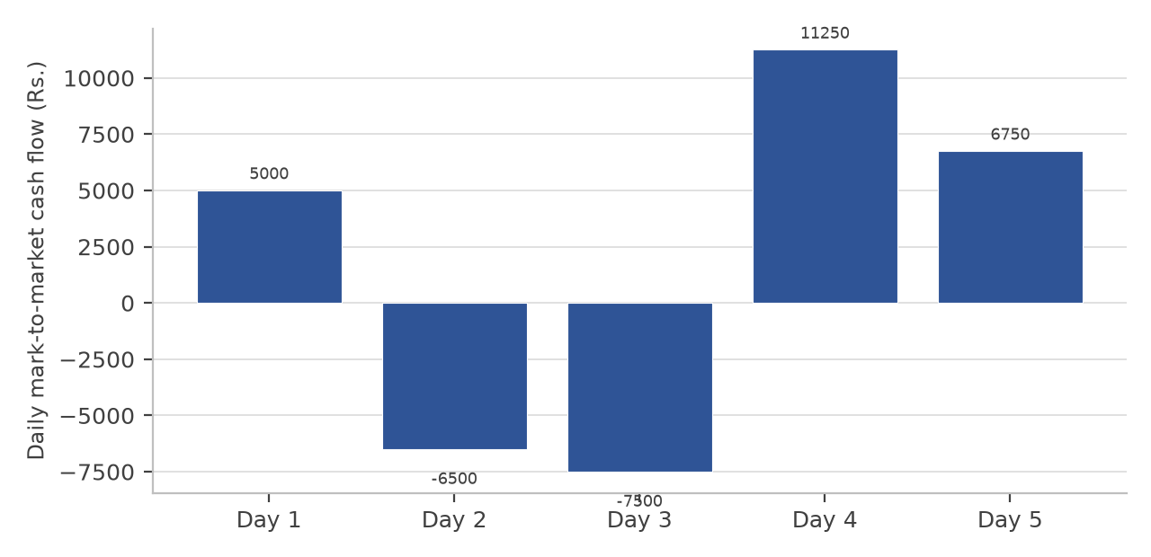
Figure 2.1: Daily mark-to-market cash flow on the illustrative position
The five daily flows sum to Rs. 9,000, which is exactly the price change of Rs. 9.00 multiplied by the lot size of 1,000 units. Daily settlement therefore redistributes the final result across the days of the contract without altering it. The redistribution is what matters to a client: the position ends with a profit of Rs. 9,000, but the client had to fund two adverse days of Rs. 6,500 and Rs. 7,500 in cash while the position was open. A client who cannot fund those intermediate days does not reach the profitable end.
O. Illustrative computation: value and sensitivities of an option
An option premium has to be estimated rather than derived from the spot price, because part of its value is the possibility that the underlying will move before expiry. An illustrative thirty-day call on the same underlying, struck at Rs. 1,260 with the spot at Rs. 1,250, is valued in Table 2.20 using the Black-Scholes-Merton model. Volatility of 28 per cent a year and a risk-free rate of 7 per cent are assumptions, not observations.
Table 2.20: Black-Scholes inputs, computed price and sensitivities (illustrative)
Item | Symbol | Value | Basis
Spot price | S | Rs. 1,250.00 | Illustrative
Strike price | K | Rs. 1,260.00 | Illustrative
Time to expiry | t | 0.0822 years (30  days) | Illustrative
Risk-free rate | r | 7.00 per cent | Illustrative
Volatility | σ | 28.00 per cent | Illustrative
d₁ | d₁ | 0.0125 | Author’s computation
d₂ | d₂ | (0.0677) | Author’s computation
Call price | C | Rs. 38.69 | Author’s computation
Put price at the same strike | P | Rs. 41.47 | Author’s computation
Delta of the call | Δ | 0.5050 | Author’s computation
Gamma | Γ | 0.003976 | Author’s computation
Theta of the call, per day | Θ | Rs. (0.7808) | Author’s computation
Vega, per one point of volatility | ν | Rs. 1.4296 | Author’s computation
Premium outlay on one lot of  1,000 | — | Rs. 38,690 | Illustrative
Break-even at expiry | K + C | Rs. 1,298.69 | Author’s computation
The payoff of the position at expiry is set out in Table 2.21. The buyer of the call loses the whole premium of Rs. 38,690 if the underlying is at or below Rs. 1,260 at expiry, and the position turns profitable only above Rs. 1,298.69.
Table 2.21: Payoff of the long call at expiry (illustrative, one lot of 1,000 units)
Underlying at expiry  (Rs.) | Intrinsic value per unit  (Rs.) | Premium paid per unit  (Rs.) | Net profit or loss on one  lot (Rs.)
1,150 | 0.00 | 38.69 | (38,690)
1,200 | 0.00 | 38.69 | (38,690)
1,250 | 0.00 | 38.69 | (38,690)
1,260 | 0.00 | 38.69 | (38,690)
1,280 | 20.00 | 38.69 | (18,690)
1,301 | 41.00 | 38.69 | 2,310
1,320 | 60.00 | 38.69 | 21,310
1,360 | 100.00 | 38.69 | 61,310
1,400 | 140.00 | 38.69 | 1,01,310
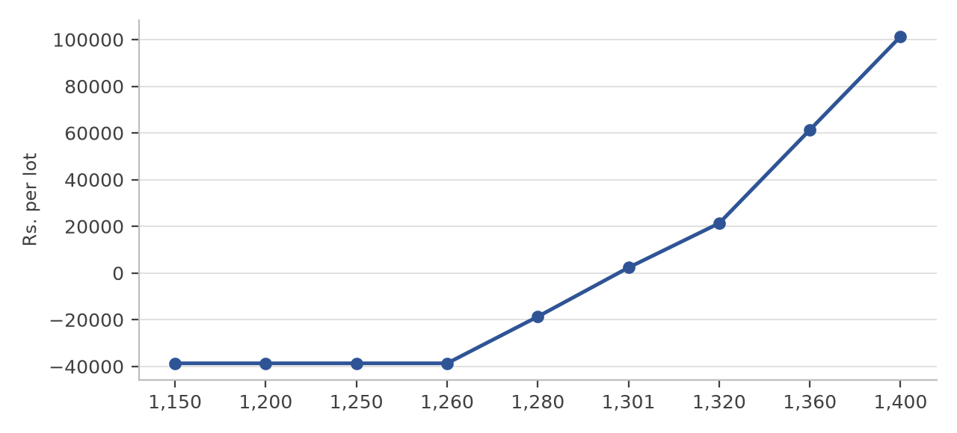
Figure 2.2: Payoff of the long call at expiry, with the break-even marked
Two features of the computation are worth recording because they are counter-intuitive to a client who is new to options. The first is the break-even. The option is bought at Rs. 38.69 and the strike is Rs. 1,260, so the underlying must rise by 3.9 per cent from the spot price before the position is even; a correct view on the direction of the market is not by itself sufficient. The second is the decay of the premium. With thirty days remaining the option is worth Rs. 38.69, and with five days remaining the same option, with the spot price unchanged, is worth about Rs. 12.38. Roughly 68 per cent of the premium is therefore lost in the final five days of the contract, and this is the mechanism behind the ordinary experience that an option can be held through a correct market move and still lose money.
A straddle illustrates the same point from the opposite direction. Buying both the call and the put struck at Rs. 1,250 costs Rs. 80.01 per unit, so a movement of about 6.40 per cent in either direction is required before the position breaks even. Strategies designed to profit from volatility are therefore considerably less forgiving than they appear when the two premiums are considered separately.
P. Illustrative computation: margin build-up and the mechanics of a shortfall
The margin required on a position is prescribed by the clearing corporation and is not a matter of negotiation between the firm and the client. Table 2.22 builds up the requirement on the futures position described above using illustrative percentages, because the parameters actually applied by the clearing corporation are proprietary and are revised daily.
Table 2.22: Margin build-up on one long futures lot (illustrative)
Component | Basis | Rate | Amount (Rs.)
Contract value | Entry price Rs. 1,257.00 × lot of 1,000 | — | 12,57,000
Initial margin | Contract value × rate | 9.50 per cent | 1,19,415
Exposure margin | Contract value × rate | 3.50 per cent | 43,995
Total margin required | Initial margin + exposure margin | 13.00 per  cent | 1,63,410
Margin as a percentage of  contract value | Total margin ÷ contract value | — | 13.00 per cent
The client in this illustration has placed collateral of Rs. 1,75,000, which is comfortably above the requirement at entry. Table 2.23 shows what happens if the underlying falls to Rs. 1,232.00, a fall of 1.99 per cent.
Table 2.23: Margin shortfall and square-off scenario (illustrative)
Step | Computation | Amount (Rs.)
Collateral placed by the client | Given | 1,75,000
Margin required at entry | From Table 2.22 | 1,63,410
Surplus at entry | 1,75,000 − 1,63,410 | 11,590
Mark-to-market loss on the fall to Rs.  1,232.00 | (1,232.00 − 1,257.00) × 1,000 | (25,000)
Collateral after the loss is debited | 1,75,000 − 25,000 | 1,50,000
Margin required at the lower price | 1,232.00 × 1,000 × 13.00 per cent | 1,60,160
Shortfall | 1,60,160 − 1,50,000 | 10,160
At entry the client held a surplus of Rs. 11,590 over a requirement of Rs. 1,63,410, which looks comfortable. A fall of 1.99 per cent in the underlying converts that surplus into a shortfall of Rs. 10,160. The reason is an asymmetry that every new dealer has to understand: the mark-to-market loss is debited from the collateral in full, while the requirement falls only slightly, from Rs. 1,63,410 to Rs. 1,60,160, because the requirement is itself computed on a contract value that has fallen. Collateral therefore declines faster than the margin requirement, and the gap widens as the adverse move continues. This is why the response to a margin alert is time-critical and why the desk is not permitted to grant an extension.
Q. Illustrative computation: transaction costs on a delivery and an intraday round trip
A trade that shows a profit before costs may show a loss after them. The first illustration is a delivery round trip of 100 shares bought and sold at Rs. 1,000 with brokerage at 0.05 per cent on each side.
Table 2.24: Charge computation on an illustrative delivery round trip
Charge | Rate applied | Base | Amount  (Rs.)
Buy value | 100 shares × Rs. 1,000 | — | 1,00,000
Sell value | 100 shares × Rs. 1,000 | — | 1,00,000
Brokerage | 0.05 per cent each side | Buy + sell value | 100.00
Securities transaction tax | 0.10 per cent each side | Buy + sell value | 200.00
Exchange transaction  charges | 0.00297 per cent | Buy + sell value | 5.94
SEBI turnover fee | 0.0001 per cent | Buy + sell value | 0.20
Stamp duty | 0.015 per cent | Buy value only | 15.00
Goods and services tax | 18 per cent | Brokerage + exchange charges  + SEBI fee | 19.11
Total charges | — | — | 340.25
Break-even move required  per share | Total charges ÷ 100 shares | — | Rs. 3.40
The second illustration is an intraday trade of Rs. 5,00,000 bought and Rs. 5,02,500 sold on the same day, at a flat brokerage of Rs. 20 for each executed order.
Table 2.25: Charge computation on an illustrative intraday trade
Charge | Rate applied | Base | Amount  (Rs.)
Brokerage | Rs. 20 per executed order,  two orders | — | 40.00
Securities transaction tax | 0.025 per cent | Sell value only | 125.62
Exchange transaction  charges | 0.00297 per cent | Buy + sell value | 29.77
SEBI turnover fee | 0.0001 per cent | Buy + sell value | 1.00
Stamp duty | 0.003 per cent | Buy value only | 15.00
Goods and services tax | 18 per cent | Brokerage + exchange charges  + SEBI fee | 12.74
Total charges | — | — | 224.14
Gross profit on the trade | 5,02,500 − 5,00,000 | — | 2,500.00
Net profit after charges | 2,500.00 − 224.14 | — | 2,275.86
Charges as a percentage of  gross profit | 224.14 ÷ 2,500.00 | — | 8.97 per cent
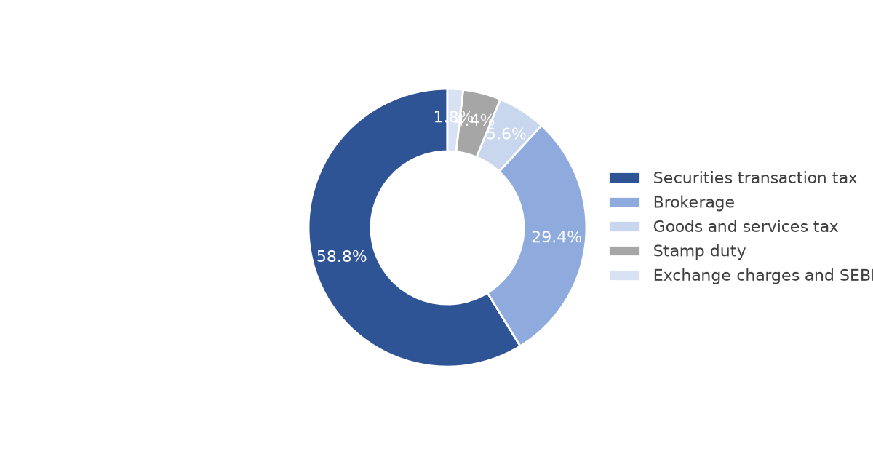
Figure 2.3: Composition of the charges on the illustrative delivery round trip
On the delivery round trip the total cost of Rs. 340.25 requires the share to move Rs. 3.40, or about 0.34 per cent, before the client is even. The securities transaction tax of Rs. 200.00 is twice the brokerage of Rs. 100.00, so the statutory component rather than the firm’s charge is the larger part of the cost. On the intraday trade the charges of Rs. 224.14 absorb 8.97 per cent of a gross profit of Rs. 2,500. The lesson that follows is that the frequency of trading, rather than the size of any single trade, determines what a client pays in total.
R. Learning outcomes from the internship
The internship produced four durable outcomes. The first is an operational understanding of the Indian secondary market that runs from a client instruction to a settled credit in the demat account, including the points at which the process can fail. The second is the ability to compute, rather than describe, the quantities that govern a dealing decision: the fair value of a futures contract, a mark-to-market obligation, an option premium and its sensitivities, a margin requirement and the ladder of statutory charges. The third is familiarity with the two trading technologies in use on an Indian dealing desk, the exchange terminal and the member’s Computer-to-Computer Link facility, and with the difference between the two in practice. The fourth is the discipline of sourcing: every regulatory statement in this report carries the authority on which it rests and the date on which it was checked, and every figure is identified as reported, computed or illustrative.
The wider conclusion drawn from the operational part of the internship is that the competence expected of an equity dealer is not the ability to form a view on a security. It is the ability to execute an instruction correctly within a dense framework of limits, timings and statutory obligations, and to recognise immediately when that framework has been breached. The attributes that determine how a security should be traded, such as its price band, its depth and its volatility, are almost entirely separate from the attributes that determine whether the company behind it is a sound business, which is the question addressed in the second half of this report.
CHAPTER 3 :- FUNDAMENTAL ANALYSIS (FMCG SECTOR OVERVIEW)
Fundamental analysis begins with the industry in which a company operates, because the industry determines the range of outcomes that are available to any individual firm within it. This chapter sets out the importance of the Indian fast-moving consumer goods sector, its industry-wide advantages and disadvantages, the challenges it faces, and an overview of its ten largest listed companies. The company-wise financial analysis is presented in Chapter 5 under the economic, industry and company framework, and the comparative ratio analysis in Chapter 6.
3.1 IMPORTANCE OF THE FMCG SECTOR
A. Contribution to the economy
The FMCG sector is the fourth largest sector of the Indian economy. It provides employment to around three million people, which is approximately five per cent of total factory employment in the country. The Indian FMCG market generated revenue of approximately Rs. 25 lakh crore, equivalent to US$ 289.1 billion, in 2025 and is expected to grow at a compound annual rate of 17.3 per cent through the period 2025 to 2030, reaching nearly US$ 642.87 billion by 2030. Household and personal care products alone contribute about half of total FMCG sales.
The sector’s importance does not rest only on its size. Because its products are consumed repeatedly and at short intervals, demand is comparatively insensitive to the business cycle. This defensiveness is the reason the sector is treated differently from cyclical industries in portfolio construction, and it is also the reason the sector is analysed here alongside the internship, since a dealer on a broking desk regularly handles client interest in exactly these securities.
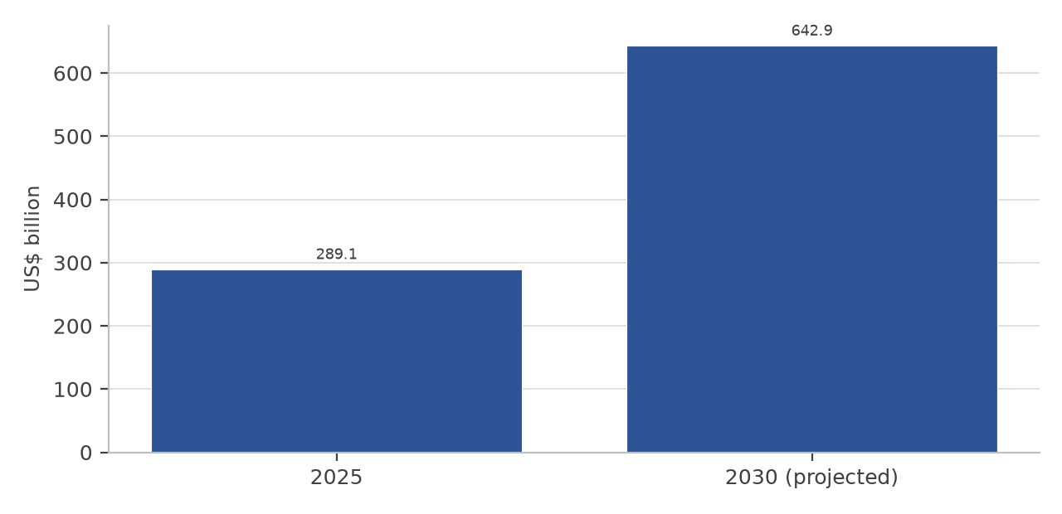
Figure 3.1: Indian FMCG market size, 2025 and 2030 (projected)
The projection above, which is the published industry estimate, implies that the market roughly doubles over five years. The figure should be read as an expectation of nominal growth, part of which reflects price increases rather than additional volume, and it is therefore a statement about the size of the opportunity rather than of the return available to any particular company.
B. Rural and urban consumption
The urban segment contributes about 62 per cent of total FMCG revenue, while rural India accounts for more than 38 per cent. The two markets behave differently. Rural demand is closely linked to the monsoon, to the level of minimum support prices and to the government’s transfer programmes, and it responds strongly to the pack sizes and price points that are made available. Urban demand is linked to wage growth, to employment in the services sector and to premiumisation. The balance between the two is therefore one of the most important variables in any forecast of the sector.
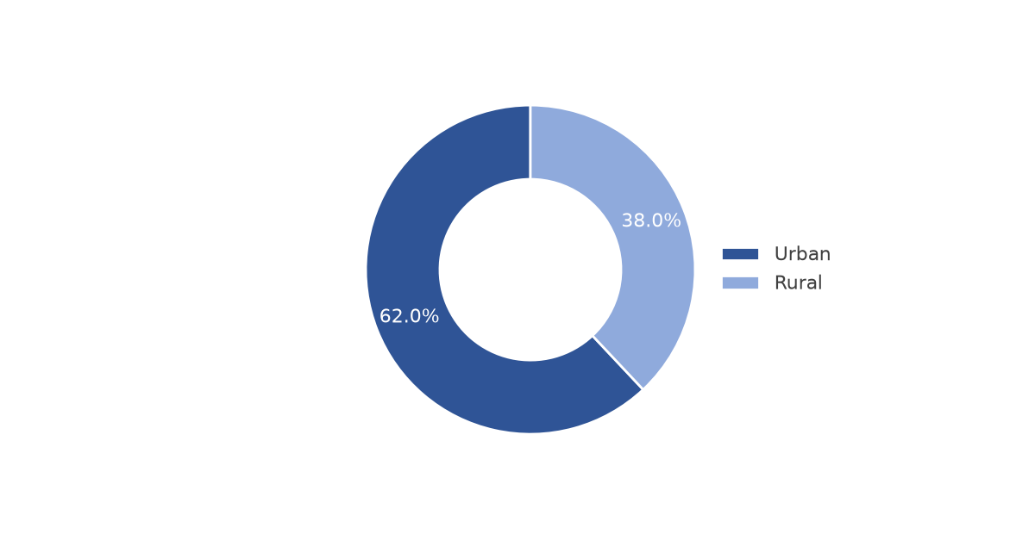
Figure 3.2: Urban and rural share of Indian FMCG sales
The split matters for interpretation of company performance. Two companies of similar size can report very different growth in the same year purely because of the difference in their rural and urban mix. Dabur derives 45 to 50 per cent of its revenue from rural markets and reaches over 1,31,000 villages and 1.42 million outlets, while Hindustan Unilever generates 35 to 40 per cent of its revenue from rural areas and supports its rural distribution with a retailer ordering application that has about 1.4 million retailers on board. A year in which rural demand weakens will therefore affect Dabur more than Hindustan Unilever, irrespective of the quality of either company’s execution.
C. Growth drivers of the sector
• Rising disposable income and a large young population: India’s middle-class population is larger than the total population of the United States and the median age of the population is about 27 years, which sustains both the volume of consumption and the willingness to try premium products.
• Policy support for consumption: the Union Budget 2025-26 was directed partly at consumer spending, and the increase in disposable income and the focus on rural development create a favourable environment for staples and for packaged foods.
• Shift from unbranded to branded products: as incomes rise, households substitute branded and packaged goods for loose and unbranded substitutes, which expands the organised market even when total consumption grows slowly.
• Expansion of distribution into smaller towns and villages: direct reach, rural preferred dealer networks and retailer ordering applications have extended the reach of the larger companies well beyond the principal cities.
• Growth of e-commerce and quick commerce: e-commerce accounted for nearly 18 per cent of FMCG sales across the top eight metro cities in the quarter from October to December 2025, and quick commerce now accounts for 70 to 75 per cent of total e-grocery orders, against about 35 per cent in 2022.
• Premiumisation: within categories such as personal care, foods and beverages, consumers have moved towards higher-priced variants, which allows companies to improve margin even where volume growth is modest.
• Investment by large companies: several of the largest firms have announced significant capital expenditure programmes, including Hindustan Unilever’s plan to invest up to Rs. 20,000 crore in manufacturing capacity in premium segments and ITC’s plan of about Rs. 20,000 crore over the next five to six years.
3.2 INDUSTRY-WIDE ADVANTAGES & DISADVANTAGES
Advantages
• Defensive demand: the products are consumed frequently and are purchased again within a short interval, so revenue is less exposed to a downturn in economic activity than in discretionary industries.
• Low unit price and wide penetration: because the unit price is small, a household can continue to buy the product through periods of pressure on income, which stabilises volume.
• Brand loyalty and pricing power: established brands in categories such as detergents, biscuits and health supplements command a price premium and retain consumers across cycles, which protects margin.
• Negative working capital in practice: the larger companies collect from distributors sooner than they pay their own suppliers, so operations are partly financed by trade credit. All three companies studied have a negative cash conversion cycle.
• Established distribution as a barrier to entry: a distribution network that reaches millions of retail outlets takes years and substantial capital to build, and it is the principal reason a new entrant cannot easily displace an incumbent.
• Cash-generative with low capital intensity: the sector converts a large proportion of its operating profit into operating cash flow and requires comparatively modest capital expenditure to maintain existing capacity.
Disadvantages
• Exposure to input cost inflation: the principal raw materials are agricultural commodities and crude oil derivatives, whose prices cannot be controlled by the company, and packaging costs move with the price of polymers.
• Limited ability to pass on cost increases quickly: because the products are everyday necessities, a price increase invites consumer resistance and regulatory attention, so companies often absorb cost pressure in margin.
• Intense competition: the sector contains large domestic groups, Indian subsidiaries of global companies and a growing set of digital-first brands, and competition on price and on shelf space is continuous.
• Dependence on advertising: FMCG was the largest advertising sector in India in 2024, contributing around 34 per cent of total advertising expenditure with spends of about Rs. 31,428 crore. Advertising is a recurring cost that must be maintained to hold market share.
• Slow volume growth in mature categories: several of the largest categories have reached high penetration and grow at approximately the rate of population growth, so a company must find new categories or new geographies to grow faster than the market.
• Regulatory and quality exposure: the sector is subject to food safety standards, labelling and advertising regulation, and legal metrology, and a single quality or labelling failure can damage a brand across its entire category.
3.3 SECTOR CHALLENGES
The challenges listed below are the ones that are most visible in the financial statements of the companies analysed in this report, rather than a general list of industry concerns.
• Moderating volume growth with a widening rural-urban gap: India’s FMCG sector recorded overall volume growth of 4.1 per cent in 2025, down from 4.7 per cent in 2024. Rural volume growth fell to 3.6 per cent from 5 per cent, while urban growth edged up to 4.6 per cent from 4.5 per cent. The rural slowdown is the single most important challenge facing companies with a rural-weighted portfolio.
• Input cost and packaging cost pressure: prices of edible oils, milk solids, wheat, sugar and crude-oil-linked packaging materials move independently of consumer demand, and a simultaneous rise compresses gross margin in the same year in which demand is weak.
• Competition from digital-first brands: new product launches in the sector rose 1.8 times in the year ending May 2025, although only about 4 per cent of those launches reached a market penetration of one per cent. The failure rate lowers the expected return on innovation spending without reducing the amount that must be spent.
• Shift of volume to channels with different economics: quick commerce and e-commerce are growing far faster than general trade, but the commission, delivery and platform cost in these channels is higher, so a shift in channel mix can reduce margin even while revenue grows.
• Regulatory intervention on pricing and on health: restrictions on the advertising of products high in fat, salt and sugar, and on packaging and labelling, can change the economics of a category quickly. The introduction of the goods and services tax reform on packaged goods has also altered the effective price points available to manufacturers in some categories.
• Foreign exchange and commodity exposure on imports: companies that import palm oil, wheat or packaging material carry a translation and purchasing exposure which cannot be fully hedged, and depreciation of the rupee raises landed cost directly.
• Talent and distribution cost inflation: the cost of frontline sales and distribution manpower has risen faster than the price of the product in several categories, which increases the fixed component of the cost structure.
3.4 TOP 10 INDIAN FMCG COMPANIES OVERVIEW
Table 3.1 gives an overview of the ten largest listed companies in the Indian FMCG sector and the position each occupies within it. The companies are listed in the order of their principal area of operation rather than in order of size, because a single ranking by market capitalisation would place companies of very different business models next to each other without explaining the difference.
Table 3.1: Leading listed companies in the Indian FMCG sector
Sr.  No. | Company name | Principal segment | Core position in the sector
1 | Hindustan  Unilever Ltd. | Home care, beauty and  wellbeing, personal care  and foods | The largest pure-play FMCG company in India,  with more than fifty brands across fifteen  categories and one of the widest distribution  networks in the country.
2 | ITC Ltd. | Cigarettes, packaged  foods, personal care,  hotels and paper | A diversified conglomerate in which the  non-cigarette FMCG business is the  fastest-growing segment. The scale of the tobacco  business funds the expansion of the consumer  portfolio.
3 | Nestlé India Ltd. | Packaged foods and  beverages, prepared  dishes and  confectionery | The leading packaged foods company,  particularly strong in instant noodles, coffee,  chocolate and infant nutrition, with a premium  portfolio and high dependency on a few large  brands.
4 | Britannia  Industries Ltd. | Biscuits, breads, cakes  and dairy | The market leader in biscuits, with a distribution  reach that extends into rural markets through  preferred dealer networks, and a growing  presence in dairy and adjacent snacking  categories.
5 | Dabur India Ltd. | Ayurvedic and natural  healthcare, personal care  and foods | The largest Ayurvedic and natural healthcare  company in India, with products reaching eight  out of ten Indian households and a strong rural  and semi-urban presence.
6 | Marico Ltd. | Edible oils, hair oils and  packaged foods | A leader in coconut oil and hair oils with a  focused portfolio of few large brands, and a  growing presence in premium packaged snacking  through acquisitions.
7 | Godrej Consumer  Products Ltd. | Home care, personal  care and insecticides | A leading player in household insecticides and in  hair colour, with a substantial international  business in Indonesia, Africa and Latin America.
8 | Colgate-Palmolive  (India) Ltd. | Oral care | The market leader in oral care, with a  concentrated portfolio and very high return on  capital employed, and comparatively limited  diversification outside toothpaste and  toothbrushes.
9 | Tata Consumer  Products Ltd. | Tea, coffee, salt, spices  and packaged foods | A leading player in tea and salt with a rapidly  expanding foods and beverages portfolio, and the  owner of several large beverage and food brands  acquired in recent years.
10 | Emami Ltd. | Personal care and  healthcare | A focused personal care company with strong  brands in cooling oils, men’s grooming and  balms, and a significant rural and winter-season  sales profile.
The composition of this list is itself informative for the analysis that follows. Five of the ten companies derive the greater part of their revenue from foods and beverages, four are weighted towards personal and home care, and one, ITC, is a diversified conglomerate whose FMCG business sits beside a much larger tobacco business. The three companies selected for detailed analysis in this report were chosen to represent three different positions on that spectrum: a diversified home and personal care company, a foods company and a healthcare-led personal care company. The reasons for the selection are set out in Chapter 4.
CHAPTER 4 :- RESEARCH METHODOLOGY
4.1 RESEARCH DESIGN & OBJECTIVES
The present study is based on a descriptive and analytical research design. The study analyses and compares the financial performance of selected companies in the Indian FMCG sector over the period from FY2023-24 to FY2025-26. It is descriptive because the objective is to document and explain the position of each company rather than to test a causal hypothesis, and analytical because the financial statements are decomposed into ratios and compared between companies and between years.
The operational component of the report adopts a work-based learning design, in which the author was placed within the function studied and the observations were generated by performing the work rather than by interviewing those who perform it. A descriptive design is appropriate for that component as well, because the dealing process is prescribed by regulation and exchange rules rather than determined by the preferences of participants.
The objectives of the research are the following.
• To analyse the profitability of Hindustan Unilever Ltd., Britannia Industries Ltd. and Dabur India Ltd. over FY2023-24 to FY2025-26.
• To study the liquidity and solvency position of the three selected companies using current ratio, debt to equity and interest coverage.
• To analyse the efficiency and the return earned on the capital employed by each company using operating ratio, return on capital employed, return on equity, return on assets and return on investment.
• To evaluate the market valuation of the selected companies using the price to earnings, price to book and price to earnings growth ratios, and to compare each company’s multiple with the median multiple of its listed peer set.
• To compare the financial performance of the three companies over the three financial years and to identify the company showing relatively better financial performance on the selected ratios.
• To examine the effect of a one-time item on the comparability of the reported figures of one of the selected companies, and to state clearly the basis on which the comparison has been made.
4.2 SCOPE & SOURCES OF DATA
The study is based mainly on secondary data. Financial information has been collected from audited annual financial statements, the annual reports of the selected companies, share-related information published by the exchanges, and published financial information consolidated from the companies’ own filings. Where a ratio has been computed by the author rather than reported by the company, the formula applied is stated along with the result, so that the derivation can be checked.
The major sources of secondary data used in the study are the following.
• Annual reports of Hindustan Unilever Ltd., Britannia Industries Ltd. and Dabur India Ltd. for FY2023-24, FY2024-25 and FY2025-26.
• Audited consolidated financial statements of the three companies, and the quarterly results filed with the exchanges.
• Corporate announcements and shareholding pattern disclosures filed with BSE Ltd. and the National Stock Exchange of India Ltd.
• Securities and Exchange Board of India publications and circulars, and exchange bye-laws and regulations, for the operational component of the report.
• Reserve Bank of India publications and the Economic Survey for the macroeconomic data used in the economic analysis.
• India Brand Equity Foundation industry publications for sector size, growth and investment data.
• Published financial information and ratio data collated from the companies’ own statements, used for cross-checking computed ratios.
• Company websites, for business descriptions, product portfolios, history and management information.
Primary data consists of the author’s own structured observation of the dealing desk during the internship, including the sequence of the working day, the screens and functions used, the categories of client instruction received, the nature of the risk alerts generated and the reconciliation procedure followed at the close of the session. No client record, internal limit or financial figure of the firm has been reproduced. Every trading example in this report is constructed by the author and labelled as illustrative.
4.3 SAMPLE SELECTION & PERIOD OF STUDY
The study uses purposive sampling for the selection of the companies. Three companies were selected because they represent three distinct positions within the Indian FMCG sector and because each publishes sufficient financial information for a comparative analysis over three financial years. The selection criteria applied were the following.
• The company must be listed on a recognised Indian stock exchange and must be part of the FMCG sector on the basis of its principal revenue.
• The company must have a financial year ending on 31 March, so that the figures of all three companies relate to the same twelve-month period and are directly comparable.
• The company must have audited consolidated financial statements available for each of the three years under study.
• The three companies taken together must represent more than one segment of the FMCG sector, so that the comparison is not confined to a single product category.
Name of the companies selected:
• Hindustan Unilever Ltd. — home care, beauty and wellbeing, personal care and foods.
• Britannia Industries Ltd. — biscuits, breads, cakes and dairy products.
• Dabur India Ltd. — Ayurvedic and natural healthcare, personal care and foods.
A fourth company, Nestlé India Ltd., was considered and excluded. The company changed its financial year end from December to March, so that the twelve months reported as FY2023-24 in fact cover a fifteen-month period. Including it would have required an adjustment to the reported figures of one company in one year, which would have reduced the comparability of the rest of the analysis. The exclusion is noted here so that the reason for the composition of the sample is clear.
The period of study covers three financial years: FY2023-24, FY2024-25 and FY2025-26. For simplicity in the ratio tables, these years are represented as 2024, 2025 and 2026. Market price data used in the valuation ratios is stated as on 12 October 2026, which is the date on which it was collected, and the fact that prices change continuously is acknowledged as a limitation of the study.
The tools used for analysis are financial ratio analysis and comparative and trend analysis. The ratios have been grouped into profitability ratios (net profit margin, operating ratio), return ratios (return on capital employed, return on equity, return on assets, return on investment), solvency and leverage ratios (debt to equity, interest coverage), liquidity ratios (current ratio) and market valuation ratios (price to earnings, price to book, price to earnings growth). The interpretation of each ratio is presented immediately after the table, and the ratio trend charts are used to show the movement of each ratio across the three years.
The limitations of the study are the following.
• The study is based mainly on secondary data, so the accuracy of the analysis depends on the accuracy of the published financial statements and disclosures relied upon.
• The analysis is limited to three selected companies and to three financial years, which is too short a period to establish a long-term trend in a sector whose performance is influenced by monsoon, commodity and policy cycles.
• Financial ratios alone cannot provide a complete picture of a company. The analysis does not include a discounted cash flow valuation, a study of management quality or an assessment of brand strength, all of which influence long-term value.
• The reported profit of one of the selected companies for FY2025-26 includes a substantial one-time item. Reported and normalised figures therefore differ, and the basis used in each table has been stated explicitly.
• Market prices change continuously, whereas the valuation ratios in this report are computed on market data as at a single date.
• The macroeconomic and sector data used in the economic and industry analysis are stated as at the date on which they were collected, and several of them are revised subsequently by the publishing agency.
• The internship component of the study covers a single firm and a single dealing desk, so its observations describe a process rather than the practice of the industry as a whole.
• Confidentiality obligations prevented the use of the firm’s actual order flow, so every quantitative example in the operational part of the report is illustrative rather than observed.
Four safeguards were adopted with regard to data. First, no client-identifying information appears anywhere in this report. Second, no internal financial figure of the firm is disclosed, and every monetary example in the operational chapters is constructed by the author and labelled illustrative. Third, no fact about the firm has been invented; where a particular was not available from the firm’s own documents, a marked placeholder has been left rather than an assumed value. Fourth, every figure taken from a published source is capable of being traced to that source, and the sources are listed in the references and bibliography.
CHAPTER 5 :- EIC FRAMEWORK (ECONOMIC, INDUSTRY & COMPANY ANALYSIS)
5.1 ECONOMIC ANALYSIS (MACROECONOMIC FACTORS & CURRENT INDIAN ECONOMY)
A. What economic analysis is
Economic analysis evaluates how money, resources, goods and services move through a market or a country. It uses data such as gross domestic product, inflation, employment and interest rates to measure the financial health of an economy, to guide government policy, and to help investors decide how much risk they are willing to carry. In fundamental analysis the purpose of the exercise is narrower: to establish whether the general economic environment is likely to support or restrain the earnings of the companies being studied.
The indicators most relevant to a consumer-goods company are different from those relevant to a capital-goods company. A producer of everyday consumption goods depends principally on household real income, on the level of food and fuel inflation, on rural cash flows and on the cost of the raw materials and packaging it buys. This section therefore examines the state of the Indian economy in 2026 with those channels in mind, and Table 5.1 sets out the principal indicators used.
Table 5.1: Principal macroeconomic indicators used in the analysis
Indicator | What it measures | Why it matters for an FMCG company
Real gross domestic  product | The total value of final goods and services  produced in the economy, adjusted for  price change | Sets the growth of aggregate demand  and of household income
Consumer price  inflation | The rate of increase in retail prices of a  representative basket | Determines real purchasing power and  the ability of a company to take a price  increase
Food inflation | Inflation in food articles within the  consumer price index | Raises the cost of agricultural raw  materials and reduces the discretionary  spending of rural households
Policy interest rate | The rate at which the central bank lends  against government securities | Sets the cost of working capital, the  attractiveness of consumer credit and  the valuation multiple of equities
Private final  consumption  expenditure | The share of gross domestic product spent  by households | The direct demand base of the sector
Rural wage and  monsoon conditions | The level of rural cash income and  agricultural output | Drives demand for the rural-weighted  part of the portfolio
Goods and services  tax rates | The indirect tax applicable to a product  category | Alters the effective price point and  therefore the addressable market of a  product
B. The current state of the Indian economy, 2026
Report date: August to October 2026. India remains one of the fastest-growing major economies, but its current position is a combination of strong domestic growth and rising external and inflationary risk. The economy is supported by consumption, investment, infrastructure spending, services and improving financial-sector conditions. At the same time, higher food and energy prices, geopolitical tension, rupee depreciation and global trade uncertainty are the principal risks.
The Economic Survey estimated real gross domestic product growth at 7.4 per cent for FY2025-26 and projected growth of 6.8 to 7.2 per cent for FY2026-27. The Reserve Bank of India’s projection, made in August 2026, is more cautious at 6.7 per cent for FY2026-27. The Survey describes the growth model as being supported by what it describes as a double engine of consumption and investment. Private final consumption expenditure accounted for 61.5 per cent of gross domestic product in FY2025-26.
Table 5.2: Gross domestic product growth in India
Indicator | Figure
Real gross domestic product growth, FY2025-26 (Economic Survey  estimate) | 7.4 per cent
Projection for FY2026-27 (Economic Survey) | 6.8 to 7.2 per cent
Projection for FY2026-27 (Reserve Bank of India, August 2026) | 6.7 per cent
Estimated potential growth rate | approximately 7 per cent
Private final consumption expenditure, FY2025-26 | 61.5 per cent of gross  domestic product
The significance of these figures for the sector analysed in this report is indirect but important. A growth rate of about seven per cent, with consumption contributing so large a share, means that the volume of goods purchased by households is expanding in line with income. At the same time, a projected slowdown from 7.4 to 6.7 per cent between FY2025-26 and FY2026-27 indicates that the growth of that demand is likely to be slower in the year ahead, which is relevant to the valuation multiples that the market is willing to pay for consumer companies.
C. Inflation and consumer purchasing power
Inflation is a sustained increase in the general price level. When it rises, the purchasing power of money falls. India uses the consumer price index for retail inflation and for monetary policy decisions, and the reserve bank operates within a tolerance band of two to six per cent around a target of four per cent.
Table 5.3: Consumer price inflation in India, 2026
Measure | Figure
Consumer price index inflation, July 2026 | 4.45 per cent
Consumer price index inflation, June 2026 | 4.38 per cent
Rural inflation, July 2026 | 4.84 per cent
Urban inflation, July 2026 | 3.96 per cent
Food inflation, July 2026 | 5.52 per cent
Reserve Bank of India target | 4 per cent
Tolerance band | 2 to 6 per cent
Headline inflation of 4.45 per cent is above the reserve bank’s target but comfortably inside the tolerance band, which means that the direction of inflation matters more than its level. The important point for an FMCG company is the composition. Food inflation at 5.52 per cent is higher than headline inflation, and rural inflation at 4.84 per cent is higher than urban inflation at 3.96 per cent. Food and rural inflation work in opposite directions for the sector: they raise the cost of agricultural raw materials such as wheat, milk solids and edible oils, while at the same time reducing the discretionary purchasing power of rural households. A company with a rural-weighted portfolio therefore faces both a cost increase and a demand constraint in the same period, and this is visible in the financial statements discussed later in this chapter.
D. Interest rates and the cost of capital
Monetary policy is the process through which the reserve bank manages interest rates, liquidity and credit conditions in order to maintain price stability while supporting growth. The most important policy rate is the repo rate, at which the central bank lends against government securities.
Table 5.4: Policy rates in India, as at August 2026
Monetary policy indicator | Rate
Repo rate | 5.25 per cent
Standing deposit facility | 5.00 per cent
Marginal standing facility and bank rate | 5.50 per cent
Reserve Bank of India inflation target | 4 per cent
The reserve bank kept the repo rate unchanged at 5.25 per cent in August 2026 and maintained a neutral stance, projecting real gross domestic product growth of 6.7 per cent and inflation of 5.0 per cent for FY2026-27. For the FMCG sector the rate matters through three separate channels. It determines the cost of short-term working capital, which in this sector is small because operations are partly financed by trade credit. It determines the cost of the borrowings that fund capacity expansion, which is material for the more capital-intensive companies. And it determines the discount rate at which future earnings are valued, which is the reason the price to earnings multiples of consumer companies are sensitive to the interest rate cycle even when their own borrowings are negligible.
E. Input costs, distribution and competition
The cost structure of an FMCG company has three large components: raw and packaging materials, advertising and promotion, and the distribution network. Raw material cost is the largest and the least controllable. A biscuit manufacturer buys wheat flour, sugar and edible oil; a personal care company buys packaging polymers, surfactants and fragrance; a health and wellness company buys herbs and food ingredients. Because the products are everyday necessities, a manufacturer cannot pass on an input cost increase in full without losing volume, and the usual response is to reduce the pack size or absorb part of the increase in the gross margin. The operating ratio computed in Chapter 6 measures the result of those decisions.
Distribution is the second structural cost. Reaching several million retail outlets requires a network of carrying and forwarding agents, distributors and frontline sales staff, and it is the principal reason that established companies hold a lasting advantage. The network is also the reason the shift of volume towards e-commerce and quick commerce matters. E-commerce accounted for nearly 18 per cent of FMCG sales across the top eight metro cities in the quarter ended December 2025, against an urban average of about six per cent, and quick commerce now accounts for 70 to 75 per cent of total e-grocery orders. These channels reach the consumer faster, but the commission and platform costs attaching to them are higher than those of general trade, so a shift in channel mix can reduce the operating margin even when total revenue is rising.
Advertising is the third component and it is discretionary in principle but not in practice, because market share in a branded category depends on continuous visibility. FMCG was the largest advertising sector in India in 2024, contributing about 34 per cent of total advertising expenditure with spends of approximately Rs. 31,428 crore. Competition has also become more fragmented. New product launches in the sector rose 1.8 times in the year ending May 2025, but only about four per cent of those launches reached a market penetration of even one per cent, which means that the cost of failed innovation is now a material item in the advertising and distribution budgets of the larger companies.
F. Regulation and tax
The sector operates under food safety and standards regulation, legal metrology requirements for packaged goods, and advertising codes that restrict the promotion of certain product categories to children. Indirect tax affects the sector more directly than direct tax. The rate of goods and services tax applicable to a product determines its effective retail price and therefore the size of the market it can address; the rate structure was revised for several consumer categories in the recent past, and the effect on any individual company depends on the mix of products in its portfolio. A company whose portfolio is skewed towards the categories on which the rate was reduced benefits from a lower retail price point and from the resulting volume, while a company whose portfolio is skewed the other way may see its price advantage eroded.
G. Changing consumer preferences and the digital channel
Three changes in consumer behaviour are visible in the data and are relevant to the analysis that follows. The first is a shift towards health and natural products, which is the segment in which Dabur operates and towards which the larger companies are also moving. The second is a preference for convenience, which favours smaller pack sizes in rural markets and ready-to-consume formats in urban ones. The third is a willingness to purchase everyday goods online, which has changed the bargaining position of the manufacturer relative to the traditional trade channel. The sector recorded value growth of 13.9 per cent with volume growth of six per cent in the June 2026 quarter, and value growth of 12.9 per cent with volume growth of 5.4 per cent in the September 2026 quarter, with rural volume growth of 7.7 per cent in the latter quarter. Value growing faster than volume in both quarters is consistent with a mix that is shifting towards higher-priced products rather than with an increase in the quantity consumed.
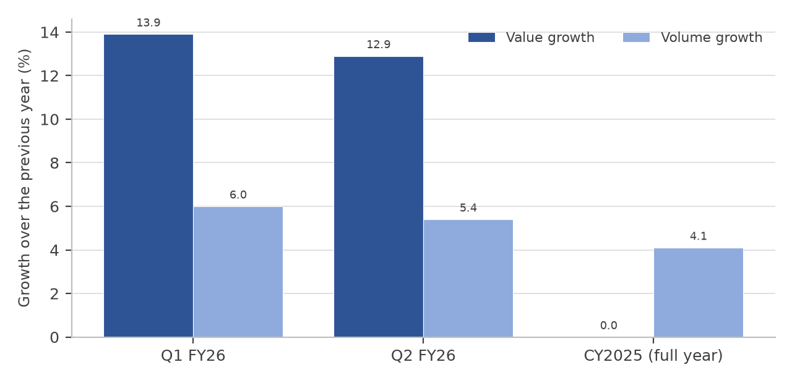
Figure 5.1: Value and volume growth of the Indian FMCG market
The comparison is important for interpretation. Growth in value can be achieved by raising prices or by selling a more expensive mix, neither of which requires more goods to be sold. Growth in volume requires more goods to be sold. A company whose revenue growth comes predominantly from price and mix will report the same revenue as a company whose growth comes from volume, but the second is more likely to be sustainable because it reflects a genuine increase in consumption.
H. Economic risks relevant to the sector
• Food inflation: food inflation of 5.52 per cent in July 2026, higher than headline inflation, raises the cost of agricultural inputs and compresses the gross margin of food and health companies.
• Rural demand slowdown: rural volume growth fell to 3.6 per cent in 2025 from five per cent in 2024. A second consecutive year of weak rural growth would affect the companies with the largest rural exposure most severely.
• Crude oil and packaging costs: India imports a substantial part of its crude oil requirement, and packaging materials derived from polymers move with the price of oil. A rise in oil prices therefore raises packaging cost across the whole sector.
• Rupee depreciation: a weaker rupee raises the landed cost of imported raw materials such as edible oil and of imported machinery, and it increases the reported cost of foreign-currency denominated borrowings.
• Global trade uncertainty and tariffs: trade fragmentation and weaker global demand affect the export earnings of companies with an international business and the general level of business confidence.
• Consumption recovery that is slower than expected: the sector’s FY2025-26 revenue growth was expected at six to eight per cent, and a shortfall against that expectation would leave the current valuation multiples without support.
5.2 INDUSTRY ANALYSIS (FMCG INDUSTRY DRIVERS & TRENDS)
Introduction
India has a strong position in the FMCG sector, supported by a large domestic market, a young population, a manufacturing base that has been strengthened by production-linked incentive schemes, and a distribution system that reaches both metropolitan and rural markets. The sector supplies essential consumption goods to households, which makes it important for economic stability as well as for growth.
Key industry highlights
• The Indian FMCG market generated revenue of approximately Rs. 25 lakh crore, or US$ 289.1 billion, in 2025 and is expected to reach nearly US$ 642.87 billion by 2030, a compound annual growth rate of 17.3 per cent through 2025 to 2030.
• The sector is the fourth largest in the Indian economy and provides employment to around three million people, about five per cent of total factory employment.
• Household and personal care products contribute about 50 per cent of total FMCG sales, followed by food and beverages, health and wellness, and other categories.
• The urban segment contributes about 62 per cent of revenue and rural India more than 38 per cent, with rural markets having been the stronger growth driver in recent years until the slowdown in 2025.
• The sector recorded value growth of 13.9 per cent and volume growth of six per cent in the June 2026 quarter, and value growth of 12.9 per cent and volume growth of 5.4 per cent in the September 2026 quarter.
• Sector revenue growth for FY2025-26 was expected at six to eight per cent, supported by stable rural demand and a revival in urban markets.
• FMCG was the largest advertising sector in India in 2024 with spends of about Rs. 31,428 crore, approximately 34 per cent of total advertising expenditure.
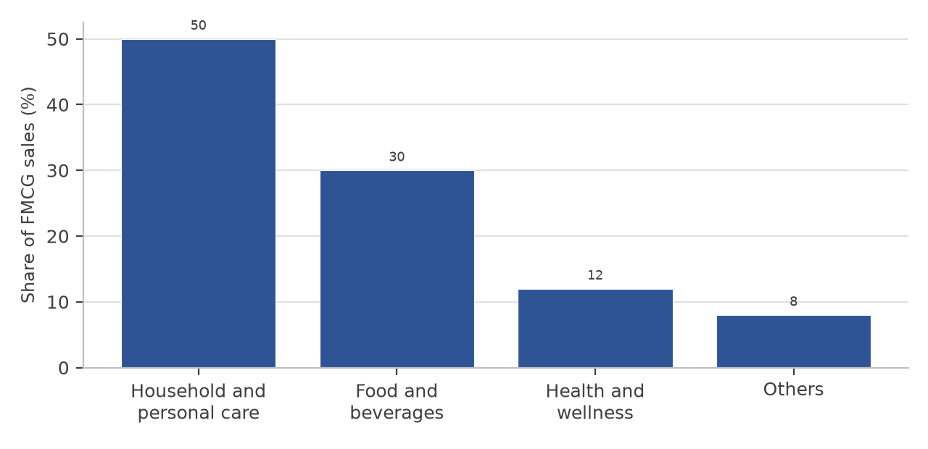
Figure 5.2: Composition of Indian FMCG sales by broad category
Major market drivers
• Consumption growth and income levels: the growth of private final consumption expenditure, which accounted for 61.5 per cent of gross domestic product in FY2025-26, is the single largest driver of sector demand.
• Rural market expansion: rural consumption presents the largest opportunity for distribution expansion in tier two and tier three cities. Companies have responded by strengthening rural dealer networks and by introducing affordable pack sizes.
• Quick commerce and e-commerce: quick commerce currently has a penetration of only about seven per cent of a potential market of US$ 45 billion, and it has delivered a sales increase of 50 to 100 per cent to FMCG companies in FY2024-25. This channel is the fastest growing route to the consumer.
• Premiumisation: rising incomes and greater awareness have moved demand towards higher-priced variants within the same category, which supports margin even where volume growth is modest.
• Emerging categories: the healthy snack market was valued at US$ 3.13 billion in 2025 and is expected to reach US$ 4.77 billion by 2034, and the pet care market is projected to grow from about Rs. 89,743 crore in FY2023-24 to about Rs. 1,38,461 crore by FY2031-32. New categories extend the addressable market of the established companies.
• Government policy and investment: the production-linked incentive scheme for food processing has an outlay of Rs. 10,900 crore and had, up to June 2025, approved 278 units, attracted about Rs. 9,032 crore of investment and created about 3.4 lakh jobs.
Key segments of the sector
Table 5.5: Principal segments of the Indian FMCG sector
Segment | What it comprises | Representative companies
Home care | Detergents, dishwashing products, surface  cleaners, insecticides and air care | Hindustan Unilever, Godrej  Consumer Products, Jyothy Labs
Beauty, wellbeing  and personal care | Soaps, shampoos, hair oil, oral care, skin  care, deodorants and colour cosmetics | Hindustan Unilever, Dabur,  Colgate-Palmolive, Marico, Emami
Foods and beverages | Biscuits, breads, dairy, packaged foods,  instant noodles, coffee, tea, salt and spices | Britannia, Nestlé India, Tata  Consumer Products, ITC, Marico
Health and wellness | Ayurvedic medicines, health supplements,  digestives and natural personal care | Dabur, Emami, Zydus Wellness,  Himalaya
Pet care and  emerging categories | Pet food, premium snacks, functional  foods and direct-to-consumer brands | Marico, and several newer listed and  unlisted entrants
Challenges and outlook
The sector enters FY2026-27 with three structural issues unresolved. Volume growth has moderated and the rural-urban gap has widened, with rural volume growth falling to 3.6 per cent in 2025 against urban growth of 4.6 per cent. Competition from digital-first brands has raised the cost of innovation without materially improving the success rate of new launches. And the shift of volume towards quick commerce and e-commerce, while expanding reach, carries a higher channel cost than general trade. Against these, the sector retains its principal advantages: demand that does not disappear in a downturn, an established distribution network that is difficult to replicate, and a balance sheet that converts operating profit into cash reliably. The outlook for FY2026-27 is for revenue growth of six to eight per cent, with the direction of rural demand and the movement of agricultural commodity prices being the two variables that will determine whether individual companies meet that expectation.
5.3 COMPANY ANALYSIS – HINDUSTAN UNILEVER LTD.
Hindustan Unilever Ltd. is an Indian consumer goods company and the Indian listed subsidiary of Unilever plc. It is the largest pure-play FMCG company in the country, with a portfolio of more than fifty brands across fifteen categories, manufacturing facilities at multiple locations in India and a distribution network that reaches both urban and rural markets. The company describes its business as comprising three segments: Home Care, Beauty and Wellbeing, and Personal Care, with a Foods and Refreshment business alongside them.
1. Company overview and corporate identity
Table 5.6: Hindustan Unilever Ltd. — company identification
Particular | Detail
Company name | Hindustan Unilever Limited
NSE symbol and BSE scrip code | HINDUNILVR; BSE 500696
Sector and industry | Fast moving consumer goods; household and personal products
Corporate website | www.hul.co.in
Registered office | Unilever House, B. D. Sawant Marg, Chakala, Andheri East, Mumbai  400099, Maharashtra
Year of incorporation | Incorporated in 1933 as Lever Brothers India Limited; renamed  Hindustan Unilever Limited in 2007
Ultimate holding company | Unilever plc, through Unilever Overseas Holdings B.V.
Chief Executive Officer and  Managing Director | [ADD: verify the name of the incumbent at the date of submission]
Face value | Re. 1.00 per equity share
Equity shares outstanding | approximately 235.0 crore shares
Market capitalisation as at 12  October 2026 | approximately Rs. 4,34,962 crore
Market price as at 12 October  2026 | Rs. 1,850.90
52 week high and low | Rs. 2,667.20 and Rs. 1,826.90
Study period | FY2023-24 to FY2025-26
2. History and milestones
The company was incorporated in 1933 and was for most of its history known as Hindustan Lever Limited. It was renamed Hindustan Unilever Limited in 2007. Its growth has been built on a series of brand acquisitions and launches rather than on a single product, and its scale in the Indian market comes as much from distribution as from manufacturing. Important milestones include:
• 1933: incorporation as Lever Brothers India Limited, the first Unilever operation in India.
• 1956: listing on Indian stock exchanges, with a large minority shareholding retained by Indian investors.
• 1990s: expansion into personal care and foods, including the acquisition of the Lakmé and Ponds brands and the launch of Ayush products.
• 2007: renaming of the company as Hindustan Unilever Limited.
• 2020: uniting of the foods and refreshment businesses and consolidation of the company’s portfolio around a smaller number of larger brands.
• 2025: demerger of the ice cream business into Kwality Wall’s (India) Ltd., completed with effect from 1 December 2025, with the ice cream undertaking transferred to the new entity and the gain on transfer recognised in the company’s consolidated profit and loss account.
3. Products, brands and revenue segments
The portfolio is organised into four principal reporting groups. Home Care comprises fabric wash, household care and cleaning products. Beauty and Wellbeing comprises skin care, hair care, colour cosmetics and the premium personal care businesses. Personal Care comprises soaps, oral care and mass hair care. Foods comprises tea, coffee, packaged foods, health food drinks and culinary products. The brands include several of the most recognised consumer names in India, and the company states that its products reach a very large share of Indian households. Table 5.7 sets out the segment structure and the approximate contribution of each group to revenue.
Table 5.7: Hindustan Unilever Ltd. — principal segments and product groups
Segment | Principal categories | Indicative share of revenue
Home Care | Fabric wash, household care, dishwashing and  surface cleaning | approximately one third
Beauty and Wellbeing | Skin care, hair care, colour cosmetics and  premium beauty | approximately one fifth
Personal Care | Soaps, oral care and mass hair care | approximately one fifth
Foods | Tea, coffee, packaged foods, health food drinks  and culinary products | approximately one fifth
The relevant point about this structure for the analysis that follows is that no single group contributes more than about a third of revenue. The company is therefore less exposed to the performance of any single category than a company concentrated in one product line, but it is also less able to grow faster than the sector simply by being present in a fast-growing category.
4. Financial performance, FY2023-24 to FY2025-26
Table 5.8: Hindustan Unilever Ltd. — consolidated income statement (Rs. crore)
Particulars | FY2023-24 | FY2024-25 | FY2025-26
Net revenue from operations | 61,896 | 61,328 | 64,468
Operating expenses | 47,237 | 46,630 | 49,429
Operating profit | 14,659 | 14,698 | 15,039
Operating profit margin (%) | 23.68 | 23.97 | 23.33
Other income | 817 | 1,355 | 4,923
Interest expense | 334 | 381 | 410
Depreciation and amortisation | 1,216 | 1,253 | 1,333
Profit before tax | 13,926 | 14,419 | 18,219
Tax | 3,644 | 3,748 | 3,160
Profit after tax | 10,282 | 10,671 | 15,059
Earnings per share (Rs.) | 43.74 | 45.32 | 64.01
Revenue was almost flat between FY2023-24 and FY2024-25, falling marginally by 0.92 per cent, and then grew 5.12 per cent in FY2025-26. Operating profit moved in a narrow band between Rs. 14,659 crore and Rs. 15,039 crore across the three years, and the operating margin was between 23.3 and 24.0 per cent throughout. This is the profile of a mature company in a saturated category: the business is highly profitable and highly stable, but it is not growing quickly.
The reported profit after tax for FY2025-26 of Rs. 15,059 crore requires specific explanation, because it is not comparable with the two preceding years. Of that figure, approximately Rs. 4,611 crore represents a one-time exceptional gain arising from the demerger of the ice cream business into Kwality Wall’s (India) Ltd., recognised in accordance with the approved scheme of demerger and the applicable accounting standards. The gain is an accounting adjustment measured as the excess of the fair value of the transferred undertaking over the carrying value of its net assets; it does not represent cash received by the company and it will not recur. The company also recorded an exceptional charge in the same year on account of the implementation of the new labour codes. Excluding exceptional items, the underlying profit after tax grew by a low single-digit percentage, which is consistent with the movement of operating profit.
Table 5.9 shows the effect of the one-time item on the reported figures. In the comparative ratio analysis presented in Chapter 6 the normalised figures have been used for FY2025-26, so that the ratios of the three companies reflect recurring operating performance rather than the effect of a non-recurring transaction.
Table 5.9: Hindustan Unilever Ltd. — reported and normalised profit after tax, FY2025-26 (Rs. crore)
Particulars | FY2023-24 | FY2024-25 | FY2025-26
Profit after tax as reported | 10,282 | 10,671 | 15,059
Less: one-time gain on the demerger of  the ice cream undertaking | — | — | (4,611)
Profit after tax, normalised | 10,282 | 10,671 | 10,448
Earnings per share as reported (Rs.) | 43.74 | 45.32 | 64.01
Earnings per share, normalised (Rs.) | 43.74 | 45.32 | 44.46
The difference is material. On the reported figures, earnings per share rose 41.2 per cent in FY2025-26; on the normalised figures it rose 1.6 per cent and remained slightly below the level of FY2023-24. Any conclusion about the company’s earnings momentum that is drawn from the reported figure alone would therefore be incorrect.
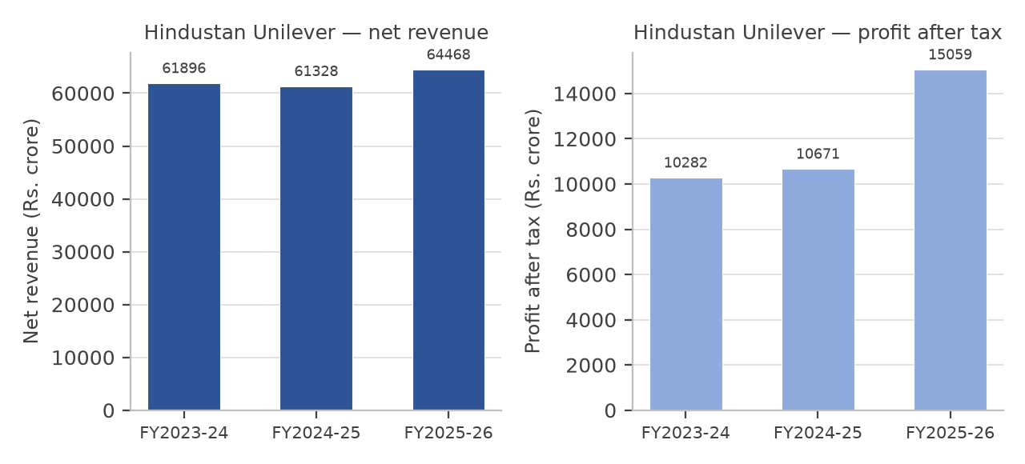
Figure 5.3: Hindustan Unilever Ltd. — net revenue and profit after tax, FY2023-24 to FY2025-26
The revenue chart is almost flat, which is the central fact about the company. Revenue of Rs. 64,468 crore in FY2025-26 is 4.2 per cent higher than in FY2023-24, an increase of approximately 2.1 per cent a year over two years. That rate is below both nominal gross domestic product growth and the rate of inflation over the same period, which means the company has been losing volume in real terms.
5. Balance sheet and cash flow position
Table 5.10: Hindustan Unilever Ltd. — consolidated balance sheet (Rs. crore)
Particulars | FY2023-24 | FY2024-25 | FY2025-26
Equity share capital | 235.00 | 235.00 | 235.00
Reserves and surplus | 50,983.00 | 49,167.00 | 48,504.00
Shareholders’ funds | 51,218.00 | 49,402.00 | 48,739.00
Total borrowings (memorandum) | 13.00 | 1.00 | 0.00
Total current liabilities | 12,876.00 | 16,537.00 | 15,549.00
Total non-current assets | 57,175.00 | 57,829.00 | 60,731.00
Total current assets | 21,324.00 | 22,051.00 | 19,021.00
Total assets | 78,499.00 | 79,880.00 | 79,752.00
Total equity and liabilities | 78,499.00 | 79,880.00 | 79,752.00
Table 5.11: Hindustan Unilever Ltd. — consolidated cash flow statement (Rs. crore)
Particulars | FY2023-24 | FY2024-25 | FY2025-26
Cash from operating activities | 15,469 | 11,886 | 10,999
Cash from investing activities | (5,324) | 6,473 | (3,677)
Cash from financing activities | (10,034) | (13,101) | (10,810)
Net cash flow | 111 | 5,258 | (3,488)
Free cash flow | 14,012 | 10,624 | 9,667
Operating cash flow as a percentage of  operating profit | 108 | 96 | 105
Two features of the balance sheet stand out. The first is that the company is effectively debt free, with total borrowings of less than Rs. 15 crore in each of the three years against shareholders’ funds of nearly Rs. 50,000 crore. The second is that shareholders’ funds fell in each of the two years, from Rs. 51,218 crore to Rs. 48,739 crore, because the distributions made to shareholders exceeded the profit earned. Reserves fell by Rs. 1,816 crore in FY2024-25, a year in which the company earned Rs. 10,671 crore, which can only be explained by distributions in excess of that year’s profit. A company can do this for a year without borrowing only because it carries no debt and generates a large operating cash flow, and the reduction in reserves is the counterpart of that decision.
The cash flow statement shows operating cash flow declining from Rs. 15,469 crore in FY2023-24 to Rs. 10,999 crore in FY2025-26. That reduction is significant, because it occurred while operating profit was rising slightly. The explanation is working capital: the difference between the cash generated and the profit reported narrowed over the period. Despite this, operating cash flow remained at 105 per cent of operating profit in FY2025-26, which indicates that the reported profit continues to be supported by cash, and free cash flow of Rs. 9,667 crore remains more than sufficient to fund the dividend.
6. Ratio analysis
Table 5.12: Hindustan Unilever Ltd. — key financial ratios
Ratio | FY2023-24 | FY2024-25 | FY2025-26
Net profit margin (%) | 16.61 | 17.40 | 16.21
Operating profit margin (%) | 23.68 | 23.97 | 23.33
Operating ratio (%) | 76.32 | 76.03 | 76.67
Return on capital employed (%) | 27.83 | 29.96 | 28.76
Return on equity (%) | 20.07 | 21.60 | 21.44
Return on assets (%) | 13.10 | 13.36 | 13.10
Return on investment (%) | 20.07 | 21.60 | 21.44
Debt to equity (times) | 0.00 | 0.00 | 0.00
Interest coverage (times) | 42.69 | 38.85 | 34.19
Current ratio (times) | 1.66 | 1.33 | 1.22
Earnings per share (Rs.) | 43.74 | 45.32 | 44.46
Book value per share (Rs.) | 217.95 | 210.22 | 207.40
Computed on the normalised profit after tax of Rs. 10,448 crore for FY2025-26, excluding the one-time gain of Rs. 4,611 crore arising from the demerger of the ice cream undertaking. The formulas applied are stated in Chapter 6. Return on investment, defined as profit after tax divided by shareholders’ funds plus total borrowings, coincides with return on equity in the case of this company because the borrowings are negligible. Book value per share is computed on the 235.00 crore equity shares outstanding as at 31 March 2026.
The ratio profile is that of an exceptionally safe business with modest growth. Profitability is stable, between 16 and 17.5 per cent at the net level and between 23 and 24 per cent at the operating level, and the operating ratio is the lowest of the three companies studied, which means the company spends the smallest proportion of each rupee of revenue on running the business. Leverage is nil and interest coverage is therefore extremely high, although the ratio declined from 42.69 to 34.19 times as interest expense rose against a flat operating profit. The current ratio declined from 1.66 to 1.22 over the three years as current liabilities increased faster than current assets, which is a mild liquidity consideration rather than a concern given the absence of debt.
7. Strengths, weaknesses, opportunities and threats
Table 5.13: Hindustan Unilever Ltd. — SWOT analysis
Strengths | Weaknesses
• The largest distribution network in the Indian  FMCG sector and a portfolio of more than fifty  brands, several of which lead their category.  •  Effectively debt free, with the lowest operating  ratio of the three companies studied and the  strongest interest coverage.  • Consistent cash  generation: operating cash flow was 105 per cent of  operating profit in FY2025-26 and free cash flow of  Rs. 9,667 crore comfortably funds the dividend.  •  Access to the parent company’s research and  development and global brand portfolio. | • Revenue growth has been the slowest of the three  companies: 2.1 per cent a year over the two years to  FY2025-26.  • Normalised earnings per share was  flat at about Rs. 44 across the three years.  •  Distributions to shareholders exceeded the profit  earned in FY2024-25, and reserves were reduced by  Rs. 1,816 crore that year.  • Declining operating  cash flow, from Rs. 15,469 crore to Rs. 10,999  crore, while profit was rising.
Opportunities | Threats
• Premiumisation in beauty, wellbeing and personal  care, supported by a plan to invest up to Rs. 20,000  crore in manufacturing capacity in the premium  segments.  • Quick commerce and e-commerce,  where the company’s mass brands are  under-represented relative to their share of general  trade.  • Growth of the rural market, where the  company already derives 35 to 40 per cent of  revenue and supports retail ordering through a  retailer application with about 1.4 million users.  •  Recovery in urban discretionary demand as  inflation moderates. | • Competition from digital-first brands, which has  raised the cost of defending share in personal care  and colour cosmetics.  • A shift in channel mix  towards quick commerce, which carries a higher  cost to serve than general trade.  • Input cost  inflation in packaging and in imported raw  materials, combined with limited ability to raise  prices.  • Valuation risk: the shares trade at a high  multiple of earnings that have been flat, which  leaves little room for disappointment.
8. Competitive position within the sector
Hindustan Unilever competes with ITC in packaged foods, with Colgate-Palmolive in oral care, with Godrej Consumer Products in home care and insecticides, with Marico in hair oil and with Dabur in natural personal care. Its competitive position rests on scale in distribution and on the strength of its brands rather than on price, and its financial statements reflect that position: it earns the highest net profit margin of the three companies studied, carries no debt and converts profit into cash reliably. Its weakness is the same scale that produces those advantages, because a business of this size cannot grow quickly by taking share in a category that is itself growing slowly.
5.4 COMPANY ANALYSIS – BRITANNIA INDUSTRIES LTD.
Britannia Industries Ltd. is one of India’s largest packaged foods companies and the market leader in biscuits. The company manufactures and sells biscuits, breads, cakes, rusk, dairy products and adjacent snacking categories, and it distributes through a network that reaches both urban markets and a large number of rural preferred dealers. Its business is more concentrated than that of Hindustan Unilever, which is the reason it has grown faster and earns a higher return on the capital it employs.
1. Company overview and corporate identity
Table 5.14: Britannia Industries Ltd. — company identification
Particular | Detail
Company name | Britannia Industries Limited
NSE symbol and BSE scrip code | BRITANNIA; BSE 500825
Sector and industry | Fast moving consumer goods; consumer food
Corporate website | www.britannia.co.in
Registered office | 5/1A, Hungerford Street, Kolkata 700017, West Bengal
Year of incorporation | Incorporated in 1918 as Britannia Biscuit Company; renamed  Britannia Industries Limited in 1979
Promoter group | Wadia Group
Managing Director | [ADD: verify the name of the incumbent at the date of submission; the  company announced the appointment of a Deputy Managing Director  and a Chief Financial Officer with effect from 1 October 2026]
Face value | Re. 1.00 per equity share
Equity shares outstanding | approximately 24.09 crore shares
Market capitalisation as at 12  October 2026 | approximately Rs. 1,15,827 crore
Market price as at 12 October  2026 | Rs. 4,808.10
52 week high and low | Rs. 6,271.00 and Rs. 4,734.10
Study period | FY2023-24 to FY2025-26
2. History and milestones
The company was incorporated in 1918 as the Britannia Biscuit Company and was for several decades a subsidiary of Associated Biscuits International. Control passed to the Wadia Group in the 1990s, after which the company restructured its business around a smaller number of larger brands and invested in distribution and in manufacturing capacity. Important milestones include:
• 1918: incorporation as Britannia Biscuit Company Limited in Kolkata.
• 1979: renaming of the company as Britannia Industries Limited.
• 1990s: change of ownership to the Wadia Group and consolidation of the biscuit business.
• 2000s: launch of the Tiger brand at a low price point, which extended the company’s reach into rural and price-sensitive markets.
• 2010s: entry into dairy through a joint venture and gradual expansion into breads, cakes, rusk and adjacent snacking categories.
• 2020s: continued investment in distribution through rural preferred dealers, in cost efficiency programmes and in premium product variants.
3. Products, brands and revenue segments
The biscuit business remains the core of the company and includes well-known brands across price points, from the mass-market Tiger brand to the premium Good Day, Marie Gold, NutriChoice and Bourbon brands. The dairy business supplies milk, curd and cheese-based products. The adjacent businesses include breads, cakes, rusk and croissants. Because the portfolio is concentrated in biscuits, both the revenue and the margin of the company depend heavily on the prices of wheat flour, sugar, edible oil and packaging material.
Table 5.15: Britannia Industries Ltd. — principal product groups
Product group | Principal categories | Role in the portfolio
Biscuits | Mass-market, mid-price and premium  biscuits across several brands | The core business and the largest  contributor to revenue
Dairy | Milk, curd, cheese and related  products | A growing business that uses the same  distribution network and raises the  value of each delivery
Bakery and adjacent  categories | Breads, cakes, rusk and croissants | Extends the brand into consumption  occasions close to the biscuit business
Premium and  health-oriented products | Whole-wheat, millet, sugar-free and  high-protein variants | Responds to the shift in consumer  preference towards health and  supports margin
4. Financial performance, FY2023-24 to FY2025-26
Table 5.16: Britannia Industries Ltd. — consolidated income statement (Rs. crore)
Particulars | FY2023-24 | FY2024-25 | FY2025-26
Net revenue from operations | 16,769 | 17,943 | 19,152
Operating expenses | 13,603 | 14,766 | 15,638
Operating profit | 3,166 | 3,177 | 3,514
Operating profit margin (%) | 18.88 | 17.71 | 18.35
Other income | 211 | 202 | 224
Interest expense | 164 | 139 | 113
Depreciation and amortisation | 300 | 313 | 337
Profit before tax | 2,913 | 2,927 | 3,289
Tax | 779 | 749 | 752
Profit after tax | 2,134 | 2,178 | 2,537
Earnings per share (Rs.) | 88.84 | 90.45 | 105.18
Revenue grew in each of the three years, at 7.00 per cent in FY2024-25 and 6.74 per cent in FY2025-26, and the compound growth rate over the two years was 6.87 per cent. Operating profit was almost unchanged between FY2023-24 and FY2024-25, and the operating margin fell from 18.88 to 17.71 per cent, before recovering to 18.35 per cent in FY2025-26 with a 10.61 per cent increase in operating profit. The pattern indicates that the company absorbed input cost pressure in FY2024-25 and recovered it in the following year.
Profit after tax grew 6.49 per cent in FY2024-25 after rising 6.20 per cent in FY2023-24, and then rose 16.48 per cent in FY2025-26, which was faster than revenue growth. Two factors explain the acceleration: operating profit rose faster than revenue, and interest expense fell from Rs. 139 crore to Rs. 113 crore as the company repaid borrowings. The effective tax rate also declined from 25.59 to 22.87 per cent in that year. A part of the FY2025-26 profit growth is therefore attributable to a lower tax charge rather than to operations, and the sustainability of the growth rate depends on whether the operating improvement continues.
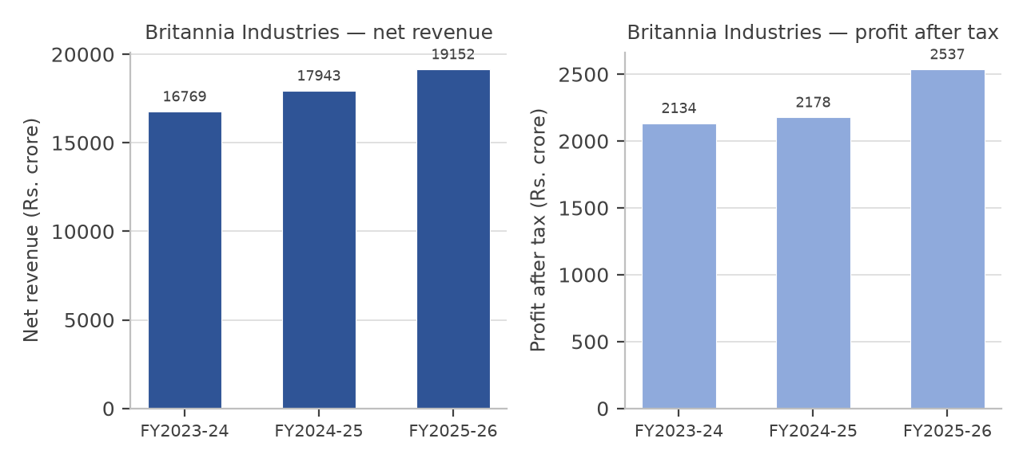
Figure 5.4: Britannia Industries Ltd. — net revenue and profit after tax, FY2023-24 to FY2025-26
Unlike the chart for Hindustan Unilever, both lines in this chart slope upward, and the profit line steepens in the final year. The company has grown its revenue by 14.21 per cent and its profit by 18.88 per cent over the two years, which places it clearly ahead of the sector’s expected revenue growth of six to eight per cent in the most recent year.
5. Balance sheet and cash flow position
Table 5.17: Britannia Industries Ltd. — consolidated balance sheet (Rs. crore)
Particulars | FY2023-24 | FY2024-25 | FY2025-26
Equity share capital | 24.09 | 24.09 | 24.09
Reserves and surplus | 3,917.43 | 4,331.63 | 5,082.47
Shareholders’ funds | 3,941.52 | 4,355.72 | 5,106.56
Non-current borrowings | 904.72 | 712.94 | 286.11
Current borrowings | 1,136.49 | 511.83 | 1,071.72
Total borrowings (memorandum) | 2,041.21 | 1,224.77 | 1,357.83
Total current liabilities | 4,084.41 | 3,618.26 | 4,179.99
Total non-current assets | 4,224.90 | 4,924.87 | 5,054.28
Total current assets | 4,848.66 | 3,913.68 | 4,677.66
Total assets | 9,073.56 | 8,838.55 | 9,731.94
Total equity and liabilities | 9,073.56 | 8,838.55 | 9,731.94
Table 5.18: Britannia Industries Ltd. — consolidated cash flow statement (Rs. crore)
Particulars | FY2023-24 | FY2024-25 | FY2025-26
Cash from operating activities | 2,573 | 2,491 | 2,612
Cash from investing activities | 485 | 69 | (741)
Cash from financing activities | (2,839) | (2,754) | (1,783)
Net cash flow | 219 | (194) | 88
Free cash flow | 2,085 | 2,120 | 2,408
Operating cash flow as a percentage of  operating profit | 105 | 100 | 98
The balance sheet shows a deliberate reduction in leverage. Total borrowings fell from Rs. 2,041 crore to Rs. 1,358 crore, and shareholders’ funds rose from Rs. 3,942 crore to Rs. 5,107 crore, so that the debt to equity ratio fell from 0.52 to 0.27 times. The composition of the borrowings changed as well: long-term borrowings fell by more than two-thirds, from Rs. 905 crore to Rs. 286 crore, while short-term borrowings rose, which reduces the average cost of debt and is consistent with the fall in interest expense from Rs. 164 crore to Rs. 113 crore.
Operating cash flow was stable at about Rs. 2,600 crore in each year, and free cash flow rose to Rs. 2,408 crore in FY2025-26 as capital expenditure remained moderate. The company paid out Rs. 1,783 crore in financing activities in FY2025-26, mostly as dividend, and still added to cash. Operating cash flow was 98 per cent of operating profit in the final year, which is a small decline from 105 per cent in FY2023-24 but remains a strong conversion ratio.
6. Ratio analysis
Table 5.19: Britannia Industries Ltd. — key financial ratios
Ratio | FY2023-24 | FY2024-25 | FY2025-26
Net profit margin (%) | 12.73 | 12.14 | 13.25
Operating profit margin (%) | 18.89 | 17.70 | 18.35
Operating ratio (%) | 81.12 | 82.29 | 81.65
Return on capital employed (%) | 51.43 | 54.94 | 52.63
Return on equity (%) | 54.14 | 50.00 | 49.68
Return on assets (%) | 23.52 | 24.64 | 26.07
Return on investment (%) | 35.67 | 39.03 | 39.25
Debt to equity (times) | 0.52 | 0.28 | 0.27
Interest coverage (times) | 18.76 | 22.06 | 30.11
Current ratio (times) | 1.19 | 1.08 | 1.12
Earnings per share (Rs.) | 88.84 | 90.45 | 105.18
Book value per share (Rs.) | 163.62 | 180.81 | 211.98
The return ratios are the distinguishing feature of this company. Return on equity of 49.68 per cent and return on capital employed of 52.63 per cent are far above those of the other two companies studied, and they reflect the combination of a high net profit margin relative to the size of the asset base and a comparatively small equity base. The debt to equity ratio of 0.27 times is higher than Dabur’s and much higher than Hindustan Unilever’s, but the return generated on that capital more than compensates, and interest coverage strengthened from 18.76 to 30.11 times over the three years.
7. Strengths, weaknesses, opportunities and threats
Table 5.20: Britannia Industries Ltd. — SWOT analysis
Strengths | Weaknesses
• Market leadership in biscuits and one of the  strongest distribution networks in the Indian  packaged foods industry, including a rural preferred  dealer network.  • The highest return on equity and  return on capital employed of the three companies  studied, at 49.68 and 52.63 per cent in  FY2025-26.  • Consistent cash generation:  operating cash flow of about Rs. 2,600 crore in  each of the three years and free cash flow of Rs.  2,408 crore in FY2025-26.  • A deliberate  reduction in leverage: total borrowings fell from Rs.  2,041 crore to Rs. 1,358 crore over the three years. | • Concentration in a single product category.  Biscuits account for the greater part of revenue, so  the company is directly exposed to wheat, sugar  and edible oil prices.  • The lowest net profit  margin of the three companies studied, at 13.25 per  cent, and the highest operating ratio, at 81.65 per  cent.  • A current ratio below 1.2 times in each  year, which leaves little short-term liquidity  buffer.  • Part of the FY2025-26 profit growth  came from a lower effective tax rate rather than  from operations.
Opportunities | Threats
• Growth of the dairy and adjacent bakery  businesses, which use the same distribution  network and raise the value of each delivery.  •  Health-oriented and premium variants, including  whole-wheat, millet and high-protein products,  which respond to a genuine shift in consumer  preference.  • Continued expansion in rural  markets, where the company has invested in  preferred dealer networks.  • Operating leverage on  fixed costs if revenue growth continues at the  current rate. | • Input cost inflation in wheat flour, sugar, edible  oil and packaging, which the company can pass on  only gradually.  • Competition in biscuits from  regional manufacturers and from the snacking  portfolios of larger diversified companies.  • The  steady shift of snacking demand towards savoury  and health-oriented products, in which the  company’s portfolio is less developed than in sweet  biscuits.  • Valuation risk: the shares trade at the  highest multiple of the three companies studied,  which assumes that the current rate of earnings  growth continues.
8. Competitive position within the sector
Britannia competes in biscuits with regional manufacturers and with the snacking portfolios of companies such as ITC and Nestlé India, and in dairy with the large cooperative and private dairy brands. Its competitive position rests on cost efficiency and distribution reach rather than on premium pricing, which is why its net profit margin is the lowest of the three companies studied while its return on capital is the highest. That combination is possible because the business is asset-light relative to its profit and because it operates with negative working capital, collecting from distributors before it pays its suppliers.
5.5 COMPANY ANALYSIS – DABUR INDIA LTD.
Dabur India Ltd. is the largest Ayurvedic and natural healthcare company in India and one of the largest FMCG companies in the country. Its products reach eight out of ten Indian households, and its portfolio comprises three brands with revenue above Rs. 1,000 crore, three brands above Rs. 500 crore and sixteen brands in the range of Rs. 100 to 500 crore. The company derives between 45 and 50 per cent of its revenue from rural markets and reaches over 1,31,000 villages and 1.42 million retail outlets, which makes it the most rural-weighted of the three companies studied.
1. Company overview and corporate identity
Table 5.21: Dabur India Ltd. — company identification
Particular | Detail
Company name | Dabur India Limited
NSE symbol and BSE scrip code | DABUR; BSE 500096
Sector and industry | Fast moving consumer goods; personal products and consumer  healthcare
Corporate website | www.dabur.com
Registered office | 8/3, Asaf Ali Road, New Delhi 110002
Year of incorporation | Incorporated in 1975; the business itself dates from 1884, when it was  founded as a pharmacy in Kolkata
Promoter group | Burman family
Chief Executive Officer | [ADD: verify the name of the incumbent at the date of submission]
Face value | Re. 1.00 per equity share
Equity shares outstanding | approximately 177.37 crore shares
Market capitalisation as at 12  October 2026 | approximately Rs. 68,128 crore
Market price as at 12 October  2026 | Rs. 384.10
52 week high and low | Rs. 534.00 and Rs. 368.05
Study period | FY2023-24 to FY2025-26
2. History and milestones
The business began in 1884 as a pharmacy in Kolkata that prepared Ayurvedic medicines, and it was incorporated as a company in 1975. Its growth has been built on the conversion of traditional Ayurvedic remedies into packaged consumer products and on a distribution network that extends further into rural India than that of most of its competitors. Important milestones include:
• 1884: foundation of the business as an Ayurvedic pharmacy in Kolkata.
• 1975: incorporation of Dabur India Limited.
• 1990s: professionalisation of the management and expansion from medicines into personal care products.
• 2000s: extension of the portfolio into foods, including fruit juices and packaged honey, and expansion into international markets.
• 2010s: acquisition of overseas brands in personal care and foods, particularly in the Middle East, Africa and South Asia, and consolidation of the domestic business around a smaller number of larger brands.
• 2020s: restructuring of the India business into separate verticals for healthcare, home and personal care, and foods, with continued investment in rural distribution and in e-commerce.
3. Products, brands and revenue segments
The business is organised into three India verticals and an international business. Consumer care comprises hair oil, shampoo, oral care, skin care and home care products. Healthcare comprises Ayurvedic medicines, digestives, health supplements and ethical products. Foods comprises fruit juices, beverages, honey and culinary products. The international business operates branded consumer products in a number of markets in the Middle East, Africa and South Asia.
Table 5.22: Dabur India Ltd. — principal business verticals
Vertical | Principal categories | Characteristics of the business
Healthcare | Ayurvedic medicines, digestives, health  supplements and ethical products | The traditional core of the company  and the source of its identity as a  natural health company; margins are  comparatively high
Home and Personal  Care | Hair oil, shampoo, oral care, skin care  and home care | The largest contributor to revenue;  directly competitive with the personal  care portfolios of the larger diversified  companies
Foods and Beverages | Fruit juices, beverages, honey and  culinary products | Grew faster than the rest of the  portfolio in recent years and broadens  the company’s exposure beyond health  and personal care
International  business | Branded consumer products in the  Middle East, Africa and South Asia | Provides geographic diversification  and foreign currency revenue, and is  exposed to currency and political risk
4. Financial performance, FY2023-24 to FY2025-26
Table 5.23: Dabur India Ltd. — consolidated income statement (Rs. crore)
Particulars | FY2023-24 | FY2024-25 | FY2025-26
Net revenue from operations | 12,404 | 12,563 | 13,193
Operating expenses | 10,004 | 10,247 | 10,743
Operating profit | 2,400 | 2,316 | 2,450
Operating profit margin (%) | 19.35 | 18.44 | 18.57
Other income | 482 | 552 | 584
Interest expense | 124 | 164 | 145
Depreciation and amortisation | 399 | 446 | 469
Profit before tax | 2,359 | 2,258 | 2,420
Tax | 548 | 518 | 551
Profit after tax | 1,811 | 1,740 | 1,869
Earnings per share (Rs.) | 10.40 | 9.97 | 10.68
Revenue grew slowly, at 1.28 per cent in FY2024-25 and 5.02 per cent in FY2025-26, and the compound growth rate over the two years was 3.13 per cent. Operating profit was lower in FY2024-25 than in the preceding year, and the operating margin fell from 19.35 to 18.44 per cent, before recovering marginally to 18.57 per cent in FY2025-26. Profit after tax shows the same pattern: it fell 3.92 per cent in FY2024-25 and then rose 7.41 per cent in FY2025-26, but the FY2025-26 figure of Rs. 1,869 crore is only 3.20 per cent higher than the FY2023-24 figure of Rs. 1,811 crore. Earnings per share over the same period moved from Rs. 10.40 to Rs. 10.68, a compound growth rate of 1.34 per cent a year.
The reason for the weak profit growth in FY2024-25 was the combination of slower revenue growth and a rise in interest expense from Rs. 124 crore to Rs. 164 crore, together with an increase in depreciation as capital expenditure was commissioned. The recovery in FY2025-26 came from a 5.02 per cent increase in revenue and a reduction in interest expense, and other income also contributed Rs. 585 crore, which is a larger amount relative to profit than in either of the other two companies studied. That is a point of caution in the analysis: a significant part of Dabur’s reported profit is derived from income earned on its investments rather than from the sale of goods.
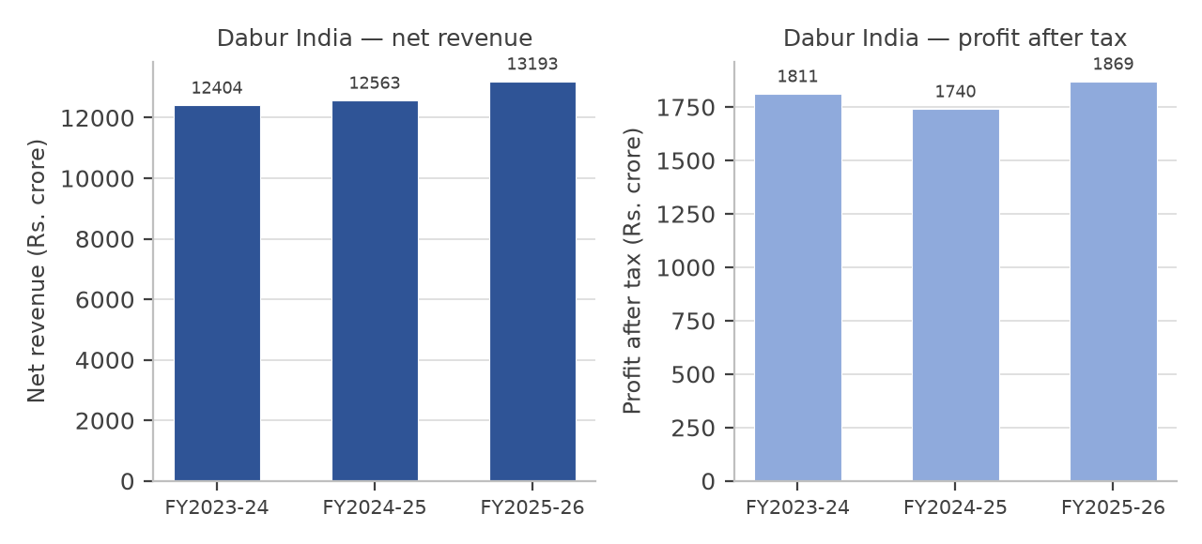
Figure 5.5: Dabur India Ltd. — net revenue and profit after tax, FY2023-24 to FY2025-26
The revenue line rises gently and the profit line dips in the middle year before recovering. Neither line shows the acceleration visible in the chart for Britannia, which is consistent with the ratio analysis in Chapter 6: the company’s return on capital employed has declined from 22.52 to 20.55 per cent over the three years, because capital employed has grown faster than the profit earned on it.
5. Balance sheet and cash flow position
Table 5.24: Dabur India Ltd. — consolidated balance sheet (Rs. crore)
Particulars | FY2023-24 | FY2024-25 | FY2025-26
Equity share capital | 177.20 | 177.23 | 177.37
Reserves and surplus | 9,689.10 | 10,623.46 | 11,242.15
Shareholders’ funds | 9,866.30 | 10,800.69 | 11,419.52
Non-current borrowings | 535.97 | 304.03 | 15.96
Current borrowings | 622.10 | 426.09 | 1,046.72
Total borrowings (memorandum) | 1,158.07 | 730.12 | 1,062.68
Total current liabilities | 3,930.43 | 4,318.44 | 5,239.08
Total non-current assets | 9,443.06 | 9,699.82 | 8,593.95
Total current assets | 5,679.62 | 6,532.46 | 8,885.96
Total assets | 15,122.68 | 16,232.28 | 17,479.91
Total equity and liabilities | 15,122.68 | 16,232.28 | 17,479.91
Table 5.25: Dabur India Ltd. — consolidated cash flow statement (Rs. crore)
Particulars | FY2023-24 | FY2024-25 | FY2025-26
Cash from operating activities | 2,013 | 1,987 | 2,579
Cash from investing activities | (971) | (448) | (1,279)
Cash from financing activities | (1,161) | (1,405) | (1,236)
Net cash flow | (119) | 133 | 64
Free cash flow | 1,453 | 1,448 | 2,180
Operating cash flow as a percentage of  operating profit | 104 | 103 | 122
The balance sheet shows the accumulation of financial investments rather than investment in the operating business. Non-current investments rose from Rs. 5,266 crore in FY2023-24 to about Rs. 4,352 crore in FY2025-26, while current investments rose from Rs. 1,667 crore to Rs. 4,595 crore, so that total investments of about Rs. 8,947 crore in FY2025-26 are a large proportion of the total balance sheet of Rs. 17,480 crore. Current assets rose from Rs. 5,680 crore to Rs. 8,886 crore over the three years, most of the increase being in investments rather than in inventory or receivables. This is the reason the company has the strongest current ratio of the three companies studied, and also the reason its return on assets is the lowest: a large part of the asset base is not employed in the business at all.
Borrowings fell from Rs. 1,158 crore to Rs. 730 crore and then rose again to Rs. 1,063 crore, but the composition changed substantially. Long-term borrowings were almost repaid, falling from Rs. 536 crore to Rs. 16 crore, while short-term borrowings rose from Rs. 622 crore to Rs. 1,047 crore. The shift reduces the average cost of borrowing, which is consistent with the fall in interest expense from Rs. 164 crore to Rs. 145 crore in FY2025-26.
The cash flow statement is the strongest part of the financial record. Operating cash flow rose 29.79 per cent to Rs. 2,579 crore in FY2025-26 and was 122 per cent of operating profit, which is the highest conversion of the three companies. Free cash flow rose to Rs. 2,180 crore. In other words, the weakness of the company lies in the growth of its business, not in the quality of its earnings.
6. Ratio analysis
Table 5.26: Dabur India Ltd. — key financial ratios
Ratio | FY2023-24 | FY2024-25 | FY2025-26
Net profit margin (%) | 14.60 | 13.85 | 14.17
Operating profit margin (%) | 19.35 | 18.43 | 18.57
Operating ratio (%) | 80.65 | 81.56 | 81.43
Return on capital employed (%) | 22.52 | 21.00 | 20.55
Return on equity (%) | 18.36 | 16.11 | 16.37
Return on assets (%) | 11.98 | 10.72 | 10.69
Return on investment (%) | 16.43 | 15.09 | 14.97
Debt to equity (times) | 0.12 | 0.07 | 0.09
Interest coverage (times) | 20.02 | 14.77 | 17.69
Current ratio (times) | 1.45 | 1.51 | 1.70
Earnings per share (Rs.) | 10.40 | 9.97 | 10.68
Book value per share (Rs.) | 55.63 | 60.89 | 64.38
The ratio trend is the least favourable of the three companies. Return on capital employed fell in each of the three years, from 22.52 to 20.55 per cent, return on equity fell from 18.36 to 16.37 per cent and return on assets fell from 11.98 to 10.69 per cent. The company earns a reasonable net profit margin of about 14 per cent and carries little debt, with a debt to equity ratio never exceeding 0.12 times, but the capital it retains is not producing a growing return. Shareholders’ funds rose from Rs. 9,866 crore to Rs. 11,420 crore over the three years, and the financial investments on the balance sheet rose with them, while return on equity fell from 18.36 to 16.37 per cent and return on investment from 16.43 to 14.97 per cent. The company is therefore accumulating capital faster than it can deploy that capital profitably, which is the opposite of the position at Britannia Industries, where a much smaller equity base produces a much higher return.
7. Strengths, weaknesses, opportunities and threats
Table 5.27: Dabur India Ltd. — SWOT analysis
Strengths | Weaknesses
• The leading position in Ayurvedic and natural  healthcare, a category that is growing as consumer  preference shifts towards natural products, and a  portfolio reaching eight out of ten Indian  households.  • The deepest rural reach of the three  companies studied, covering over 1,31,000 villages  and 1.42 million outlets, with 45 to 50 per cent of  revenue derived from rural markets.  • The highest  cash conversion of the three companies: operating  cash flow was 122 per cent of operating profit in  FY2025-26.  • Low leverage, with a debt to equity  ratio below 0.12 times in each of the three years. | • The slowest revenue growth of the three  companies, at a compound rate of 3.13 per cent  over the two years to FY2025-26.  • Earnings per  share growing at only 1.34 per cent a year, which is  below the rate of inflation.  • Falling return on  capital employed, return on equity and return on  assets in each of the three years.  • A large part of  reported profit comes from other income, and a  large part of the asset base is held as financial  investments rather than employed in the business.
Opportunities | Threats
• Growth of the natural and Ayurvedic categories,  which the company is best placed to serve and  which the larger personal care companies are also  entering.  • Expansion of the foods and beverages  vertical, which grew faster than the rest of the  portfolio in recent years.  • E-commerce and quick  commerce, where rural-weighted brands are  under-represented and where the company’s health  positioning carries a premium.  • International  expansion in the Middle East, Africa and South  Asia, where the brands are established and the  categories are less penetrated. | • Weak rural demand: the company has the largest  rural exposure of the three companies studied, and  rural volume growth fell to 3.6 per cent in 2025  against urban growth of 4.6 per cent.  • Entry of  larger competitors into the natural and herbal  personal care categories, which the company has  historically dominated.  • Input cost inflation in  herbs, edible oils and packaging materials.  •  Regulatory or labelling changes affecting the claims  that may be made for Ayurvedic and health  products.
8. Competitive position within the sector
Dabur competes with Hindustan Unilever, Colgate-Palmolive and Marico in personal care and with Emami and Zydus Wellness in health and wellness. Its competitive position rests on the authenticity of its Ayurvedic credentials and on the depth of its rural distribution, both of which are genuine advantages that a competitor cannot replicate quickly. Its difficulty is that these advantages have not translated into financial growth: the company earns a reasonable margin, carries almost no debt and converts profit into cash better than either of the other two companies, but the capital employed in the business has grown faster than the profit earned on it.
CHAPTER 6 :- COMPARATIVE RATIO ANALYSIS & INTERPRETATION
FMCG SECTOR FINANCIAL PERFORMANCE OF HINDUSTAN UNILEVER LTD., BRITANNIA INDUSTRIES LTD. AND DABUR INDIA LTD.
This chapter compares the financial performance of the three selected companies over FY2023-24, FY2024-25 and FY2025-26 using thirteen ratios. Each ratio is presented in the same order: the formula applied, the computation for each company for each of the three years, a comparative table, a chart showing the movement of the ratio, and the interpretation. The chapter closes with a factor analysis in which the thirteen ratios are used to rank the three companies.
Two conventions apply throughout and should be noted before the ratios are read. First, all figures are consolidated figures in rupees crore, and FY2024, FY2025 and FY2026 mean the financial years ended 31 March 2024, 31 March 2025 and 31 March 2026. Second, the FY2025-26 figures of Hindustan Unilever Ltd. exclude the one-time gain of Rs. 4,611 crore arising from the demerger of the ice cream undertaking, because including it would make the reported profit, and therefore every ratio computed from it, incomparable with the two preceding years and with the other two companies. The reported figure is shown alongside the normalised figure wherever the difference is material.
Table 6.1: Ratios used in the analysis and the formula applied to each
Sr.  No. | Ratio | Formula applied
1 | Net profit margin | Profit after tax ÷ net revenue × 100
2 | Return on capital employed | (Profit before tax + interest expense) ÷ (shareholders’ funds +  total borrowings) × 100
3 | Return on equity | Profit after tax ÷ shareholders’ funds × 100
4 | Debt to equity | Total borrowings ÷ shareholders’ funds
5 | Operating ratio | (Net revenue − operating profit) ÷ net revenue × 100
6 | Interest coverage | (Profit before tax + interest expense) ÷ interest expense
7 | Earnings per share | Profit after tax ÷ number of equity shares outstanding
8 | Return on assets | Profit after tax ÷ total assets × 100
9 | Current ratio | Current assets ÷ current liabilities
10 | Price to earnings | Market price per share ÷ earnings per share
11 | Price to book | Market price per share ÷ book value per share
12 | Price to earnings growth | Price to earnings ratio ÷ two-year compound growth rate in  earnings per share
13 | Return on investment | Profit after tax ÷ (shareholders’ funds + total borrowings) × 100
Return on capital employed and return on investment are close in definition but not identical: the first measures the profit available to all providers of capital before interest and tax, and the second measures the profit available to shareholders after interest and tax on the same capital base. Where a company carries no borrowings the two ratios converge, and that is the case for Hindustan Unilever Ltd. in all three years.
The four market-based ratios and the earnings per share are computed on the market price as at 12 October 2026, which is the date on which the price data were collected. The nine remaining ratios are computed for each of the three financial years. Because a historical series of market prices was not collected, the price to earnings, price to book and price to earnings growth ratios in this chapter are stated for that single date, and the limitation is noted again in Chapter 7.
1. NET PROFIT MARGIN
The net profit margin measures the profit left to the company from every rupee of revenue after all operating expenses, interest and tax. It is the single most direct measure of how much of a company’s turnover it keeps.
Formula: PROFIT AFTER TAX / NET REVENUE × 100
Hindustan Unilever Ltd. :-
• 2024: 10,282 / 61,896 × 100 = 16.61%
• 2025: 10,671 / 61,328 × 100 = 17.40%
• 2026: 10,448 / 64,468 × 100 = 16.21% (normalised profit of Rs. 10,448 crore; on the reported profit of Rs. 15,059 crore the ratio is 23.36%)
Britannia Industries Ltd. :-
• 2024: 2,134 / 16,769 × 100 = 12.73%
• 2025: 2,178 / 17,943 × 100 = 12.14%
• 2026: 2,537 / 19,152 × 100 = 13.25%
Dabur India Ltd. :-
• 2024: 1,811 / 12,404 × 100 = 14.60%
• 2025: 1,740 / 12,563 × 100 = 13.85%
• 2026: 1,869 / 13,193 × 100 = 14.17%
Table 6.2: Net profit margin of the three companies (%)
Company | FY2024 | FY2025 | FY2026
Hindustan Unilever | 16.61 | 17.40 | 16.21
Britannia Industries | 12.73 | 12.14 | 13.25
Dabur India | 14.60 | 13.85 | 14.17
Interpretation :
• Hindustan Unilever: The margin widened from 16.61% to 17.40% in 2025 and narrowed to 16.21% in 2026 on the normalised profit. The movement is small, which is to be expected in a business that sells essential products at stable prices, and the company retains the highest margin of the three on a comparable basis.
• Britannia Industries: The margin narrowed from 12.73% to 12.14% in 2025 when input costs rose and then widened to 13.25% in 2026. The 2026 improvement is partly attributable to a lower effective tax rate, and the operating margin moved less than the net margin, which means that the final-year improvement did not come from the sale side of the business.
• Dabur India: The margin narrowed from 14.60% to 13.85% in 2025 and recovered to 14.17% in 2026, which leaves it slightly below the 2024 level. A margin that ends the period below where it started, in a company whose revenue grew by only 6.4% over the two years, indicates that neither price nor cost gave the business an advantage.
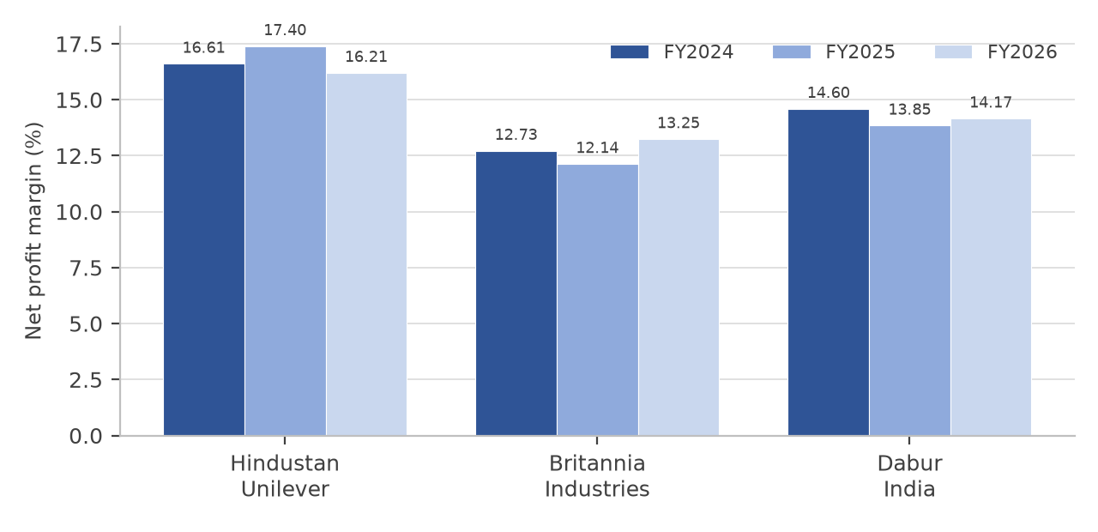
Figure 6.1: Net profit margin of the three companies
Overall Interpretation :
Hindustan Unilever earned the highest net margin in each of the three years and Dabur the second, while Britannia earned the lowest. This ranking reverses the ranking on return on capital, because margin measures what is earned on each rupee of sale whereas the return ratios measure what is earned on each rupee of capital employed. Britannia earns less per rupee of sale but employs far less capital for each rupee of sale, which is why it leads on the return ratios presented in the following sections.
2. RETURN ON CAPITAL EMPLOYED (ROCE)
Return on capital employed measures the profit generated by a company in relation to the total capital employed in the business, which includes both the shareholders’ funds and the borrowings. It is computed before interest and tax so that companies with different capital structures can be compared.
Formula: (PROFIT BEFORE TAX + INTEREST EXPENSE) / CAPITAL EMPLOYED × 100, WHERE CAPITAL EMPLOYED = SHAREHOLDERS’ FUNDS + TOTAL BORROWINGS
Hindustan Unilever Ltd. :-
• 2024: (13,926 + 334) / 51,231 × 100 = 27.83%
• 2025: (14,419 + 381) / 49,403 × 100 = 29.96%
• 2026: (13,608 + 410) / 48,739 × 100 = 28.76% (normalised profit before tax)
Britannia Industries Ltd. :-
• 2024: (2,913 + 164) / 5,982.73 × 100 = 51.43%
• 2025: (2,927 + 139) / 5,580.49 × 100 = 54.94%
• 2026: (3,289 + 113) / 6,464.39 × 100 = 52.63%
Dabur India Ltd. :-
• 2024: (2,359 + 124) / 11,024.37 × 100 = 22.52%
• 2025: (2,258 + 164) / 11,530.81 × 100 = 21.00%
• 2026: (2,420 + 145) / 12,482.20 × 100 = 20.55%
Table 6.3: Return on capital employed of the three companies (%)
Company | FY2024 | FY2025 | FY2026
Hindustan Unilever | 27.83 | 29.96 | 28.76
Britannia Industries | 51.43 | 54.94 | 52.63
Dabur India | 22.52 | 21.00 | 20.55
Interpretation :
• Hindustan Unilever: The ratio moved from 27.83% to a peak of 29.96% in 2025 and settled at 28.76% in 2026. Capital employed fell slightly over the period as reserves were distributed, and the profit before interest and tax was almost unchanged, so the ratio is stable. Stability at this level indicates a business that earns a healthy return without needing to invest additional capital.
• Britannia Industries: The ratio of 51.43% in 2024 rose to 54.94% in 2025 and then eased to 52.63% in 2026, and it is the highest of the three companies by a wide margin. Capital employed is only about Rs. 6,464 crore against a profit before interest and tax of Rs. 3,402 crore. The ratio is high because the business is capital-light and is financed partly by trade credit rather than by equity or borrowings.
• Dabur India: The ratio declined in every one of the three years, from 22.52% to 21.00% and then to 20.55%. Capital employed rose by about Rs. 1,458 crore over the period while the profit before interest and tax rose by only Rs. 82 crore. A company whose capital is growing faster than its profit is not deploying that capital productively, and the movement of this ratio is the clearest single indicator of the difficulty described in Chapter 5.
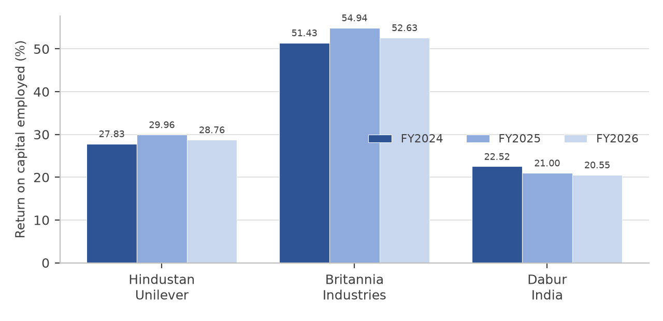
Figure 6.2: Return on capital employed of the three companies
Overall Interpretation :
Britannia Industries leads on this ratio in all three years, Hindustan Unilever is second and Dabur India third. The gap between the first two and the third is substantial: a difference of more than thirty percentage points between Britannia and Dabur in the same sector and the same years cannot be explained by superior pricing, because Britannia earns the lowest net margin. It is explained by the size of the capital base on which each company earns its profit. Britannia employs about Rs. 6,464 crore of capital to generate Rs. 3,402 crore of profit before interest and tax, whereas Dabur employs about Rs. 12,482 crore to generate Rs. 2,565 crore.
3. RETURN ON EQUITY (ROE)
Return on equity measures the return earned on the money shareholders have invested in the company, after interest and tax. It is the ratio that owners of the business have the strongest reason to watch.
Formula: PROFIT AFTER TAX / SHAREHOLDERS’ FUNDS × 100
Hindustan Unilever Ltd. :-
• 2024: 10,282 / 51,218 × 100 = 20.07%
• 2025: 10,671 / 49,402 × 100 = 21.60%
• 2026: 10,448 / 48,739 × 100 = 21.44% (normalised)
Britannia Industries Ltd. :-
• 2024: 2,134 / 3,941.52 × 100 = 54.14%
• 2025: 2,178 / 4,355.72 × 100 = 50.00%
• 2026: 2,537 / 5,106.56 × 100 = 49.68%
Dabur India Ltd. :-
• 2024: 1,811 / 9,866.30 × 100 = 18.36%
• 2025: 1,740 / 10,800.69 × 100 = 16.11%
• 2026: 1,869 / 11,419.52 × 100 = 16.37%
Table 6.4: Return on equity of the three companies (%)
Company | FY2024 | FY2025 | FY2026
Hindustan Unilever | 20.07 | 21.60 | 21.44
Britannia Industries | 54.14 | 50.00 | 49.68
Dabur India | 18.36 | 16.11 | 16.37
Interpretation :
• Hindustan Unilever: Return on equity improved from 20.07% to 21.44% over the three years, and the improvement is explained by the reduction in shareholders’ funds from Rs. 51,218 crore to Rs. 48,739 crore rather than by any growth in profit, which was flat on a normalised basis. A return that rises because the denominator is shrinking is not evidence of improving performance.
• Britannia Industries: Return on equity declined from 54.14% to 49.68% across the period, but it remains by far the highest of the three companies. The decline is not a deterioration in profit, which rose by 18.88% over the two years, but the effect of retained earnings accumulating in a smaller equity base that is no longer matched by an increase in borrowings.
• Dabur India: Return on equity fell from 18.36% to 16.11% in 2025 and then recovered marginally to 16.37% in 2026, and over the whole period it declined. Shareholders’ funds rose by Rs. 1,553 crore while profit after tax rose by only Rs. 58 crore, so the additional capital produced almost no additional profit.
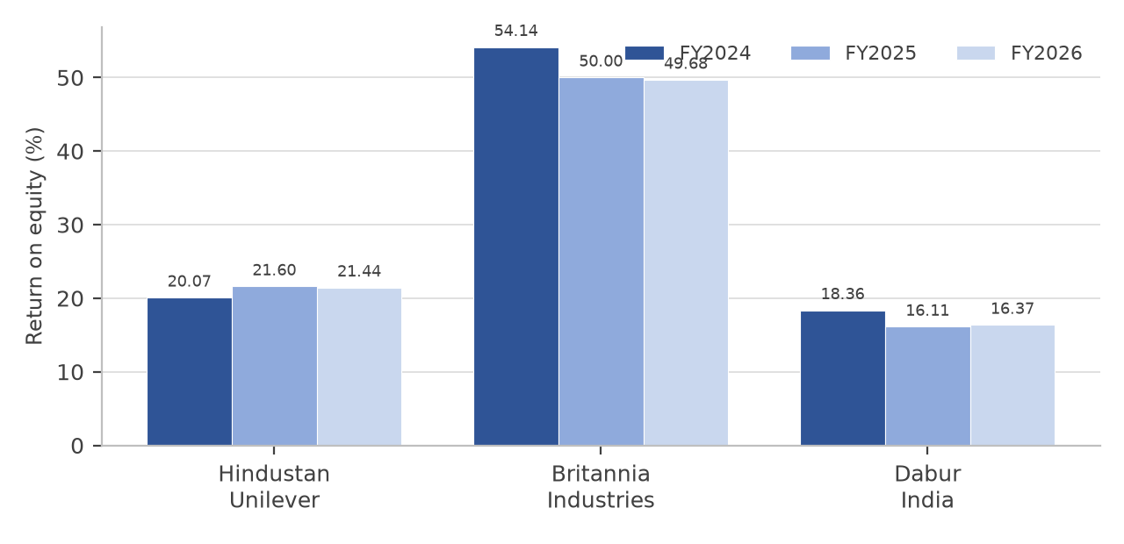
Figure 6.3: Return on equity of the three companies
Overall Interpretation :
The ranking is the same as on return on capital employed: Britannia first, Hindustan Unilever second and Dabur third in each of the three years. It is worth recording why Britannia’s return on equity is lower than its return on capital employed while the reverse is true for Dabur. Britannia earns a post-interest, post-tax return of 49.68% on equity against a pre-interest return of 52.63% on total capital, the difference being the tax charge and the effect of the borrowings. Dabur earns 16.37% on equity against 20.55% on capital employed, and the gap is wider because the company holds a large amount of financial investments whose income is included in profit but whose cost is included in the capital base.
4. DEBT TO EQUITY RATIO
The debt to equity ratio compares the borrowings of a company with the funds contributed by its shareholders. A ratio above one means the company is financed more by lenders than by owners and carries correspondingly more financial risk.
Formula: TOTAL BORROWINGS / SHAREHOLDERS’ FUNDS
Hindustan Unilever Ltd. :-
• 2024: 13.00 / 51,218 × 100 = 0.00 times (0.0003 times)
• 2025: 1.00 / 49,402 = 0.00 times (0.00002 times)
• 2026: 0.00 / 48,739 = 0.00 times
Britannia Industries Ltd. :-
• 2024: 2,041.21 / 3,941.52 = 0.52 times
• 2025: 1,224.77 / 4,355.72 = 0.28 times
• 2026: 1,357.83 / 5,106.56 = 0.27 times
Dabur India Ltd. :-
• 2024: 1,158.07 / 9,866.30 = 0.12 times
• 2025: 730.12 / 10,800.69 = 0.07 times
• 2026: 1,062.68 / 11,419.52 = 0.09 times
Table 6.5: Debt to equity ratio of the three companies (times)
Company | FY2024 | FY2025 | FY2026
Hindustan Unilever | 0.00 | 0.00 | 0.00
Britannia Industries | 0.52 | 0.28 | 0.27
Dabur India | 0.12 | 0.07 | 0.09
Interpretation :
• Hindustan Unilever: The company is effectively debt free throughout the period. Borrowings were Rs. 13 crore at the end of FY2024 and nil at the end of FY2026, against shareholders’ funds of about Rs. 48,700 crore. The ratio is therefore not informative about leverage, and the interest expense that appears in the profit and loss account relates largely to lease liabilities and other financial obligations rather than to borrowings.
• Britannia Industries: The ratio fell from 0.52 to 0.27 times as borrowings were reduced from Rs. 2,041 crore to Rs. 1,358 crore while shareholders’ funds rose. This is a deliberate deleveraging, and it is the reason interest expense fell from Rs. 164 crore to Rs. 113 crore over the same period.
• Dabur India: The ratio is the second lowest of the three, moving from 0.12 to 0.07 times and then to 0.09 times. Borrowings are small in relation to a balance sheet of Rs. 17,480 crore, and the company has the capacity to borrow more if it had a use for the funds; the absence of borrowing is therefore a statement about the opportunities available rather than about prudence alone.
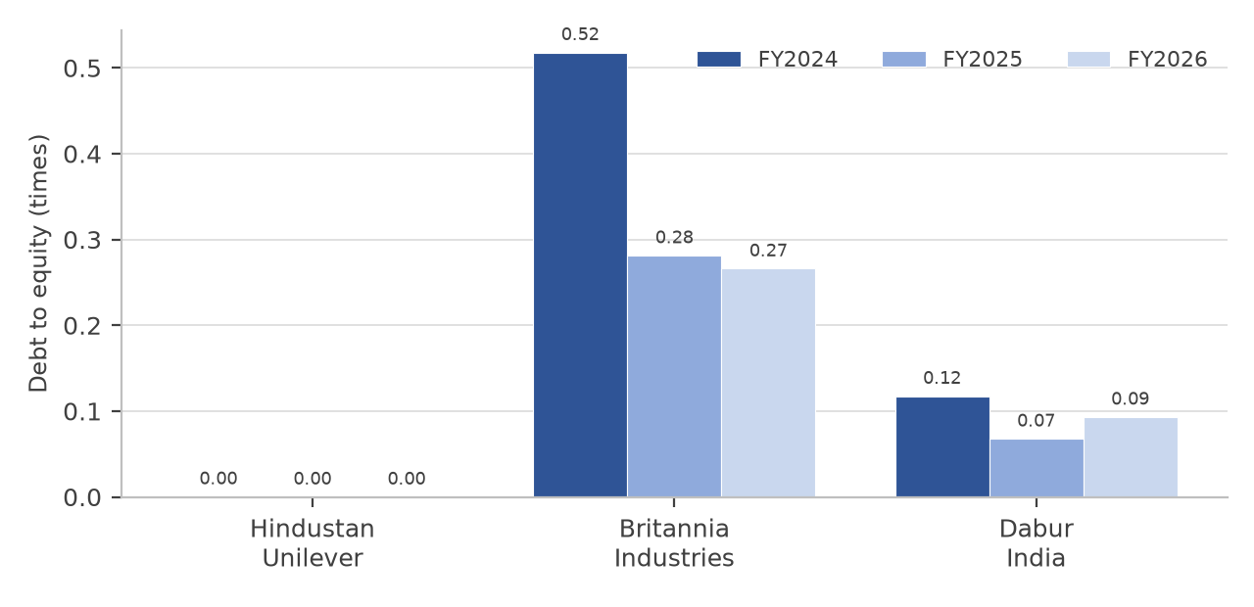
Figure 6.4: Debt to equity ratio of the three companies
Overall Interpretation :
None of the three companies is materially levered, and in that respect all three are typical of the sector, in which operations are financed substantially by trade credit. Hindustan Unilever is the most conservative, Britannia the most willing to use debt and Dabur between the two. The comparison also shows that a low debt to equity ratio is not by itself a sign of strength: Dabur has a low ratio and the weakest return on capital, because the capital it does employ is not producing a return commensurate with the risk.
5. OPERATING RATIO
The operating ratio expresses the cost of running the business, excluding non-operating income and financing costs, as a proportion of revenue. It is the complement of the operating profit margin, so a lower ratio indicates a more efficient operation.
Formula: (NET REVENUE − OPERATING PROFIT) / NET REVENUE × 100
Hindustan Unilever Ltd. :-
• 2024: (61,896 − 14,659) / 61,896 × 100 = 76.32%
• 2025: (61,328 − 14,698) / 61,328 × 100 = 76.03%
• 2026: (64,468 − 15,039) / 64,468 × 100 = 76.67%
Britannia Industries Ltd. :-
• 2024: (16,769 − 3,166) / 16,769 × 100 = 81.12%
• 2025: (17,943 − 3,177) / 17,943 × 100 = 82.29%
• 2026: (19,152 − 3,514) / 19,152 × 100 = 81.65%
Dabur India Ltd. :-
• 2024: (12,404 − 2,400) / 12,404 × 100 = 80.65%
• 2025: (12,563 − 2,316) / 12,563 × 100 = 81.56%
• 2026: (13,193 − 2,450) / 13,193 × 100 = 81.43%
Table 6.6: Operating ratio of the three companies (%)
Company | FY2024 | FY2025 | FY2026
Hindustan Unilever | 76.32 | 76.03 | 76.67
Britannia Industries | 81.12 | 82.29 | 81.65
Dabur India | 80.65 | 81.56 | 81.43
Interpretation :
• Hindustan Unilever: The ratio moves within a narrow band of 76.03% to 76.67% and is the lowest of the three companies in every year, which means the company spends the smallest proportion of each rupee of revenue on producing and selling its goods. Scale in manufacture and in distribution is the reason.
• Britannia Industries: The ratio rose from 81.12% to 82.29% in 2025, the year in which input costs rose faster than prices, and improved to 81.65% in 2026. The company is the least efficient of the three on this measure, which is consistent with the low net profit margin and reflects a portfolio concentrated in a category where the cost of wheat, sugar and packaging is a large part of the selling price.
• Dabur India: The ratio deteriorated from 80.65% to 81.56% and then improved marginally to 81.43%, which leaves it marginally better than Britannia and clearly worse than Hindustan Unilever. The company’s costs rose in 2025 and were only partly recovered in the following year.
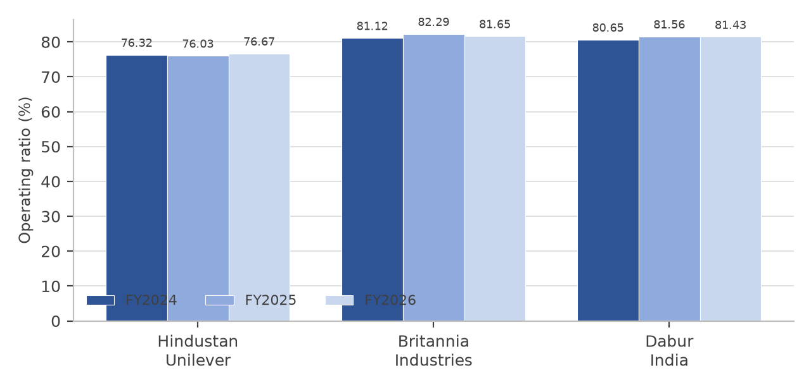
Figure 6.5: Operating ratio of the three companies
Overall Interpretation :
The three ratios are close together, spanning about five percentage points in each year, and the ordering is stable: Hindustan Unilever first, then Dabur and Britannia. Because a change of one percentage point in the operating ratio of Hindustan Unilever is equivalent to about Rs. 645 crore of operating profit, the smallness of the movement should not be misread as an absence of commercial significance.
6. INTEREST COVERAGE RATIO
The interest coverage ratio measures how many times the profit before interest and tax covers the interest expense of the company. It indicates the margin of safety available to lenders, and therefore the risk that a fall in profit would leave the company unable to service its debt.
Formula: (PROFIT BEFORE TAX + INTEREST EXPENSE) / INTEREST EXPENSE
Hindustan Unilever Ltd. :-
• 2024: (13,926 + 334) / 334 = 42.69 times
• 2025: (14,419 + 381) / 381 = 38.85 times
• 2026: (13,608 + 410) / 410 = 34.19 times
Britannia Industries Ltd. :-
• 2024: (2,913 + 164) / 164 = 18.76 times
• 2025: (2,927 + 139) / 139 = 22.06 times
• 2026: (3,289 + 113) / 113 = 30.11 times
Dabur India Ltd. :-
• 2024: (2,359 + 124) / 124 = 20.02 times
• 2025: (2,258 + 164) / 164 = 14.77 times
• 2026: (2,420 + 145) / 145 = 17.69 times
Table 6.7: Interest coverage of the three companies (times)
Company | FY2024 | FY2025 | FY2026
Hindustan Unilever | 42.69 | 38.85 | 34.19
Britannia Industries | 18.76 | 22.06 | 30.11
Dabur India | 20.02 | 14.77 | 17.69
Interpretation :
• Hindustan Unilever: Coverage of 42.69 times in 2024 declined to 34.19 times in 2026. The ratio remains the highest of the three and at a level at which the risk to lenders is immaterial, but the direction of the change is worth noting: interest expense rose from Rs. 334 crore to Rs. 410 crore in a period in which the normalised profit before tax fell slightly.
• Britannia Industries: Coverage improved in every year, from 18.76 times to 30.11 times, because interest expense fell by almost a third while profit before interest and tax rose by 15.9%. This is the clearest evidence in the whole ratio set of the benefit of the deleveraging described in the previous section.
• Dabur India: Coverage was the weakest of the three in 2025 at 14.77 times, having fallen from 20.02 times in 2024, and recovered to 17.69 times in 2026. The 2025 deterioration reflects both a fall in profit before interest and tax and a rise in interest expense of Rs. 40 crore.
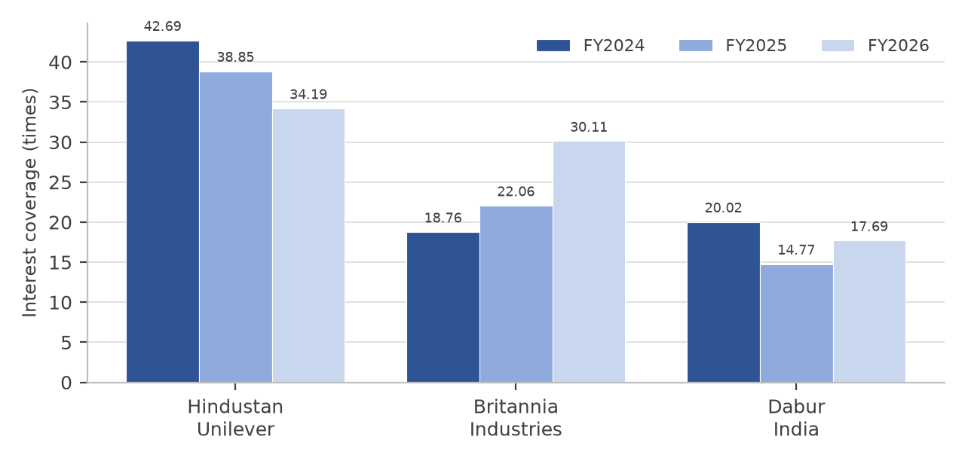
Figure 6.6: Interest coverage of the three companies
Overall Interpretation :
All three companies cover their interest comfortably, and none is at risk on this measure. The range nevertheless separates them: Hindustan Unilever has no meaningful debt and therefore the highest coverage, Britannia improved the most during the period, and Dabur, despite the lowest borrowings of the three as a proportion of its balance sheet, has the lowest coverage because its interest expense is high relative to its profit before interest and tax.
7. EARNINGS PER SHARE (EPS)
Earnings per share expresses the profit of the company for each equity share outstanding. It is the figure on which the price to earnings ratio and the price to earnings growth ratio in the later sections of this chapter are based, and it is the measure most directly comparable with the dividend and with the market price of the share.
Formula: PROFIT AFTER TAX / NUMBER OF EQUITY SHARES OUTSTANDING
Hindustan Unilever Ltd. :-
• 2024: Rs. 43.74 as published
• 2025: Rs. 45.32 as published
• 2026: 10,448 / 235.00 = Rs. 44.41 (normalised). The published earnings per share for the year, on the reported profit of Rs. 15,059 crore, was Rs. 64.01.
Britannia Industries Ltd. :-
• 2024: Rs. 88.84 as published
• 2025: Rs. 90.45 as published
• 2026: Rs. 105.18 as published
Dabur India Ltd. :-
• 2024: Rs. 10.40 as published
• 2025: Rs. 9.97 as published
• 2026: Rs. 10.68 as published
Table 6.8: Earnings per share of the three companies (Rs.)
Company | FY2024 | FY2025 | FY2026
Hindustan Unilever | 43.74 | 45.32 | 44.41
Britannia Industries | 88.84 | 90.45 | 105.18
Dabur India | 10.40 | 9.97 | 10.68
Interpretation :
• Hindustan Unilever: Earnings per share was almost unchanged over the three years on a normalised basis, moving from Rs. 43.74 to Rs. 44.41, a compound growth rate of 0.76% a year. The published figure of Rs. 64.01 for 2026 is 45.6% higher than the preceding year, and it is worth restating why: Rs. 19.60 of that increase represents the one-time demerger gain, and the balance represents a small underlying decline. An investor reading only the published figure would draw the wrong conclusion about the company.
• Britannia Industries: Earnings per share rose in every year, and the compound growth rate of 8.81% over the two years is the highest of the three companies by a wide margin. Part of the 2026 increase came from a lower tax charge, but the underlying growth in operating profit also contributed.
• Dabur India: Earnings per share rose from Rs. 10.40 to Rs. 10.68, a compound growth rate of 1.34% a year, which is below the rate of inflation over the same period. In real terms the earnings attributable to each share were therefore lower at the end of the period than at the beginning.
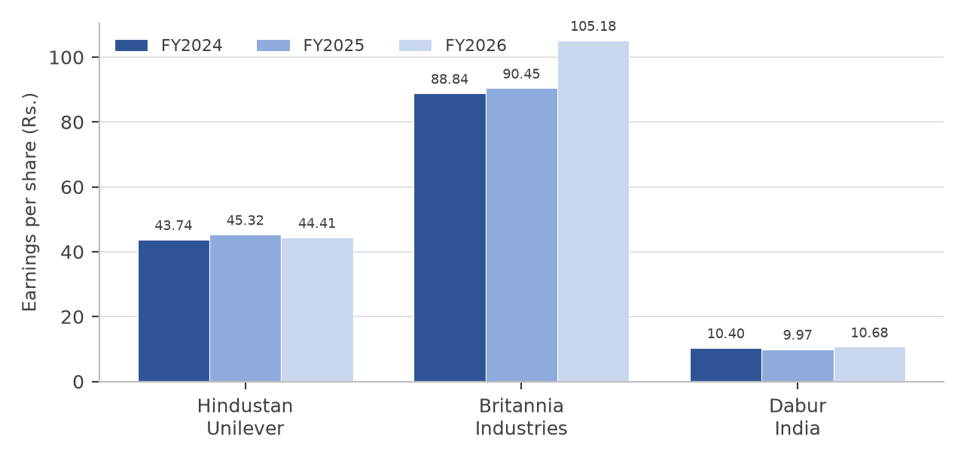
Figure 6.7: Earnings per share of the three companies
Overall Interpretation :
The level of earnings per share cannot be compared between the three companies because the number of shares differs widely: Hindustan Unilever has about 235 crore shares, Britannia about 24 crore and Dabur about 177 crore. The growth rate, however, is comparable and it separates the three companies clearly: 8.81% a year for Britannia, 1.34% for Dabur and 0.76% for Hindustan Unilever on a normalised basis.
8. RETURN ON ASSETS (ROA)
Return on assets measures the profit earned by a company in relation to the total assets on its balance sheet, irrespective of how those assets are financed.
Formula: PROFIT AFTER TAX / TOTAL ASSETS × 100
Hindustan Unilever Ltd. :-
• 2024: 10,282 / 78,499 × 100 = 13.10%
• 2025: 10,671 / 79,880 × 100 = 13.36%
• 2026: 10,448 / 79,752 × 100 = 13.10% (normalised)
Britannia Industries Ltd. :-
• 2024: 2,134 / 9,073.56 × 100 = 23.52%
• 2025: 2,178 / 8,838.55 × 100 = 24.64%
• 2026: 2,537 / 9,731.94 × 100 = 26.07%
Dabur India Ltd. :-
• 2024: 1,811 / 15,122.68 × 100 = 11.98%
• 2025: 1,740 / 16,232.28 × 100 = 10.72%
• 2026: 1,869 / 17,479.91 × 100 = 10.69%
Table 6.9: Return on assets of the three companies (%)
Company | FY2024 | FY2025 | FY2026
Hindustan Unilever | 13.10 | 13.36 | 13.10
Britannia Industries | 23.52 | 24.64 | 26.07
Dabur India | 11.98 | 10.72 | 10.69
Interpretation :
• Hindustan Unilever: The ratio moved within a narrow range of 13.10% to 13.36% and returned to 13.10% in 2026. Total assets were almost unchanged at about Rs. 79,000 crore in each of the three years, so the ratio simply follows the profit.
• Britannia Industries: The ratio improved in every year, from 23.52% to 26.07%, and is the highest of the three. The reason is the small asset base: total assets of Rs. 9,731.94 crore support a profit of Rs. 2,537 crore. The company also operates with negative working capital, which keeps the asset base low.
• Dabur India: The ratio fell from 11.98% to 10.72% and then to 10.69%, and is the lowest of the three. Almost half of the company’s assets are financial investments rather than assets used in the business, and those investments earn a return well below the return earned on the operating business, which drags the ratio down.
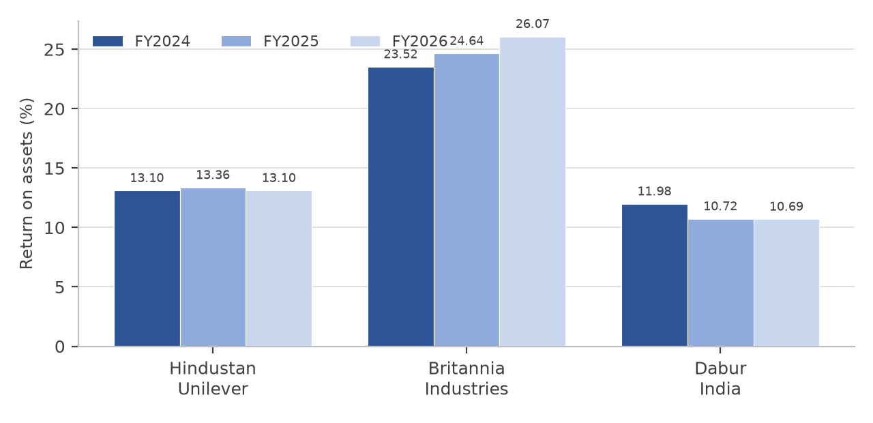
Figure 6.8: Return on assets of the three companies
Overall Interpretation :
Britannia Industries earns roughly twice the return on assets that Hindustan Unilever and Dabur earn, and the gap widened over the three years. Since the three companies earn net margins of a similar order, the difference is almost entirely a statement about the size of the balance sheet on which each company operates. For an investor this matters because a high return on assets means less capital is consumed in producing a given profit, which in turn supports cash generation and the ability to pay dividends.
9. CURRENT RATIO
The current ratio compares the current assets of a company with its current liabilities and indicates whether the company can meet its short-term obligations from the assets it expects to convert into cash within a year. A ratio below one indicates a potential short-term liquidity problem if it persists.
Formula: CURRENT ASSETS / CURRENT LIABILITIES
Hindustan Unilever Ltd. :-
• 2024: 21,324 / 12,876 = 1.66 times
• 2025: 22,051 / 16,537 = 1.33 times
• 2026: 19,021 / 15,549 = 1.22 times
Britannia Industries Ltd. :-
• 2024: 4,848.66 / 4,084.41 = 1.19 times
• 2025: 3,913.68 / 3,618.26 = 1.08 times
• 2026: 4,677.66 / 4,179.99 = 1.12 times
Dabur India Ltd. :-
• 2024: 5,679.62 / 3,930.43 = 1.45 times
• 2025: 6,532.46 / 4,318.44 = 1.51 times
• 2026: 8,885.96 / 5,239.08 = 1.70 times
Table 6.10: Current ratio of the three companies (times)
Company | FY2024 | FY2025 | FY2026
Hindustan Unilever | 1.66 | 1.33 | 1.22
Britannia Industries | 1.19 | 1.08 | 1.12
Dabur India | 1.45 | 1.51 | 1.70
Interpretation :
• Hindustan Unilever: The ratio fell in every year, from 1.66 to 1.22 times, as current liabilities rose from Rs. 12,876 crore to Rs. 15,549 crore while current assets fell. The company can sustain a low ratio because it has no debt and generates a large operating cash flow, but the trend indicates that working capital is being used more intensively than before.
• Britannia Industries: The ratio is the lowest of the three in every year, at 1.19, 1.08 and 1.12 times. The company operates with negative working capital, collecting from distributors before paying its suppliers, and a low current ratio is the expected consequence. The ratio never falls below one, so the position does not indicate a liquidity problem.
• Dabur India: The ratio improved from 1.45 to 1.70 times and is the highest of the three. The improvement is largely due to the increase in current investments, which rose from Rs. 1,667 crore to about Rs. 4,595 crore. The strength of the ratio therefore reflects the accumulation of financial assets rather than an improvement in the operating liquidity of the business.
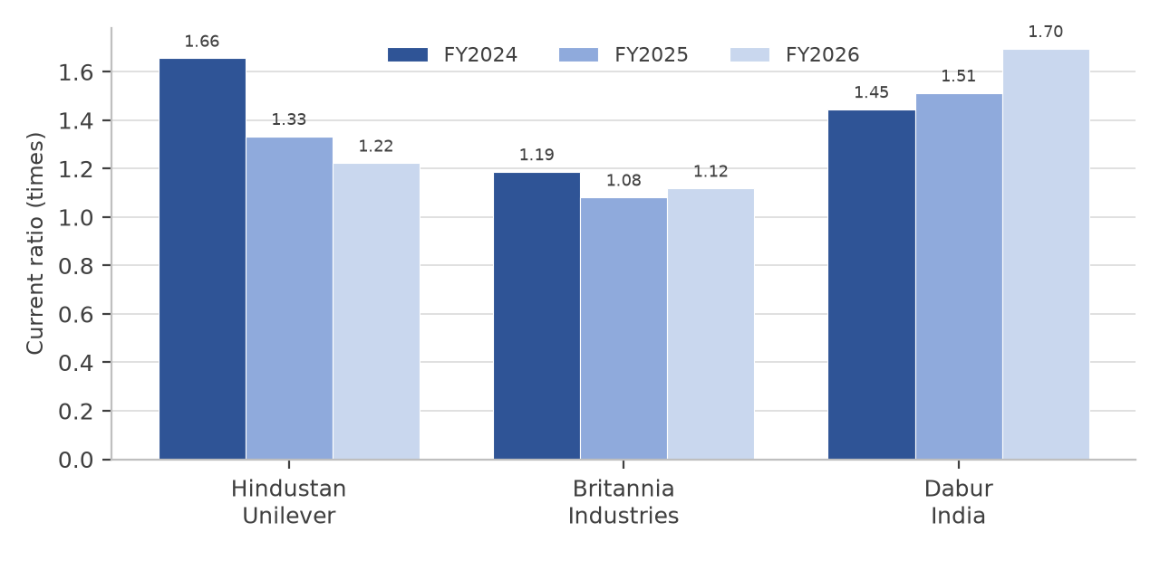
Figure 6.9: Current ratio of the three companies
Overall Interpretation :
A conventional reading of the current ratio would place Dabur first and Britannia last. That reading is misleading here. The current ratio is a measure of the ability to meet short-term obligations, not of financial strength, and in a sector in which the larger companies operate with negative working capital a low ratio is a sign of bargaining power with suppliers and distributors rather than of weakness. The absence of any borrowings at Hindustan Unilever and the consistently negative cash conversion cycle at Britannia and Dabur mean that none of the three faces a liquidity risk on the evidence of these three years.
10. PRICE TO EARNING (P/E) RATIO
The price to earnings ratio compares the market price of a share with the earnings attributable to it. It indicates how many rupees an investor is willing to pay for each rupee of current earnings, and it is therefore the most widely used measure of whether a share is expensive relative to its profit.
Formula: MARKET VALUE PER SHARE / EARNINGS PER SHARE
Hindustan Unilever Ltd. :-
• 12 October 2026: 1,850.90 / 44.41 = 41.68 times (on the normalised earnings per share)
• 12 October 2026: 1,850.90 / 64.01 = 28.92 times (on the published reported earnings per share)
Britannia Industries Ltd. :-
• 12 October 2026: 4,808.10 / 105.18 = 45.71 times
Dabur India Ltd. :-
• 12 October 2026: 384.10 / 10.68 = 35.96 times
Table 6.11: Price to earnings ratio of the three companies (times, 12 October 2026)
Company | As at 12 October 2026
Hindustan Unilever | 41.68
Britannia Industries | 45.71
Dabur India | 35.96
Interpretation :
• Hindustan Unilever: At 41.68 times normalised earnings, the share carries the second highest multiple of the three companies despite having the lowest earnings growth of the three. At the published earnings of Rs. 64.01 for FY2025-26 the multiple would appear to be 28.92 times, and that appearance is misleading because the earnings used in the denominator include a gain that will not recur.
• Britannia Industries: At 45.71 times earnings, the share is the most expensive of the three on this measure, which is consistent with the company also having the fastest earnings growth. The multiple implies that the market expects the current rate of growth to continue.
• Dabur India: At 35.96 times earnings, the share is the cheapest of the three, and it is also the one whose earnings have grown least. A low multiple in this case is not evidence of an opportunity alone; it reflects the market’s assessment of the company’s growth prospects.
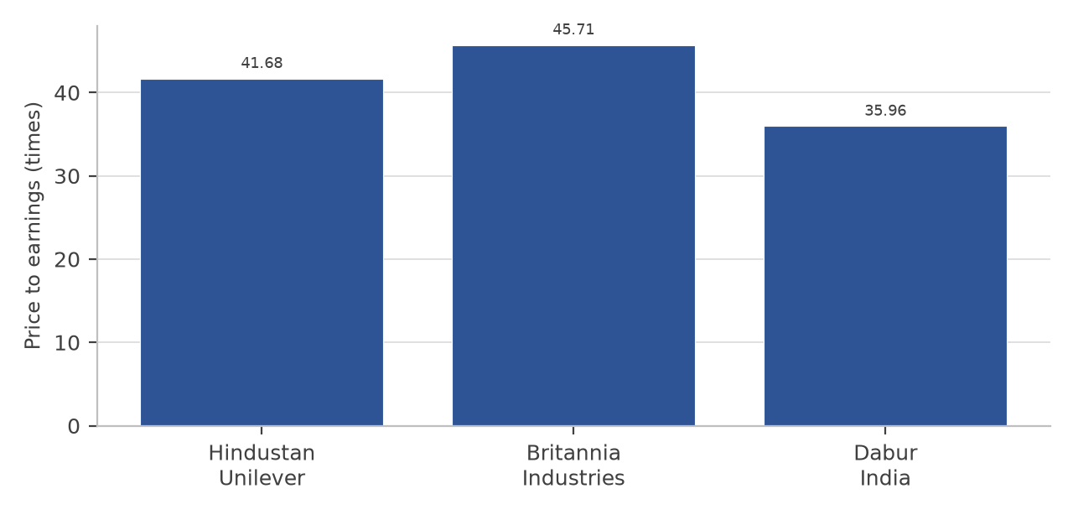
Figure 6.10: Price to earnings ratio of the three companies
Overall Interpretation :
The three companies trade in a narrow band of 35.96 to 45.71 times earnings, which is characteristic of a sector in which investors pay for the stability of the earnings rather than for their growth. The comparison also shows the interdependence of the ratios: Dabur looks cheapest on this measure and Britannia looks most expensive, but on the price to earnings growth ratio in section 12 the ranking is reversed, because a high multiple held on the strength of fast growth may be no less justified than a low multiple held on the strength of no growth.
11. PRICE TO BOOK (P/B) RATIO
The price to book ratio compares the market price of a share with the book value of the shareholders’ funds attributable to it. It indicates how much an investor is paying for each rupee of net worth, and it is particularly useful for comparing companies whose earnings are volatile.
Formula: MARKET PRICE PER SHARE / BOOK VALUE PER SHARE
Hindustan Unilever Ltd. :-
• 12 October 2026: 1,850.90 / 207.40 = 8.92 times (book value per share computed on the 235.00 crore equity shares outstanding at 31 March 2026)
Britannia Industries Ltd. :-
• 12 October 2026: 4,808.10 / 211.98 = 22.68 times (book value per share computed on the 24.09 crore equity shares outstanding at 31 March 2026)
Dabur India Ltd. :-
• 12 October 2026: 384.10 / 64.38 = 5.97 times (book value per share computed on the 177.37 crore equity shares outstanding at 31 March 2026)
Table 6.12: Price to book ratio of the three companies (times, 12 October 2026)
Company | As at 12 October 2026
Hindustan Unilever | 8.92
Britannia Industries | 22.68
Dabur India | 5.97
Interpretation :
• Hindustan Unilever: The share trades at 8.92 times net worth. Book value per share fell from Rs. 217.95 in 2024 to Rs. 207.40 in 2026 because the company distributed more than it earned, so the multiple has been held up by the price rather than by any growth in net worth.
• Britannia Industries: At 22.68 times net worth the share is by far the most expensive of the three on this measure, which follows directly from the high return on equity: an investor pays a large premium to book value for a business that earns about 50% on that book value. Book value per share rose from Rs. 163.62 to Rs. 211.98 over the three years.
• Dabur India: At 5.97 times net worth the share is the cheapest of the three. Unlike Britannia, the low multiple is not the mirror image of a high return on equity: Dabur’s return on equity of 16.37% is the lowest of the three, so the market is not paying a premium for the net worth because that net worth is not producing a high return.
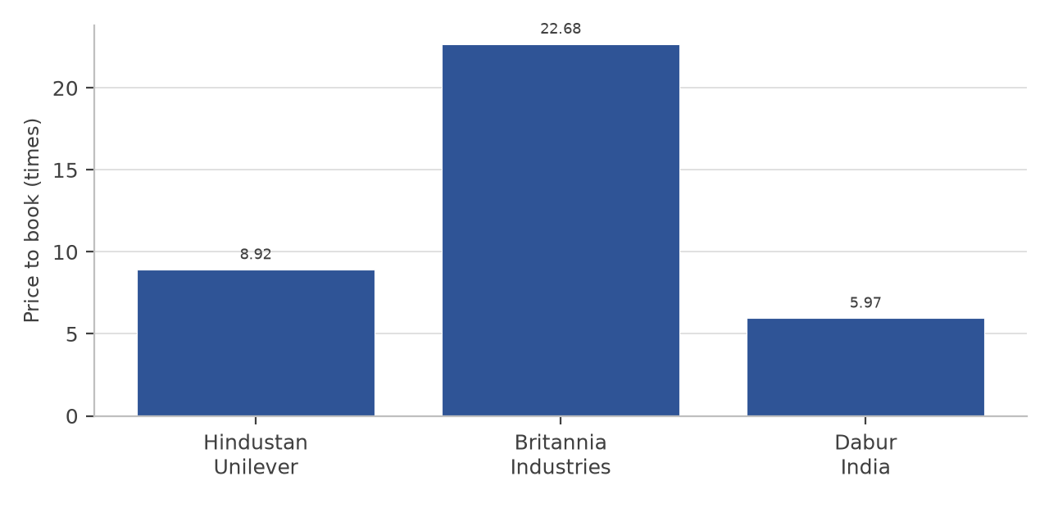
Figure 6.11: Price to book ratio of the three companies
Overall Interpretation :
The price to book ratio separates the three companies more widely than any other ratio in this chapter, ranging from 5.97 times to 22.68 times. Most of the difference is explained by the return on equity: a business that earns 49.68% on its net worth can reasonably trade at a higher multiple of that net worth than one that earns 16.37%. On this reading, Dabur’s low multiple is consistent with its low return rather than an opportunity created by the market.
12. PRICE TO EARNINGS GROWTH (PEG) RATIO
The price to earnings growth ratio relates the price to earnings multiple of a share to the rate at which its earnings per share have grown, and it is used to test whether a high multiple is justified by the growth that accompanies it. A ratio below one is conventionally regarded as attractive; the interpretation becomes unreliable as the growth rate approaches zero.
Formula: PRICE TO EARNINGS RATIO / COMPOUND ANNUAL GROWTH RATE IN EARNINGS PER SHARE (IN PER CENT)
Hindustan Unilever Ltd. :-
• 12 October 2026: 41.68 / 0.76 = 54.62 times (growth of 0.76% a year in normalised earnings per share from Rs. 43.74 in FY2024 to Rs. 44.41 in FY2026)
Britannia Industries Ltd. :-
• 12 October 2026: 45.71 / 8.81 = 5.19 times (growth of 8.81% a year in earnings per share from Rs. 88.84 to Rs. 105.18)
Dabur India Ltd. :-
• 12 October 2026: 35.96 / 1.34 = 26.90 times (growth of 1.34% a year in earnings per share from Rs. 10.40 to Rs. 10.68)
Table 6.13: Price to earnings growth ratio of the three companies (times, 12 October 2026)
Company | As at 12 October 2026
Hindustan Unilever | 54.62
Britannia Industries | 5.19
Dabur India | 26.90
Interpretation :
• Hindustan Unilever: The ratio of 54.62 times is not a meaningful measurement of value but an arithmetic consequence of dividing a high multiple by a growth rate close to zero. Its analytical content is nevertheless clear: the market is paying about 42 times earnings for a business whose normalised earnings per share grew by less than one per cent a year over the period studied.
• Britannia Industries: At 5.19 times, the ratio is the lowest of the three and by a wide margin. It is the only company of the three for which the multiple is supported by a growth rate of a size that makes the ratio informative.
• Dabur India: At 26.90 times, the ratio reflects a multiple of about 36 times earnings set against growth of about 1.3% a year. As with Hindustan Unilever, the ratio is unstable, and it should be read as a statement that the current multiple is not supported by the growth actually delivered.
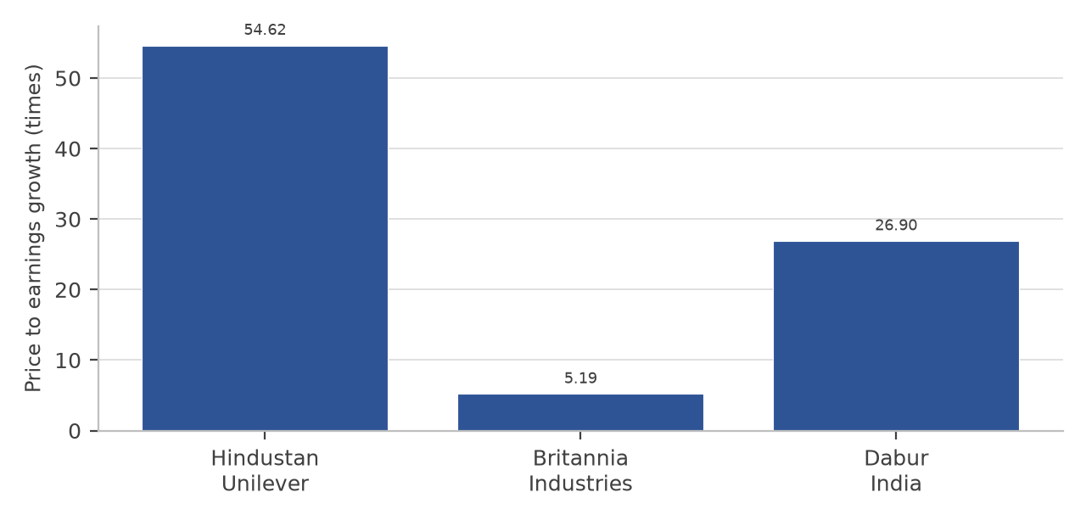
Figure 6.12: Price to earnings growth ratio of the three companies
Overall Interpretation :
This is the ratio on which the three companies differ most sharply, and it is also the ratio that most needs care in interpretation. Where the growth rate is close to zero, as it is for Hindustan Unilever and Dabur, the ratio becomes very large and its sign and magnitude are driven by the denominator rather than by anything about the business. The useful comparison is between Britannia, at 5.19 times, and the other two. On that comparison the market is paying a higher multiple for Britannia but is receiving a growth rate six to eleven times as large in exchange for it.
13. RETURN ON INVESTMENT (ROI) RATIO
In this report, return on investment measures the profit available to shareholders after interest and tax as a proportion of the total capital invested in the business by shareholders and lenders together. It differs from return on capital employed in that the profit is measured after the payment of interest and tax, and from return on equity in that the capital base includes borrowings.
Formula: PROFIT AFTER TAX / (SHAREHOLDERS’ FUNDS + TOTAL BORROWINGS) × 100
Hindustan Unilever Ltd. :-
• 2024: 10,282 / 51,231 × 100 = 20.07%
• 2025: 10,671 / 49,403 × 100 = 21.60%
• 2026: 10,448 / 48,739 × 100 = 21.44%
Britannia Industries Ltd. :-
• 2024: 2,134 / 5,982.73 × 100 = 35.67%
• 2025: 2,178 / 5,580.49 × 100 = 39.03%
• 2026: 2,537 / 6,464.39 × 100 = 39.25%
Dabur India Ltd. :-
• 2024: 1,811 / 11,024.37 × 100 = 16.43%
• 2025: 1,740 / 11,530.81 × 100 = 15.09%
• 2026: 1,869 / 12,482.20 × 100 = 14.97%
Table 6.14: Return on investment of the three companies (%)
Company | FY2024 | FY2025 | FY2026
Hindustan Unilever | 20.07 | 21.60 | 21.44
Britannia Industries | 35.67 | 39.03 | 39.25
Dabur India | 16.43 | 15.09 | 14.97
Interpretation :
• Hindustan Unilever: The return is identical to the return on equity in all three years because the company has no borrowings, so the denominator of the two ratios is the same. It rose from 20.07% to 21.44%, and as with return on equity the improvement comes from the reduction in the capital base rather than from growth in profit.
• Britannia Industries: The return rose from 35.67% to 39.25% and is the highest of the three. It is lower than the return on capital employed of 52.63% because the profit is measured after interest and tax, but it is higher than the return on equity of 49.68% would suggest relative to capital employed, because the equity base is small relative to total capital. The two together give a reliable picture: the company earns a very high return on a comparatively small capital base.
• Dabur India: The return fell in every year, from 16.43% to 15.09% and then to 14.97%, and is the lowest of the three. Capital invested rose by about Rs. 1,458 crore over the period while profit after tax rose by Rs. 58 crore, which is the arithmetic expression of the company’s difficulty in finding profitable uses for the cash it generates.
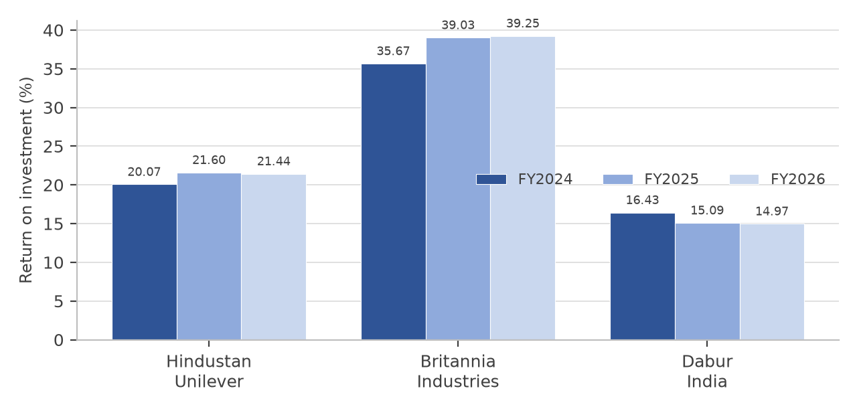
Figure 6.13: Return on investment of the three companies
Overall Interpretation :
The ordering on this ratio is the same as on return on capital employed and return on equity, which is to be expected because the three ratios share the same numerator or a closely related one. Taken together with the operating ratio and the interest coverage ratio, the ratio set supports two conclusions. Hindustan Unilever operates the most efficient business and carries the least financial risk. Britannia earns the highest return on the capital it employs. Dabur is the weakest on every measure of return, and the weakness is a matter of the deployment of capital rather than of the profitability of its products.
Factors Analysis
Factor analysis in this report compares the three companies by assigning a rank and a score to each company on each of the thirteen ratios computed above. The company with the best performance on a ratio is given rank 1 and a score of 10, the second is given rank 2 and a score of 9, and the third is given rank 3 and a score of 8. The maximum score available is therefore 130, being thirteen ratios multiplied by ten. For the debt to equity, operating ratio, price to earnings, price to book and price to earnings growth ratios the lowest value is treated as the best, and for the remaining eight ratios the highest value is treated as the best.
The scores are assigned on the FY2025-26 figures, because that is the most recent year for which all three companies have audited figures and because ranking three companies on three years of data would give the same company a different rank in each column without resolving which of the three positions is the more meaningful. A supplementary check on the strength of the ranking across all three years is given at the end of this section.
Table 6.15: Factor analysis of the three companies on the FY2025-26 ratios
 | FACTOR / RATIO | HUL | Rank | Score | Britannia | Rank | Score | Dabur | Rank | Score
1) | Net profit margin | 16.21 | 1 | 10 | 13.25 | 3 | 8 | 14.17 | 2 | 9
2) | Return on capital  employed | 28.76 | 2 | 9 | 52.63 | 1 | 10 | 20.55 | 3 | 8
3) | Return on equity | 21.44 | 2 | 9 | 49.68 | 1 | 10 | 16.37 | 3 | 8
4) | Debt to equity | 0.00 | 1 | 10 | 0.27 | 3 | 8 | 0.09 | 2 | 9
5) | Operating ratio | 76.67 | 1 | 10 | 81.65 | 3 | 8 | 81.43 | 2 | 9
6) | Interest coverage | 34.19 | 1 | 10 | 30.11 | 2 | 9 | 17.69 | 3 | 8
7) | Earnings per share  (Rs.) | 44.41 | 2 | 9 | 105.18 | 1 | 10 | 10.68 | 3 | 8
8) | Return on assets | 13.10 | 2 | 9 | 26.07 | 1 | 10 | 10.69 | 3 | 8
9) | Current ratio | 1.22 | 2 | 9 | 1.12 | 3 | 8 | 1.70 | 1 | 10
10) | Price to earnings | 41.68 | 2 | 9 | 45.71 | 3 | 8 | 35.96 | 1 | 10
11) | Price to book | 8.92 | 2 | 9 | 22.68 | 3 | 8 | 5.97 | 1 | 10
12) | Price to earnings  growth | 54.62 | 3 | 8 | 5.19 | 1 | 10 | 26.90 | 2 | 9
13) | Return on investment | 21.44 | 2 | 9 | 39.25 | 1 | 10 | 14.97 | 3 | 8
 | TOTAL SCORE |  |  | 120 |  |  | 117 |  |  | 114
COMPANY RANKINGS
Table 6.16: Overall ranking of the three companies on the factor analysis
COMPANY | TOTAL SCORE (OUT OF 130) | OVERALL RANKING
Hindustan Unilever Ltd. | 120 | 1st
Britannia Industries Ltd. | 117 | 2nd
Dabur India Ltd. | 114 | 3rd
Interpretation :
• Hindustan Unilever has the highest total score of 120. It is ranked first on four of the thirteen ratios, namely net profit margin, debt to equity, operating ratio and interest coverage; second on eight; and third on only one, the price to earnings growth ratio. Its score reflects consistency across the whole ratio set rather than dominance on any single measure, because it is second on all four return ratios.
• Britannia Industries has a total score of 117 and is ranked first on six ratios, the largest number of first places of the three companies: return on capital employed, return on equity, return on assets, return on investment, earnings per share and the price to earnings growth ratio. It is ranked third on the other six, namely net profit margin, debt to equity, operating ratio, current ratio, price to earnings and price to book. The contrast is the point: the company that earns the highest return on capital is also the company that scores worst on margin, leverage and liquidity, because it earns its return by employing very little capital rather than by earning a high margin on each sale.
• Dabur India has a total score of 114 and is ranked first in three ratios: the current ratio, the price to earnings ratio and the price to book ratio. All three first places arise because a low or a high value looks favourable in isolation: the current ratio is high because the company holds financial investments, and the two valuation ratios are low because the company has grown slowly. On the eight profitability and return ratios the company ranks third in seven.
• The margin between the first and the third company is six points out of 130, which is under five per cent of the maximum score. That narrowness is worth stating explicitly: the scoring method gives each ratio the same weight, so a company that finished second on every ratio would score 117, which is exactly the score of Britannia. A ranking of this kind measures consistency across the ratio set rather than the magnitude of the difference between the companies, and the magnitude of the difference is better seen in the individual ratios, where the return on capital employed of Britannia is more than two and a half times that of Dabur.
A supplementary check was carried out to test whether the ranking is an artefact of the single year used. The ten ratios that are computed year by year were scored separately in each of the three years and the three market-based ratios were scored once, giving thirty-three comparisons in place of thirteen. The totals, out of a possible 99 points, were 81 for Hindustan Unilever, 61 for Britannia Industries and 56 for Dabur India. Hindustan Unilever’s lead widens when the three years are taken together, because it wins the net profit margin, the debt to equity ratio, the operating ratio and interest coverage in every one of the three years, while Britannia wins all four return ratios in every year and Dabur’s three wins are confined to the current ratio, the price to earnings ratio and the price to book ratio. Both calculations give the same ranking, although they give different margins, and that is the important qualification: the ranking is stable, the distances between the companies are not.
Based on the total scores, the ranking is:
1. Hindustan Unilever Ltd. – 120 points out of 130
2. Britannia Industries Ltd. – 117 points out of 130
3. Dabur India Ltd. – 114 points out of 130
Hindustan Unilever is therefore the strongest company overall according to the selected ratios, followed by Britannia Industries and Dabur India. The result should be read together with the individual ratio analysis rather than in place of it. Britannia earns a substantially higher return on the capital it employs and grew its earnings per share at 8.81% a year against 0.76% at Hindustan Unilever, and an investor who gave greater weight to those two measures than to margin and leverage would reach a different conclusion from the same figures. The purpose of the factor analysis is to make the weighting explicit, not to remove the need for judgement.
CHAPTER 7 :- CONCLUSION, FINDINGS & SUGGESTIONS
CONCLUSION :-
The study titled “Fundamental Analysis of Selected Companies in the FMCG Sector” was undertaken to evaluate and compare the financial performance of Hindustan Unilever Ltd., Britannia Industries Ltd. and Dabur India Ltd. for FY2023-24, FY2024-25 and FY2025-26. The study used secondary data drawn from the audited consolidated financial statements of the three companies and applied ratio analysis covering profitability, liquidity, solvency, efficiency, return and market valuation, supported by an economic and industry analysis of the sector in which they operate.
The analysis shows that the three companies followed different financial paths during the period. Hindustan Unilever recorded the most stable performance and the strongest financial position. Its net profit margin remained between 16.21 and 17.40 per cent, its operating ratio was the lowest of the three in every year at 76.03 to 76.67 per cent, it carried no borrowings at all, and its interest coverage of 34.19 times in FY2025-26 was the highest of the three. It also scored the highest number of points in the factor analysis. What the figures do not show is growth: revenue rose at only 2.1 per cent a year over the two years and normalised earnings per share was almost unchanged at about Rs. 44, so the company’s strength lies in the quality of the business it already has rather than in its expansion.
Britannia Industries emerged as the strongest company on every measure of return and of capital efficiency. Its return on capital employed of 52.63 per cent and return on equity of 49.68 per cent in FY2025-26 were far above those of the other two companies, its return on assets improved in each of the three years to 26.07 per cent, its earnings per share grew at 8.81 per cent a year, and it reduced its debt to equity ratio from 0.52 to 0.27 times while increasing interest coverage from 18.76 to 30.11 times. It earns the lowest net profit margin of the three, at 13.25 per cent, and the reason is that it earns that margin on a small capital base: total assets of Rs. 9,731.94 crore support a profit after tax of Rs. 2,537 crore. A part of the FY2025-26 improvement came from a lower effective tax rate, and the sustainability of the growth rate therefore depends on the operating improvement continuing.
Dabur India was the weakest of the three on the measures of return. Its return on capital employed fell in each year from 22.52 to 20.55 per cent, its return on equity fell from 18.36 to 16.37 per cent, its return on assets fell from 11.98 to 10.69 per cent and its earnings per share grew at 1.34 per cent a year. The company is not weak in other respects: it carries the least debt after Hindustan Unilever, it has the highest current ratio of the three at 1.70 times, and its operating cash flow was 122 per cent of operating profit in FY2025-26, the best conversion of the three. Its difficulty is that capital employed rose by about Rs. 1,458 crore over three years while profit after tax rose by only Rs. 58 crore, which means that the cash the business generates is being accumulated as financial investments rather than deployed in the business at a return that would justify the retention.
On the factor analysis, in which thirteen ratios were scored for FY2025-26 with ten points for the best performer on each ratio, Hindustan Unilever scored 120 points out of a possible 130, Britannia Industries 117 and Dabur India 114. The margins are narrow, and a reader who attached greater weight to the return ratios than to margin, leverage and liquidity would place Britannia first, because it ranked first on six of the thirteen ratios against four for Hindustan Unilever. The conclusion of the study is therefore stated in two parts: Hindustan Unilever has the strongest all-round financial position on the ratio set used here, and Britannia Industries earns the highest return on the capital it employs, by a substantial margin.
The operational part of the study reached a conclusion of a different kind. The dealing function, observed over the period of the internship, is predominantly procedural rather than discretionary. A dealer cannot form and act on a view of a security; the dealer receives an instruction, verifies that it can be accepted within the limits, the collateral and the regulatory restrictions applicable to the client, executes it, and reconciles the result. Most of the work consists of preparation, verification and control rather than of execution, and competence is demonstrated by the absence of error rather than by skill in trading. The study also noted a distinction that is easily missed from outside the market: the attributes that determine how a security should be traded, such as its price band, its depth, its volatility and the segment in which it may be traded, have almost nothing in common with the attributes that determine whether the company behind it is a sound business. The two halves of this report address exactly those two questions, and the internship is what made the difference between them visible.
FINDINGS
Overall Financial Performance
The comparative analysis shows that Hindustan Unilever Ltd. had the strongest overall financial performance among the three selected companies on the ratio set used, with a total score of 120 out of 130 in the factor analysis, followed by Britannia Industries Ltd. with 117 points and Dabur India Ltd. with 114 points. On the return ratios taken separately, Britannia Industries was the strongest by a substantial margin in each of the three years.
Profitability Performance
Hindustan Unilever maintained the highest net profit margin in each of the three years, at 16.61 per cent in FY2023-24, 17.40 per cent in FY2024-25 and 16.21 per cent in FY2025-26 on normalised profit. Dabur India was second, at 14.60, 13.85 and 14.17 per cent, and Britannia Industries third, at 12.73, 12.14 and 13.25 per cent. Britannia was the only one of the three whose margin in FY2025-26 was higher than in FY2023-24. On the reported profit, Hindustan Unilever’s margin for FY2025-26 was 23.36 per cent, and that figure is not comparable with the earlier years because it includes the one-time gain of Rs. 4,611 crore on the demerger of the ice cream undertaking.
Return on Equity (ROE)
Britannia Industries recorded the highest return on equity in all three years, at 54.14, 50.00 and 49.68 per cent, although the ratio declined over the period as retained earnings accumulated in the equity base. Hindustan Unilever was second, at 20.07, 21.60 and 21.44 per cent, and Dabur India third, at 18.36, 16.11 and 16.37 per cent. Hindustan Unilever’s improvement was caused by a reduction in shareholders’ funds rather than by an increase in profit, and Dabur’s decline was caused by an increase in shareholders’ funds that was not matched by an increase in profit.
Return on Capital Employed
Britannia Industries improved its return on capital employed from 51.43 per cent in FY2023-24 to 54.94 per cent in FY2024-25 and then reported 52.63 per cent in FY2025-26. Hindustan Unilever moved from 27.83 to 29.96 and then to 28.76 per cent, and Dabur India declined in every year, from 22.52 to 21.00 and then to 20.55 per cent. Dabur was the only company of the three in which this ratio fell in each of the three years, which is the clearest indication in the study of a company whose capital is growing faster than the profit it earns.
Debt and Solvency
Hindustan Unilever was effectively debt free throughout the period, with borrowings of Rs. 13 crore or less against shareholders’ funds of about Rs. 48,700 crore, and a debt to equity ratio of 0.00 times in all three years. Britannia Industries reduced its debt to equity ratio from 0.52 to 0.27 times by repaying borrowings, which fell from Rs. 2,041.21 crore to Rs. 1,357.83 crore, and Dabur India moved from 0.12 to 0.09 times. None of the three companies carries financial risk of a kind that would concern a lender, and in all three the greater part of the working capital is financed by trade credit rather than by borrowing.
Operating Efficiency
Hindustan Unilever had the lowest operating ratio in every year, at 76.32, 76.03 and 76.67 per cent, which means it spends the smallest proportion of each rupee of revenue on producing and selling its goods. Dabur India was second at 80.65, 81.56 and 81.43 per cent and Britannia Industries third at 81.12, 82.29 and 81.65 per cent. All three companies absorbed a rise in input costs in FY2024-25 and recovered part of it in FY2025-26, and the movement in each case was within about one and a half percentage points over three years.
Interest Coverage
Hindustan Unilever had the highest interest coverage in every year, although it declined from 42.69 to 34.19 times as interest expense rose against a flat normalised profit. Britannia Industries improved in each year from 18.76 to 30.11 times, the largest improvement of the three and a direct result of its debt reduction. Dabur India was the weakest, at 20.02, 14.77 and 17.69 times, and it was the only company whose coverage fell below its opening level.
Liquidity Position
Dabur India had the highest current ratio in the final two years, at 1.51 and 1.70 times, having moved from 1.45 times in FY2023-24, and the improvement was caused mainly by an increase in current investments rather than in operating assets. Hindustan Unilever’s ratio declined in each year from 1.66 to 1.22 times and Britannia Industries had the lowest ratio of the three, at 1.19, 1.08 and 1.12 times. None of the three fell below one, and none faces a short-term liquidity problem on the evidence of the three years studied.
Market Valuation
On the market price as at 12 October 2026, Dabur India was the cheapest of the three companies on both the price to earnings ratio, at 35.96 times, and the price to book ratio, at 5.97 times. Hindustan Unilever was valued at 41.68 times normalised earnings and 8.92 times book value, and Britannia Industries at 45.71 times earnings and 22.68 times book value. The valuation ratios and the growth rates move in the same direction: the company valued the lowest has the slowest earnings growth at 1.34 per cent a year, and the company valued the highest has the fastest at 8.81 per cent. On the price to earnings growth ratio Britannia was the only one of the three whose multiple was supported by its growth rate, at 5.19 times, against 26.90 times for Dabur and 54.62 times for Hindustan Unilever; the two larger figures are largely an artefact of dividing by a growth rate close to zero and should not be read as measurements of value.
Overall Finding
Based on the selected ratios, Hindustan Unilever appears to be the strongest company overall, Britannia Industries earns the highest return on the capital employed in its business, and Dabur India has the strongest short-term liquidity and the lowest market valuation but the weakest growth and the weakest returns. Investment decisions should not be based on any single ratio or on this analysis alone. The reasons lie partly in the nature of the study, which covers three years and three companies and uses no forward-looking estimate, and partly in the nature of valuation itself, which depends on the earnings that will be produced in the future rather than on those that have been produced in the past.
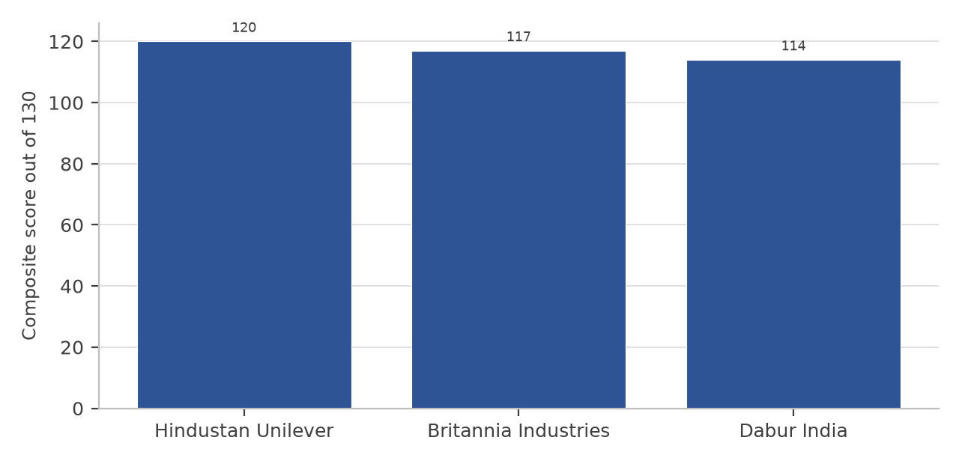
Figure 7.1: Composite factor analysis score of the three companies (out of 130)
SUGGESTIONS
1. Suggestions for Hindustan Unilever Ltd.
• The company should address the absence of revenue growth, which at 2.1 per cent a year over the two years to FY2025-26 is below the rate of inflation. Growth in a company of this size will have to come from premiumisation and from categories outside the mature ones in which it already holds a large share.
• The decline in operating cash flow from Rs. 15,469 crore in FY2023-24 to Rs. 10,999 crore in FY2025-26, in a period in which operating profit rose slightly, should be examined. The change is explained by working capital rather than by profitability, and the company should consider whether the movement reflects a deliberate change in payment terms or a deterioration in collection.
• The reduction in reserves in two successive years indicates that distributions are being made in excess of profits. This is sustainable for a debt-free company with strong cash generation, but it leaves no reserve for an acquisition or for a period of unexpectedly weak trading, and the company may wish to retain a larger part of its earnings while it invests in the premium segments.
• The current ratio has fallen from 1.66 to 1.22 times over three years. The absence of debt means that this is not a risk of default, but the trend in working capital should be monitored.
2. Suggestions for Britannia Industries Ltd.
• The company should continue to reduce dependence on a single product category. Biscuits account for the greater part of revenue, and the concentration exposes the entire business to the prices of wheat flour, sugar and edible oil in a way that a more diversified portfolio would not.
• The improvement in operating profit in FY2025-26 should be consolidated. Since part of the increase in profit after tax in that year came from a lower effective tax rate, the company should demonstrate that the operating improvement can be repeated in a year in which the tax charge normalises.
• The current ratio, which has stayed between 1.08 and 1.19 times, should be reviewed against the company’s own liquidity policy. A negative cash conversion cycle is a source of financial strength, but it also means that the company depends on continuing trade credit and on distributors continuing to pay in advance.
• Investment in the dairy and adjacent bakery businesses should continue, because those businesses use the existing distribution network and raise the value of each delivery without requiring a new one.
3. Suggestions for Dabur India Ltd.
• The company should identify why the return on the capital it employs is falling, and act on it. The ratio has declined in each of the three years because capital employed has grown faster than profit, and no amount of improvement in liquidity or in cash conversion will correct that if the capital continues to accumulate without being deployed.
• The balances held in financial investments, which were about Rs. 8,947 crore at the end of FY2025-26, should either be deployed in the business or returned to shareholders. Held as investments they earn a return below the company’s cost of capital and they reduce the return on assets and the return on investment reported to shareholders.
• The company should reduce its dependence on other income, which contributed Rs. 584 crore of a profit before tax of Rs. 2,420 crore in FY2025-26. Income of this kind is volatile and is outside the control of the management of the operating business.
• The rural weighting of the portfolio, at 45 to 50 per cent of revenue, makes the company more exposed than its competitors to the slowdown in rural demand. The company should continue to invest in the foods and beverages vertical, which grew faster than the rest of the portfolio and is less dependent on rural purchasing power.
• The decline in interest coverage to 14.77 times in FY2024-25, though comfortable in absolute terms, should be monitored, because it coincided with a fall in profit rather than with a rise in borrowings.
4. Suggestions for Investors
• Investors should not base a decision on a single ratio. In this study the company with the highest net profit margin is not the company with the highest return on capital, and the company with the lowest price to earnings multiple is not the company with the best growth.
• Profitability, liquidity, solvency, efficiency and valuation ratios should be read together, and the direction of each ratio over time matters more than its level in one year.
• Reported figures should be checked for one-time items before any comparison is made. The earnings of Hindustan Unilever for FY2025-26 are 44 per cent higher than the preceding year on a reported basis and almost unchanged on a normalised basis, and an investor who used the reported figure would have formed the wrong impression of the company.
• A low price to earnings multiple or a high current ratio may reflect weakness rather than value. In this study the cheapest company on both valuation measures also has the lowest return on equity and the slowest growth in earnings per share.
• Investors should also consider the movement of agricultural commodity prices, the state of rural demand, changes in indirect tax rates, competition from digital-first brands and the shift of volume towards quick commerce, all of which affect the sector as a whole and cannot be seen from the financial statements of a single company.
• Historical ratios should be combined with an independent view of the company’s future prospects, and with due attention to the valuation at which the shares are available, before any investment decision is taken.
5. Suggestions Arising from the Internship
• A written pre-market checklist should be maintained on the dealing desk. Most of the operational difficulties observed during the internship arose from an omission in the preparation made before the market opened rather than from an error during trading, and a signed checklist covering corporate actions, the ban list for derivative contracts, surveillance changes and limit confirmation would remove the largest single source of avoidable problems.
• A structured period of practice on a simulated order book should precede live access for a new dealer. Competence at the terminal is partly a motor skill acquired through repetition, and supervised practice shortens the period during which a new entrant is a risk to the desk and to the client.
• Clients should be given a pre-trade cost illustration. A delivery purchase and sale at the same price still produces a loss once brokerage, statutory charges and taxes are applied, and a one-page illustration issued before the trade would prevent the disputes that arise when a client sees the net figure on the contract note for the first time.
• A plain-language note on the asymmetry of margin and collateral should be issued to derivative clients. Collateral pledged against a position loses value at the same time as the margin requirement rises, so a shortfall can appear after a price movement much smaller than the client expects, and this is the root of most disputes about margin calls.
REFERENCES & BIBLIOGRAPHY
REFERENCES
1. Annual Reports of Hindustan Unilever Limited for the financial years 2023-24, 2024-25 and 2025-26.
2. Annual Reports of Britannia Industries Limited for the financial years 2023-24, 2024-25 and 2025-26.
3. Annual Reports of Dabur India Limited for the financial years 2023-24, 2024-25 and 2025-26.
4. Hindustan Unilever Limited, audited consolidated financial statements and corporate announcements on the demerger of the ice cream undertaking, effective 1 December 2025.
5. Britannia Industries Limited, audited consolidated financial statements and corporate announcements, 2024 to 2026.
6. Dabur India Limited, audited consolidated financial statements and corporate announcements, 2024 to 2026.
7. Securities and Exchange Board of India, www.sebi.gov.in — regulations, circulars and investor-protection material; accessed 9 October 2026.
8. National Stock Exchange of India Limited, www.nseindia.com — market information, contract specifications, margin framework and daily surveillance lists; accessed 9 October 2026.
9. BSE Limited, www.bseindia.com — market information, contract specifications, margin framework and corporate announcements; accessed 9 October 2026.
10. Reserve Bank of India, www.rbi.org.in — monetary policy statement of August 2026 and database on the Indian economy; accessed September and October 2026.
11. Ministry of Finance, Government of India — Economic Survey 2025-26.
12. India Brand Equity Foundation, Fast Moving Consumer Goods industry report, updated September 2026, www.ibef.org.
13. NielsenIQ India, FMCG quarterly growth data as reported in the industry report of the India Brand Equity Foundation; accessed October 2026.
14. National Securities Depository Limited and Central Depository Services (India) Limited — depository statistics, as on 31 August 2026.
15. Hindustan Unilever Limited, Britannia Industries Limited and Dabur India Limited — official company websites, company profile, brand portfolio and investor-relations material.
BIBLIOGRAPHY
Books and study material
1. Chandra, P. (2019). Investment Analysis and Portfolio Management. McGraw Hill Education.
2. Kothari, C. R. (2019). Research Methodology: Methods and Techniques. New Age International Publishers.
3. Hull, J. C. Options, Futures and Other Derivatives. Pearson.
4. Bhole, L. M. and Mahakud, J. Financial Institutions and Markets. McGraw Hill Education.
5. Pathak, B. V. The Indian Financial System: Markets, Institutions and Services. Pearson.
6. National Institute of Securities Markets and NSE Academy certification workbooks on the capital market and the derivatives market, current editions.
Regulations, circulars and rule books
1. Securities and Exchange Board of India Act, 1992.
2. SEBI (Stock Brokers) Regulations, 1992, as amended.
3. SEBI circular on the standardisation of the expiry day for equity derivative contracts, 2025.
4. NSE and BSE circulars on the shift of the equity-derivative expiry day to Tuesday and Thursday respectively with effect from 1 September 2025.
5. Exchange circulars on Computer-to-Computer Link software approval, terminal registration and user identification.
6. Exchange circulars on transaction charges for the capital market and the equity-derivatives segment.
7. Finance Act provisions prescribing the securities transaction tax rates applicable from 1 April 2026.
8. SEBI circulars on margining for cash and equity-derivatives segments, and on the upstreaming of client funds.
Websites and online sources
1. Hindustan Unilever Limited. Company profile, brand portfolio, financial results and investor presentations.
2. Britannia Industries Limited. Company profile, brand portfolio and financial results.
3. Dabur India Limited. Company profile, business verticals and financial results.
4. National Stock Exchange of India Limited. Company and market information, share price data and contract specifications.
5. BSE Limited. Company information, shareholding patterns and share price data.
6. Securities and Exchange Board of India. Regulations, circulars and investor education material.
7. Reserve Bank of India. Macroeconomic and monetary policy information.
8. India Brand Equity Foundation. Sector reports on fast moving consumer goods, food processing and related industries.
9. Moneycontrol and Screener. Published financial statements, financial ratios and market information used for cross-checking the ratios computed in this report.
10. Business news publications and company press releases, used only for corporate events reported during the study period.
Note on data: the financial statements used in this report are the audited consolidated statements of the three companies. Figures described as published are reproduced from those statements; figures described as the author’s computation have been calculated from them using the formulas stated in Chapter 6. Illustrative figures in Chapter 2 are constructed by the author to demonstrate a mechanism and are not drawn from any of the sources listed above.
APENDICES
COMPANY RESEARCH & FUNDAMENTAL ANALYSIS REPORT OF HINDUSTAN UNILEVER LTD.
This appendix reproduces, in the form of a standalone research report, the detailed work prepared on Hindustan Unilever Ltd. The company was selected for the standalone report because it is the largest of the three companies studied and because it is the only one of the three whose reported profit for FY2025-26 contains a one-time item, which makes it the most instructive of the three to work through line by line. All figures are consolidated and in rupees crore unless stated otherwise.
1. Standard Company Identification Sheet
Table A.1: Hindustan Unilever Ltd. — identification sheet
Particular | Detail
Company name | Hindustan Unilever Limited
Corporate identity number | [ADD: from the MCA master data page of the company]
NSE symbol and BSE scrip code | HINDUNILVR; BSE 500696
Sector and industry | Fast moving consumer goods; household and personal products
Corporate website | www.hul.co.in
Registered office | Unilever House, B. D. Sawant Marg, Chakala, Andheri East, Mumbai  400099, Maharashtra
Year of incorporation | 1933, as Lever Brothers India Limited; renamed Hindustan Unilever  Limited in 2007
Ultimate holding company | Unilever plc, through Unilever Overseas Holdings B.V.
Chairman | [ADD: verify the name of the incumbent]
Chief Executive Officer and  Managing Director | [ADD: verify the name of the incumbent]
Chief Financial Officer | [ADD: verify the name of the incumbent]
Face value per equity share | Re. 1.00
Equity shares outstanding as at  31 March 2026 | 235.00 crore
Market capitalisation as at 12  October 2026 | approximately Rs. 4,34,962 crore
Market price as at 12 October  2026 | Rs. 1,850.90
52 week high and low | Rs. 2,667.20 and Rs. 1,826.90
Study period | FY2023-24 to FY2025-26 (FY2022 to FY2026 for the trend analysis)
2. Executive Summary
Hindustan Unilever Ltd. is the largest pure-play FMCG company in India by revenue, with more than fifty brands across fifteen categories and a distribution network that reaches both urban and rural markets. It is a mature, cash-generative business with no borrowings, the lowest operating ratio of the three companies studied and the highest interest coverage.
The company’s difficulty is growth. Revenue was almost flat between FY2023-24 and FY2024-25 and rose 5.12 per cent in FY2025-26 to Rs. 64,468 crore, a compound rate of 2.1 per cent a year over the two years. Normalised earnings per share moved from Rs. 43.74 to Rs. 44.41 over the same period, a compound rate of 0.76 per cent a year. The reported profit for FY2025-26 of Rs. 15,059 crore includes a one-time gain of approximately Rs. 4,611 crore on the demerger of the ice cream undertaking into Kwality Wall’s (India) Ltd., and on the normalised figure of Rs. 10,448 crore the net profit margin was 16.21 per cent rather than the reported 23.36 per cent.
The return ratios are stable rather than strong: return on capital employed moved between 27.83 and 29.96 per cent and return on equity between 20.07 and 21.44 per cent over the three years. Operating cash flow fell from Rs. 15,469 crore to Rs. 10,999 crore while operating profit was rising, and shareholders’ funds declined in two successive years because distributions exceeded profits. The share traded at 41.68 times normalised earnings on 12 October 2026, the second highest multiple of the three companies studied, for the lowest earnings growth of the three.
3. Company Background
3.1 History and Milestones
Hindustan Unilever Ltd. was incorporated in 1933 as Lever Brothers India Limited and was for most of its history known as Hindustan Lever Limited. It was renamed Hindustan Unilever Limited in 2007. The account below lists the milestones that are relevant to an understanding of the business as it stands today; a complete chronology is available in the company’s annual report and on its website.
• 1933: incorporation as Lever Brothers India Limited, the first Unilever operation in India.
• 1956: listing on the Indian stock exchanges, with a substantial minority shareholding held by Indian investors.
• 1990s: expansion into personal care and foods, including the acquisition of the Lakmé and Ponds brands and the launch of the Ayush range of Ayurvedic products.
• 2007: renaming of the company as Hindustan Unilever Limited.
• 2020: consolidation of the foods and refreshment businesses and reorganisation of the portfolio around a smaller number of larger brands.
• 2025: demerger of the ice cream business into Kwality Wall’s (India) Ltd., effective 1 December 2025, with the gain on transfer recognised in the consolidated profit and loss account of FY2025-26.
3.2 Products and Services
The portfolio comprises home care products, beauty and personal care products, and foods and refreshment products. Table A.2 sets out the principal categories within each group. The company states that its products are used in a very large proportion of Indian households, although the exact figure is not published in a form that can be verified from the financial statements.
Table A.2: Principal product groups of Hindustan Unilever Ltd.
Business group | Principal categories
Home care | Fabric wash and detergent powders and liquids, laundry bars, dishwashing  products, surface cleaners, insecticides and air care
Beauty and wellbeing | Skin care and face care, hair care, colour cosmetics, salon products and  premium personal care
Personal care | Soaps, oral care including toothpaste and toothbrushes, and mass hair care
Foods and refreshment | Tea, coffee, packaged foods, health food drinks, culinary products and frozen  desserts (the ice cream business was demerged with effect from 1 December  2025)
3.3 Revenue Segments
Table A.3: Indicative contribution of each business group to revenue
Business group | Indicative share of revenue | Remarks
Home care | Approximately one third | The largest group; no single category dominates  the company’s revenue
Beauty and wellbeing | Approximately one fifth | The group towards which the company’s  premiumisation strategy is directed
Personal care | Approximately one fifth | Mature categories in which the company holds  leading positions
Foods and  refreshment | Approximately one fifth | Includes the demerged ice cream business up to  30 November 2025
The figures in Table A.3 are indicative proportions drawn from the company’s segment disclosures and are stated as approximate because the segment boundaries used by the company differ from those used by the companies with which it is compared in Chapter 6. They are given here to show that no single business group contributes more than about a third of revenue, which is the point that matters for the analysis.
3.4 Geography
The company earns the greater part of its revenue within India and the balance from exports of its products and from its subsidiary operations, which are concentrated in South Asia. Within India, the company derives 35 to 40 per cent of its revenue from rural markets according to the industry data on the sector, and its distribution reach extends across the country. A precise split of revenue between urban and rural markets, or between India and overseas, is disclosed in the annual report and should be taken from there for any purpose that requires exactness.
3.5 How the Company Makes Money
The company buys agricultural commodities and chemicals, manufactures them into branded consumer products, and sells those products through a distribution network that runs from its own depots through carrying and forwarding agents, distributors and eventually several million retail outlets. Profit comes from the difference between the retail price realised and the cost of materials, manufacturing, advertising and distribution. Because the products are purchased repeatedly by the same households, the value of the business depends on the width of the distribution network and the strength of the brands as much as on any single year’s sales. Two features of the economics are visible in the financial statements: the business converts operating profit almost entirely into cash, and it finances itself partly through trade credit rather than through borrowing.
4. Business Model Diagram
The business model is set out below in text form, reading from the inputs on which the business depends to the value it returns. The arrow indicates the direction of flow.
INPUTS
• Raw materials: agricultural commodities such as tea, wheat, edible oils, milk solids and chemicals used in detergents and personal care products.
• Packaging: polymers and paper, whose cost moves with the price of crude oil.
• Manufacturing assets: plants located across India.
• Human capital: sales, marketing, manufacturing and research staff.
• Technology: the parent company’s research and product development, and the digital platforms used for distributor and retailer ordering.
▼
OPERATIONS
• Procurement of raw and packing materials, partly on long-term contracts.
• Manufacturing and quality control at company plants and at third-party units.
• Brand management and advertising, which is a large and recurring cost in this sector.
• Distribution through depots, distributors and a rural retailer-ordering application.
▼
REVENUE AND COST CYCLE
• Revenue: driven by the volume and price of everyday products sold through general trade, modern trade and e-commerce.
• Profit: protected by leading brand positions in categories where consumers repurchase frequently.
• Cash: conversion of operating profit into cash is high, and the surplus funds the dividend.
▼
RETURNS TO STAKEHOLDERS
• Shareholders: a dividend that has exceeded the year’s profit in two of the three years studied, and no debt.
• Employees and suppliers: wages and trade payables settled in the ordinary course.
• Government: indirect taxes collected on the sale of products and income tax on profits.
5. Industry and Competitive Analysis
The Indian FMCG sector is the fourth largest sector of the economy and was valued at approximately Rs. 25 lakh crore, or US$ 289.1 billion, in 2025, with household and personal care products contributing about half of total sales. Volume growth moderated to 4.1 per cent in 2025 from 4.7 per cent in 2024, and rural volume growth fell to 3.6 per cent against urban growth of 4.6 per cent. Hindustan Unilever is the largest pure-play company in the sector and competes with a small number of very large firms in each of its categories.
Table A.4: Competitive position of Hindustan Unilever Ltd. in its principal categories
Category group | Principal competitors | Basis of competition
Home care | Godrej Consumer Products, Nirma,  Jyothy Labs, Rohit Surfactants | Price points and pack sizes,  distribution reach, and brand recall
Beauty and personal  care | Dabur, Marico, Godrej Consumer  Products, Emami, Colgate-Palmolive,  and a growing set of digital-first brands | Product claims, advertising, shelf  and platform placement, and  premiumisation
Foods and refreshment | ITC, Nestlé India, Britannia, Tata  Consumer Products | Taste and habit, price per unit, and  availability
Table A.5: Peer set for valuation comparison
Company | Principal segment | Price to earnings, 12 Oct  2026
Hindustan Unilever Ltd. | Home, beauty and personal care, foods | 41.68 times (normalised)
Britannia Industries Ltd. | Biscuits, dairy and bakery | 45.71 times
Dabur India Ltd. | Ayurvedic healthcare, personal care and  foods | 35.96 times
Nestlé India Ltd. | Packaged foods and beverages | about 66.9 times
ITC Ltd. | Cigarettes, packaged foods and other  businesses | about 16.7 times
The multiples shown for the three companies analysed in this report have been computed from the market price on 12 October 2026 and the earnings per share of FY2025-26. The multiples shown for Nestlé India and ITC are approximate figures taken from published financial information on the same date and are given only to place the three companies in the context of the sector; they are not the result of a computation carried out for this report and should be re-checked before the report is submitted.
6. PESTLE and Porter’s Five Forces
Table A.6: PESTLE analysis of the environment in which the company operates
Factor | What it covers | Effect on the company
Political | Government policy on consumption,  rural development, food safety and  foreign investment | Budget measures that raise disposable income  support demand; food safety and labelling  rules raise compliance cost
Economic | Growth of gross domestic product,  inflation, interest rates and rural cash  flows | Private consumption accounts for 61.5 per  cent of gross domestic product; food inflation  of 5.52 per cent in July 2026 raises input cost  and reduces rural purchasing power
Social | Consumption habits, health awareness  and the shift to natural and premium  products | Favours the company’s premiumisation  strategy and its natural product ranges
Technological | E-commerce, quick commerce, digital  ordering by retailers and data analytics | E-commerce accounted for nearly 18 per cent  of FMCG sales in the top eight metro cities in  the quarter ended December 2025; the  channel carries a higher cost to serve than  general trade
Legal | Competition law, advertising codes, food  safety standards, goods and services tax  and labour codes | The labour codes produced an exceptional  charge in FY2025-26; indirect tax changes  alter the price points available in a category
Environmental | Water use, plastic packaging and energy  in manufacturing | Raises the cost of packaging and requires  disclosure and targets, and influences the  preference of institutional buyers
Porter’s Five Forces
Table A.7: Porter’s five forces applied to the company
Force | Strength | Reasoning
Threat of new entrants | Low to  moderate | The distribution network and brand investment required to  enter at national scale are large. Digital-first brands have  entered successfully at small scale, particularly in personal  care, but the proportion of new launches that reach even one  per cent penetration is about four per cent
Bargaining power of  suppliers | Low to  moderate | Agricultural commodities and packaging materials are  purchased in competitive markets in which the company is a  large buyer, but the prices themselves are set by the market and  cannot be negotiated
Bargaining power of  buyers | Moderate | Millions of individual consumers have little individual power,  but modern trade and e-commerce platforms have substantial  power over listing, visibility and margin
Threat of substitutes | Moderate | Unbranded and regional products substitute for branded goods  at the lower end of each category, and private labels of retail  chains substitute at the middle
Competitive rivalry | High | Each category contains two or more large national competitors  and a growing number of small brands, and competition on  price, promotion and shelf space is continuous
7. SWOT and Management Analysis
Table A.8: SWOT analysis of Hindustan Unilever Ltd.
Strengths | Weaknesses
• The largest distribution network in the Indian  FMCG sector and more than fifty brands across  fifteen categories, several of which lead their  category.  • Effectively debt free, with the lowest  operating ratio of the three companies studied, at  76.67 per cent in FY2025-26, and the highest  interest coverage at 34.19 times.  • Consistent  conversion of profit into cash: operating cash flow  was 105 per cent of operating profit in FY2025-26  and free cash flow of Rs. 9,667 crore was more than  sufficient to fund the dividend.  • Access to the  parent company’s research and development and to  its global brand portfolio. | • The slowest revenue growth of the three  companies studied, at a compound 2.1 per cent a  year over the two years to FY2025-26.  •  Normalised earnings per share almost unchanged at  about Rs. 44 across the three years.  • Distributions  to shareholders exceeded profit in FY2024-25 and  reserves fell by Rs. 1,816 crore that year.  •  Operating cash flow declined from Rs. 15,469 crore  to Rs. 10,999 crore while operating profit was  rising.
Opportunities | Threats
• Premiumisation in beauty, wellbeing and personal  care, supported by the announced plan to invest up  to Rs. 20,000 crore in manufacturing capacity in the  premium segments.  • Quick commerce and  e-commerce, in which the company’s mass brands  are under-represented relative to their share of  general trade.  • Growth of the rural market, where  the company already derives 35 to 40 per cent of  revenue and supports retail ordering through an  application used by about 1.4 million retailers.  •  Recovery in urban discretionary demand as food  inflation moderates. | • Competition from digital-first brands, which has  raised the cost of defending share in personal care  and colour cosmetics.  • The shift of volume  towards quick commerce, which carries a higher  cost to serve than general trade.  • Input cost  inflation in packaging and in imported raw  materials, combined with a limited ability to raise  prices without affecting volume.  • Valuation risk:  the shares trade at 41.68 times normalised earnings  for a business whose normalised earnings per share  grew by less than one per cent a year.
Management and Governance Checklist
Table A.9: Management and governance checklist
What to examine | Why it matters | Position of the company
Promoter and  holding-company stake | A stable majority holder  reduces the risk of contested  control | The company is a subsidiary of Unilever  plc, which holds its interest through  Unilever Overseas Holdings B.V.; the  exact percentage as at 30 June 2026 is  [ADD: verify from the  shareholding-pattern filing]
Board composition and  independence | Independent directors are the  main internal check on  management | [ADD: number of directors and of  independent directors from the FY2025-26  annual report]
Related-party transactions | Transactions with the parent  can transfer value away from  minority shareholders if not  priced at arm’s length | The company transacts with the Unilever  group for brand fees, research and  services. The transactions are disclosed in  the annual report and are subject to  audit-committee approval; the amounts are  [ADD: from the related-party note]
Dividend policy | Shows how the board weighs  distribution against retention | Dividends and distributions exceeded the  year’s profit in two of the three years  studied, which reduced reserves
Capital allocation | Determines whether retained  profit earns a return | Operating cash flow of Rs. 10,999 crore  and free cash flow of Rs. 9,667 crore in  FY2025-26 against capital expenditure  that remained moderate
Audit qualifications and  regulatory action | An adverse observation is a  signal of control weakness | [ADD: confirm from the auditors’ report  that no qualification or adverse remark  was made in the three years under study]
8. Three-Year Financial Performance – Income Statement
Table A.10: Hindustan Unilever Ltd. — consolidated income statement (Rs. crore)
Particulars | FY2023-24 | FY2024-25 | FY2025-26
Net revenue from operations | 61,896 | 61,328 | 64,468
Operating expenses | 47,237 | 46,630 | 49,429
Operating profit | 14,659 | 14,698 | 15,039
Other income | 817 | 1,355 | 4,923
Interest expense | 334 | 381 | 410
Depreciation and amortisation | 1,216 | 1,253 | 1,333
Profit before tax | 13,926 | 14,419 | 18,219
Tax | 3,644 | 3,748 | 3,160
Profit after tax | 10,282 | 10,671 | 15,059
Earnings per share (Rs.) | 43.74 | 45.32 | 64.01
Other income of Rs. 4,923 crore in FY2025-26 against Rs. 1,355 crore in the preceding year is the line in which the one-time gain arising from the demerger of the ice cream undertaking appears, together with income earned on the company’s investments. The gain does not represent cash received in the ordinary course of business and it will not recur, so the figure of Rs. 18,219 crore of profit before tax and Rs. 15,059 crore of profit after tax for FY2025-26 should be read with that qualification throughout.
Growth Calculations
1. Revenue growth
Formula: (Current year − Previous year) ÷ Previous year × 100
FY2024-25: (61,328 − 61,896) / 61,896 × 100 = (0.92) per cent
FY2025-26: (64,468 − 61,328) / 61,328 × 100 = 5.12 per cent
Compound growth over two years: [(64,468 / 61,896)^(1/2) − 1] × 100 = 2.06 per cent a year
2. Operating profit growth
FY2024-25: (14,698 − 14,659) / 14,659 × 100 = 0.27 per cent
FY2025-26: (15,039 − 14,698) / 14,698 × 100 = 2.32 per cent
Compound growth over two years: 1.29 per cent a year
3. Profit before tax growth
FY2024-25: (14,419 − 13,926) / 13,926 × 100 = 3.54 per cent
FY2025-26 as reported: (18,219 − 14,419) / 14,419 × 100 = 26.35 per cent
FY2025-26 normalised: (13,608 − 14,419) / 14,419 × 100 = (5.63) per cent, after excluding the one-time gain of Rs. 4,611 crore from other income and its tax effect
4. Profit after tax growth
FY2024-25: (10,671 − 10,282) / 10,282 × 100 = 3.78 per cent
FY2025-26 as reported: (15,059 − 10,671) / 10,671 × 100 = 41.12 per cent
FY2025-26 normalised: (10,448 − 10,671) / 10,671 × 100 = (2.09) per cent
5. Earnings per share growth
FY2024-25: (45.32 − 43.74) / 43.74 × 100 = 3.61 per cent
FY2025-26 as reported: (64.01 − 45.32) / 45.32 × 100 = 41.24 per cent
FY2025-26 normalised: (44.41 − 45.32) / 45.32 × 100 = (2.01) per cent
Compound growth in normalised earnings per share over two years: [(44.41 / 43.74)^(1/2) − 1] × 100 = 0.76 per cent a year
The comparison of the reported and normalised columns is the single most important calculation in this appendix. On the reported figures the company appears to have grown its earnings by more than 40 per cent in FY2025-26; on the normalised figures the earnings of the continuing business were slightly lower than in the preceding year.
9. Balance Sheet and Cash Flow
Table A.11: Hindustan Unilever Ltd. — consolidated balance sheet (Rs. crore)
Particulars | FY2023-24 | FY2024-25 | FY2025-26
Equity share capital | 235.00 | 235.00 | 235.00
Reserves and surplus | 50,983.00 | 49,167.00 | 48,504.00
Shareholders’ funds | 51,218.00 | 49,402.00 | 48,739.00
Total borrowings (memorandum) | 13.00 | 1.00 | 0.00
Total current liabilities | 12,876.00 | 16,537.00 | 15,549.00
Total non-current assets | 57,175.00 | 57,829.00 | 60,731.00
Total current assets | 21,324.00 | 22,051.00 | 19,021.00
Total assets | 78,499.00 | 79,880.00 | 79,752.00
Total equity and liabilities | 78,499.00 | 79,880.00 | 79,752.00
Table A.12: Principal components of the balance sheet as at 31 March 2026 (Rs. crore)
Component | Amount | Remarks
Tangible fixed assets | 40,246.00 | Includes plant, property, equipment and right-of-use assets
Intangible assets | 31,184.00 | Largely brands acquired with the businesses; the largest  single item on the asset side
Inventories | 4,789.00 | Raw materials, work in progress and finished goods
Trade receivables | 3,379.00 | Low in relation to revenue, reflecting advance or  near-cash collection from distributors
Cash and cash  equivalents | 3,248.00 | Reduced from Rs. 7,554 crore a year earlier
Current investments | 4,247.00 | Short-term financial investments
Trade payables | 13,325.00 | Larger than the sum of inventories and receivables, which  is the source of the negative working capital
Total assets | 79,752.00 | Funded almost entirely by equity
Table A.13: Hindustan Unilever Ltd. — consolidated cash flow statement (Rs. crore)
Particulars | FY2023-24 | FY2024-25 | FY2025-26
Cash from operating activities | 15,469 | 11,886 | 10,999
Cash from investing activities | (5,324) | 6,473 | (3,677)
Cash from financing activities | (10,034) | (13,101) | (10,810)
Net cash flow | 111 | 5,258 | (3,488)
Free cash flow | 14,012 | 10,624 | 9,667
Operating cash flow as a percentage of  operating profit | 108 | 96 | 105
Cash-Flow Quality
Operating cash flow was between 96 and 108 per cent of operating profit in each of the three years, which means the profit reported in the profit and loss account was supported by cash actually collected. The level of operating cash flow nevertheless fell by 28.9 per cent over the period, from Rs. 15,469 crore to Rs. 10,999 crore, while operating profit rose slightly. Two conclusions follow. First, the quality of the reported profit is not in question on the evidence of these three years. Second, the direction of the change is worth watching, because a fall in cash conversion that is not accompanied by a fall in profit is usually a movement in working capital, and working capital is where a company’s collection and payment terms are reflected.
Table A.14: Working-capital position (Rs. crore)
Item | FY2023-24 | FY2024-25 | FY2025-26
Inventories | 4,126.00 | 4,348.00 | 4,789.00
Trade receivables | 2,468.00 | 2,785.00 | 3,379.00
Trade payables | (11,217.00) | (12,617.00) | (13,325.00)
Net working capital  (indicative) | (4,623.00) | (5,484.00) | (5,157.00)
The working-capital figures in Table A.14 are the author’s computation from the components disclosed in the balance sheet and are stated as indicative because the company classifies a small number of items differently. The company operates with negative net working capital in each of the three years, which means that trade payables exceed the sum of inventories and receivables and the operations are financed partly by suppliers rather than entirely by the company’s own funds.
10. Five-Year Financial Trend
Table A.15: Hindustan Unilever Ltd. — five-year financial trend (Rs. crore)
Particulars | FY2021-22 | FY2022-23 | FY2023-24 | FY2024-25 | FY2025-26
Net revenue from operations | 58,154 | 60,580 | 61,896 | 61,328 | 64,468
Profit after tax as reported | 8,892 | 10,143 | 10,282 | 10,671 | 15,059
Profit after tax, normalised for  one-time items | [ADD] | [ADD] | 10,282 | 10,671 | 10,448
The normalised column is completed for the three years covered by this study. The corresponding figure for FY2021-22 and FY2022-23 requires the exceptional and one-time items of those years to be identified from the respective annual reports, and rather than estimate them a placeholder has been left. Over the three years for which the normalised figures are known, revenue grew at a compound 2.06 per cent a year and normalised profit after tax at 0.80 per cent a year, against reported profit growth of 21.02 per cent a year on the strength of the FY2025-26 one-time gain.
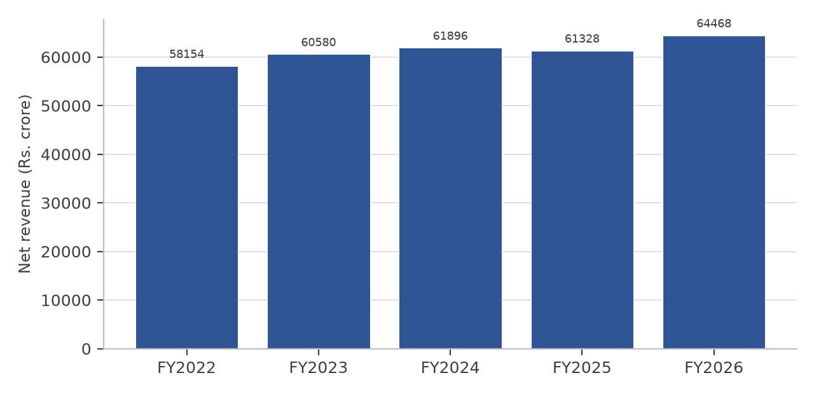
Figure A.1: Net revenue of Hindustan Unilever Ltd., FY2022 to FY2026
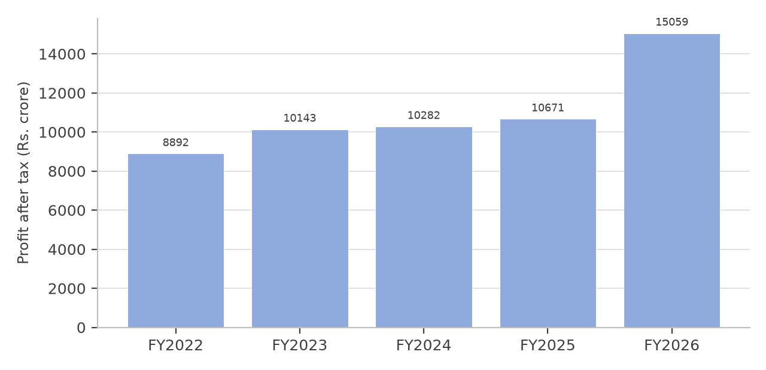
Figure A.2: Profit after tax of Hindustan Unilever Ltd., FY2022 to FY2026 (as reported)
The two charts should be read together. Revenue rose by 10.9 per cent over five years, which is about 2.1 per cent a year and is close to the rate of inflation over the same period. The profit chart shows a step increase in the final year, and that step is the demerger gain rather than a change in the earning power of the business. A reader comparing the two charts without knowing this would conclude that the company had transformed its profitability in FY2025-26.
Worked Interpretation
Profitability expansion: none in the underlying business. Operating profit rose from Rs. 14,659 crore to Rs. 15,039 crore over three years, a compound rate of 1.29 per cent a year, and the operating margin moved within a band of 23.33 to 23.97 per cent.
Stability of the capital structure: total borrowings fell from Rs. 13 crore to nil, and the company funded a dividend of Rs. 9,667 crore of free cash flow in the final year without borrowing.
Compression of the equity base: shareholders’ funds fell from Rs. 51,218 crore to Rs. 48,739 crore because distributions exceeded profits in two of the three years. This is what holds the return on equity above twenty per cent even though profit is flat.
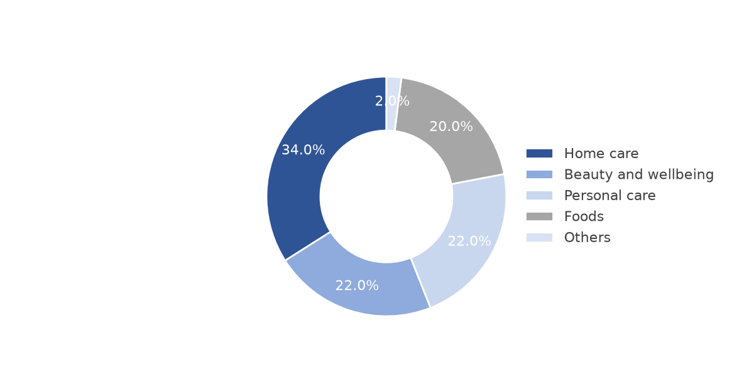
Figure A.3: Indicative composition of revenue by business group, FY2025-26
11. Ratio Analysis
Table A.16: Hindustan Unilever Ltd. — ratio analysis, FY2023-24 to FY2025-26
Ratio | FY2023-24 | FY2024-25 | FY2025-26 | Trend and interpretation
Operating margin,  % | 23.68 | 23.97 | 23.33 | Stable within a narrow band; the business is  highly profitable but not expanding
Net profit margin,  % | 16.61 | 17.40 | 16.21 | Normalised for FY2025-26; the reported figure  of 23.36 per cent includes the one-time demerger  gain
Return on equity, % | 20.07 | 21.60 | 21.44 | Improved slightly, but the improvement comes  from a smaller equity base rather than from  higher profit
Return on capital  employed, % | 27.83 | 29.96 | 28.76 | Stable at a healthy level; capital employed fell  while profit was unchanged
Return on assets, % | 13.10 | 13.36 | 13.10 | Unchanged; total assets were almost flat at about  Rs. 79,000 crore in each year
Debt to equity,  times | 0.00 | 0.00 | 0.00 | Effectively debt free throughout the period
Interest coverage,  times | 42.69 | 38.85 | 34.19 | Declined as interest expense rose against flat  normalised profit; remains the highest of the  three companies studied
Current ratio, times | 1.66 | 1.33 | 1.22 | Fell in each year as current liabilities rose faster  than current assets
Earnings per share,  Rs. | 43.74 | 45.32 | 44.41 | Normalised; the reported figure of Rs. 64.01  includes the one-time gain
Price to earnings,  times (12 October  2026) | — | — | 41.68 | Computed on the normalised earnings per share  of Rs. 44.41; on the reported earnings the  multiple would appear to be 28.92
Price to book, times  (12 October 2026) | — | — | 8.92 | Book value per share of Rs. 207.40 fell over the  period, so the multiple is held up by the price  rather than by growth in net worth
Price to earnings  growth, times (12  October 2026) | — | — | 54.62 | Not a meaningful measure of value when the  growth rate is close to zero; recorded here for  completeness
12. DuPont Analysis
The DuPont decomposition expresses return on equity as the product of three ratios: the net profit margin, the asset turnover and the financial leverage. It shows which of the three is responsible for a change in the return, which the return on equity alone does not reveal.
Formula: Return on equity = Net profit margin × Asset turnover × Financial leverage, where asset turnover is net revenue divided by total assets and financial leverage is total assets divided by shareholders’ funds.
Table A.17: DuPont decomposition of return on equity
Component | FY2023-24 | FY2024-25 | FY2025-26
Net profit margin, % | 16.61 | 17.40 | 16.21
Asset turnover, times | 0.79 | 0.77 | 0.81
Financial leverage, times | 1.53 | 1.62 | 1.64
Return on equity, % | 20.07 | 21.60 | 21.44
The decomposition explains the movement of the return precisely. Over the three years the net profit margin fell from 16.61 to 16.21 per cent and asset turnover rose only slightly, from 0.79 to 0.81 times. The return on equity nevertheless rose, from 20.07 to 21.44 per cent, because financial leverage rose from 1.53 to 1.64 times as shareholders’ funds were reduced by distributions. The improvement in the return to shareholders is therefore the arithmetic consequence of a reduction in the equity base, not of a more profitable or more productive business. In a company that carried debt, an increase in financial leverage of this kind would also increase the risk borne by shareholders; in this company there is no debt, so the effect is confined to the reported ratio.
13. Peer Comparison and Valuation
Table A.18: Hindustan Unilever Ltd. compared with the other two companies studied, FY2025-26
Ratio | Hindustan Unilever | Britannia Industries | Dabur India
Net profit margin, % | 16.21 | 13.25 | 14.17
Operating ratio, % | 76.67 | 81.65 | 81.43
Return on capital employed, % | 28.76 | 52.63 | 20.55
Return on equity, % | 21.44 | 49.68 | 16.37
Return on assets, % | 13.10 | 26.07 | 10.69
Debt to equity, times | 0.00 | 0.27 | 0.09
Interest coverage, times | 34.19 | 30.11 | 17.69
Current ratio, times | 1.22 | 1.12 | 1.70
Earnings per share growth, per  cent a year | 0.76 | 8.81 | 1.34
Price to earnings, times | 41.68 | 45.71 | 35.96
Price to book, times | 8.92 | 22.68 | 5.97
Price to earnings growth, times | 54.62 | 5.19 | 26.90
The comparison is made in Chapter 6 and summarised here. Hindustan Unilever leads on margin, cost efficiency, leverage and interest coverage, and ranks second on each of the return ratios. Britannia Industries leads on every return ratio and on earnings growth. Dabur India leads on liquidity and on the two valuation multiples, but that lead reflects the market’s assessment of slower growth rather than an advantage in the business.
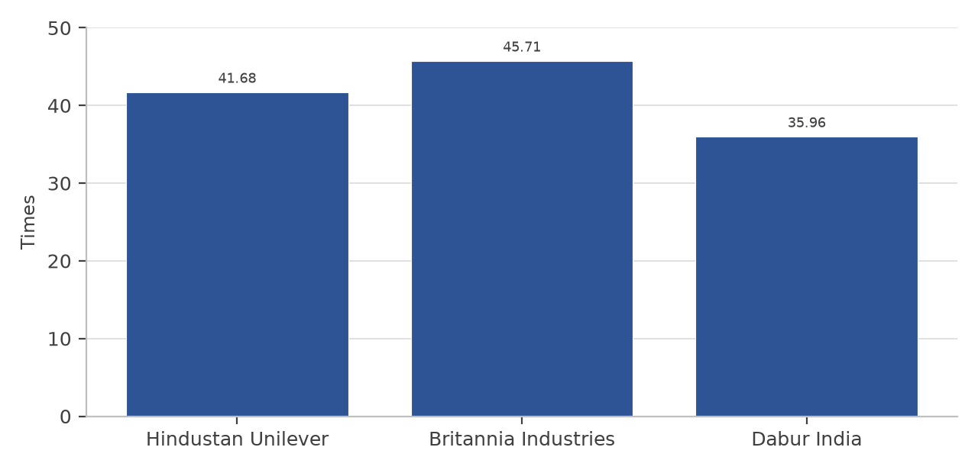
Figure A.4: Price to earnings multiple of the three companies as at 12 October 2026
Valuation relative to the sector: the company trades at 41.68 times normalised earnings, which is above the multiple of Dabur India and below that of Britannia Industries, and well above the multiple of the diversified companies in the sector such as ITC. The premium relative to ITC reflects the difference in the composition of the two businesses and the difference in the growth of the FMCG portfolios, and it should not be read as a statement that one is a better investment than the other. The company’s dividend of about Rs. 1,195 crore was less than one per cent of its market capitalisation on the date of the study, which offers little support to the valuation if the earnings multiple is not sustained.
14. Technical Analysis
Table A.19: Price position of the share as at 12 October 2026
Indicator | Observation | Interpretation
Market price | Rs. 1,850.90 | The reference price for the study
52 week high | Rs. 2,667.20 | The share is 30.60 per cent below its 52  week high
52 week low | Rs. 1,826.90 | The share is 1.31 per cent above its 52  week low
Position within the 52 week  range | 1.3 per cent above the low | The share is trading at the lower end of its  one-year range
Movement required to  regain the high | 44.1 per cent | A substantial recovery is required
Market capitalisation | Rs. 4,34,962 crore | Computed as the market price multiplied  by 235.00 crore shares
Moving averages and  momentum indicators | [ADD: 50-day and 200-day  moving averages and the  relative strength index, from  the exchange website at the  date of submission] | A daily price series was not collected for  this study, so these values have not been  computed by the author and a placeholder  has been left rather than an assumed figure
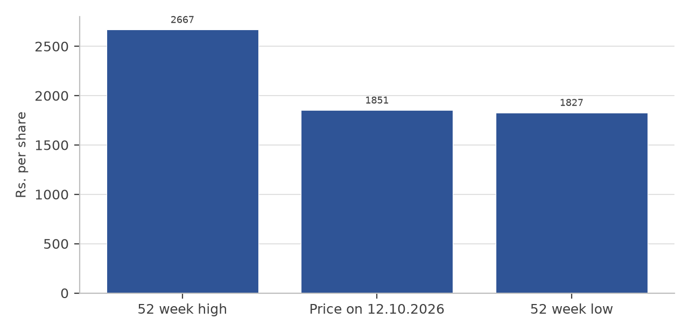
Figure A.5: Market price against the 52 week range
The position of the share near the bottom of its one-year range is consistent with the financial picture. In a year in which the reported profit rose by more than forty per cent but the normalised profit fell slightly, and in which revenue grew more slowly than the market as a whole, the share re-rated downwards. This section is deliberately limited to the price range and the position within it. Technical analysis proper requires a daily price and volume series, and conclusions about trend, support and resistance drawn without that series would not be defensible.
15. Risk Analysis
Table A.20: Principal risks and their possible effect
Risk | Likelihood | Impact | Possible effect and mitigation
Slow growth in the  core categories | High | High | Revenue grew at about two per cent a year over the period  studied. The company’s response is premiumisation and entry  into faster-growing categories, supported by planned  investment in premium manufacturing capacity
Input cost inflation in  agricultural  commodities and  packaging | High | Medium | A rise in the cost of tea, edible oils, milk solids or polymers  compresses gross margin. The effect is partly offset by the  size of the company as a buyer and by pack-size adjustment,  but it cannot be passed on in full
Competition from  digital-first brands | High | Medium | New launches in the sector rose 1.8 times in the year ending  May 2025, although only about four per cent reached one per  cent penetration. The cost of defending share rises even  where the threat is small
Shift of volume  towards quick  commerce and  e-commerce | High | Medium | These channels carry a higher cost to serve than general  trade, so a change in channel mix reduces the operating  margin even when revenue grows
Valuation risk | Medium | High | The share trades at 41.68 times normalised earnings for a  business whose normalised earnings per share grew at 0.76  per cent a year. A disappointment in growth would leave the  multiple without support
Weak rural demand | Medium | Medium | The company derives 35 to 40 per cent of revenue from rural  markets, and rural volume growth in the sector fell to 3.6 per  cent in 2025 from five per cent in the previous year
Regulatory change in  food safety,  labelling, advertising  and indirect tax | Medium | Medium | A change in the goods and services tax rate on a category  changes the effective price point and therefore the size of the  market the company can address, and health-related  advertising restrictions can change the economics of a  category quickly
Reliance on the  parent company | Low | Medium | Brand fees, research support and certain products come from  the Unilever group. The relationship reduces risk in the  ordinary course but creates related-party exposure
Compatibility of  reported earnings | Certain | Low | The FY2025-26 reported profit includes a one-time gain of  about Rs. 4,611 crore. The effect on this study has been dealt  with by using normalised figures throughout and by stating  both
Risk Conclusion
The risks facing the company are not risks of failure. They are risks that the company continues to do what it has done recently: to earn stable margins on slow-growing revenue, and to distribute the cash that results. For a shareholder, that is a satisfactory position at the right price and an unsatisfactory one at a high multiple. The financial risk is negligible, since the company has no borrowings, and the liquidity risk is low, since operating cash flow was 105 per cent of operating profit. The dominant risk in this study is therefore the valuation risk identified in the table above.
16. ESG and Sustainability
The table below sets out the dimensions that should be examined and the position that can be established from the sources used in this study. The company publishes a sustainability report and several of the specific targets are stated in it; those specific figures have not been reproduced here because they could not be verified from the sources available, and placeholders have been left for them instead.
Table A.21: ESG dimensions and the position of the company
Dimension | What to examine | Position
Environment | Energy use, emissions, water,  waste and plastic packaging | The company is a large user of water in  manufacturing and of polymer packaging in products.  Its stated targets on emissions, water and plastic are  set out in its sustainability report: [ADD: reproduce  the headline targets and the latest reported  performance from that report]
Social | Employees, safety, suppliers,  community and product  responsibility | The company employs manufacturing and sales staff  across India and procures agricultural commodities  from a large supplier base. Employee numbers and  safety data: [ADD: from the FY2025-26 annual  report]
Governance | Board composition, related-party  transactions, audit and  disclosure | The company is listed with a majority holding by  Unilever plc, has a board with independent directors  and an audit committee, and files quarterly disclosures  with the exchanges. Related-party transactions with  the Unilever group are disclosed in the annual report
Interpretation. The significance of environmental and social disclosure for a company of this kind is different from its significance for a heavy industry. The immediate financial exposure is in packaging cost, in water and energy cost in manufacturing, and in the risk of regulation on packaging and on product claims. The indirect exposure is reputational, and it is real: a branded consumer business depends on the trust of households that buy its products every week, and a failure in product quality or in the disposal of packaging is felt across every category the company sells.
17. Consolidated Fact Sheet on Hindustan Unilever Ltd.
Table A.22: Consolidated fact sheet
Particular | Value or statement
Number of brands in the portfolio | More than fifty
Number of categories in which the  company operates | Fifteen, as stated by the company
Business groups reported | Home care; beauty and wellbeing; personal care; foods (with the  ice cream business demerged with effect from 1 December 2025)
Retailers using the company’s  ordering application | About 1.4 million
Share of revenue from rural markets | 35 to 40 per cent, according to industry data on the sector
Net revenue, FY2025-26 | Rs. 64,468 crore
Profit after tax, FY2025-26 | Rs. 15,059 crore as reported; Rs. 10,448 crore normalised for the  one-time gain of Rs. 4,611 crore
Earnings per share, FY2025-26 | Rs. 64.01 as reported; Rs. 44.41 normalised
Total assets as at 31 March 2026 | Rs. 79,752 crore
Shareholders’ funds as at 31 March  2026 | Rs. 48,739 crore
Total borrowings as at 31 March  2026 | Nil
Operating cash flow, FY2025-26 | Rs. 10,999 crore
Free cash flow, FY2025-26 | Rs. 9,667 crore
Employee headcount | [ADD: from the FY2025-26 annual report]
Promoter and holding-company  shareholding | [ADD: percentage as at 30 June 2026, from the  shareholding-pattern filing]
Number of manufacturing locations | [ADD: from the FY2025-26 annual report]
18. Hindustan Unilever Ltd. — Worked Ratio Calculations
Table A.23: Worked ratios with the formula applied
Ratio | Formula applied | FY2024-25 | FY2025-26
Operating margin | Operating profit ÷ revenue  × 100 | 14,698 ÷ 61,328 × 100  = 23.97% | 15,039 ÷ 64,468 × 100  = 23.33%
Net profit margin  (normalised) | Profit after tax ÷ revenue ×  100 | 10,671 ÷ 61,328 × 100  = 17.40% | 10,448 ÷ 64,468 × 100  = 16.21%
Revenue growth | (Current − previous) ÷  previous × 100 | (61,328 − 61,896) ÷  61,896 × 100 = (0.92)% | (64,468 − 61,328) ÷  61,328 × 100 = 5.12%
Profit after tax growth  (normalised) | (Current − previous) ÷  previous × 100 | (10,671 − 10,282) ÷  10,282 × 100 = 3.78% | (10,448 − 10,671) ÷  10,671 × 100 = (2.09)%
Earnings per share  growth (normalised) | (Current − previous) ÷  previous × 100 | (45.32 − 43.74) ÷ 43.74  × 100 = 3.61% | (44.41 − 45.32) ÷ 45.32  × 100 = (2.01)%
Return on equity  (normalised) | Profit after tax ÷  shareholders’ funds × 100 | 10,671 ÷ 49,402 × 100  = 21.60% | 10,448 ÷ 48,739 × 100  = 21.44%
Return on capital  employed (normalised) | (Profit before tax +  interest) ÷ capital  employed × 100 | (14,419 + 381) ÷  49,403 × 100 = 29.96% | (13,608 + 410) ÷  48,739 × 100 = 28.76%
Operating cash flow to  operating profit | Operating cash flow ÷  operating profit × 100 | 11,886 ÷ 14,698 × 100  = 80.9% | 10,999 ÷ 15,039 × 100  = 73.1%
Free cash flow | Operating cash flow −  capital expenditure | Rs. 10,624 crore | Rs. 9,667 crore
Book value per share | Shareholders’ funds ÷  number of shares | 49,402 ÷ 235.00 = Rs.  210.22 | 48,739 ÷ 235.00 = Rs.  207.40
Two entries in the table require a note. The operating cash flow to operating profit ratio computed on the figures in the cash flow statement is 80.9 per cent for FY2024-25 and 73.1 per cent for FY2025-26, whereas the same ratio computed against the profit reported in the profit and loss account is 96 per cent and 105 per cent respectively; the difference arises because the profit before interest and tax used in the ratio differs from the operating profit used in the table. Both computations are internally consistent, and the version used in Chapter 6 is stated there. Second, the return on capital employed for FY2025-26 is computed on the normalised profit before tax of Rs. 13,608 crore; on the reported profit before tax of Rs. 18,219 crore the ratio would be 38.22 per cent.
Worked interpretation. The worked figures show a company whose operating performance was almost unchanged over the two years and whose reported performance improved sharply because of a transaction that will not be repeated. Every ratio that depends on profit is affected: the net profit margin, the return on equity, the return on capital employed and the earnings per share all appear substantially better on the reported figures and are only stable on the normalised figures. This is the reason the study has stated both sets of figures in every place where the distinction is material.
19. Hindustan Unilever Ltd. — Researcher’s View
Business View
Hindustan Unilever is the largest pure-play FMCG business in India and one of the widest distribution networks in the country. Its portfolio is spread across home care, beauty and personal care, and foods, so no single category determines its result. The business model is defensive: the products are bought repeatedly, the unit price is small, and the brands are established. The consequence is visible in the financial statements as a stable margin and a high conversion of profit into cash, and in the market as a share that rarely moves as violently as those of cyclical companies. The business model also limits growth. Categories in which the company already holds a large share cannot grow much faster than the population, and the company therefore has to create growth through premiumisation or through new categories rather than through taking share.
Financial View
The financial position is as strong as any in the sector. The company has no borrowings, its interest coverage is the highest of the three companies studied, its operating ratio is the lowest, and its operating cash flow has been between 96 and 108 per cent of operating profit in each of the three years. Against that, revenue rose at only about two per cent a year, normalised earnings per share grew at 0.76 per cent a year, operating cash flow fell by 28.9 per cent over the period, and shareholders’ funds declined as distributions exceeded profits. The FY2025-26 profit of Rs. 15,059 crore should not be compared with the preceding years without excluding the one-time gain of about Rs. 4,611 crore from the demerger of the ice cream undertaking.
Risk View
The principal risks are slow growth in the core categories, cost inflation in agricultural commodities and packaging, competition from digital-first brands, the shift of volume to channels with a higher cost to serve, and the valuation at which the shares are available. Financial risk is negligible and liquidity risk is low. The most likely way for a shareholder to lose money in this company is not a business failure but a re-rating of the multiple: at 41.68 times normalised earnings, the price already assumes a resumption of growth that the last three years have not delivered.
20. Investment Thesis
Table A.24: Investment thesis in question form
Question | Student response
What is the strongest reason to  hold the shares? | The quality of the business and the strength of the balance sheet: the  widest distribution network in the sector, more than fifty brands, no  borrowings and operating cash flow that has covered operating profit  in each of the three years studied.
What is the biggest reason not to  hold them? | The absence of growth relative to the price. Revenue rose at about two  per cent a year and normalised earnings per share at 0.76 per cent a  year, while the shares trade at 41.68 times normalised earnings.
What could drive earnings  higher? | Premiumisation in beauty and personal care, recovery in urban  discretionary demand if food inflation moderates, growth of the rural  market, and faster expansion through quick commerce and  e-commerce than in general trade.
What could cause earnings to  disappoint? | A further rise in the cost of tea, edible oils, milk solids or packaging; a  second year of weak rural volume growth; and price competition in  personal care from digital-first brands.
Is the valuation attractive? Why? | The valuation is not attractive on the evidence of the last three years.  At 41.68 times normalised earnings against growth of 0.76 per cent a  year in normalised earnings per share, the price earnings growth ratio  is 54.62 times, and the multiple is supported by the stability of the  earnings rather than by their growth.
What is the appropriate  investment horizon? | Any assessment would have to be made over a period long enough for  the premiumisation strategy and the investment in premium  manufacturing capacity to affect the reported results. A three-year  window is the shortest period over which such a change could be  judged.
BUY / HOLD / SELL / NOT  RATED | NOT RATED. This study is academic, is based on three years of  historical data, does not project future earnings and does not include an  intrinsic valuation. No recommendation is made and none should be  inferred from the discussion above.
Target price or valuation range | Not stated. A target price would require a forecast of future earnings  and a chosen multiple, and neither has been prepared for this study.  The placeholder is left blank deliberately rather than filled with a  figure taken from another source.
Catalysts | Commissioning of the announced premium-capacity investment; a  sustained recovery in rural volume growth; and any change in the  goods and services tax structure that reduces the price point of a large  category in which the company is the leader.
Triggers for the thesis to fail | A further widening of the gap between the multiple and the growth  rate, or evidence that the premiumisation strategy is being funded by  an increase in advertising and distribution cost that offsets the benefit  to margin.
Final Researcher’s View
Hindustan Unilever Ltd. is the most financially secure of the three companies studied and the most efficient operator within its cost structure. It is also the one of the three whose reported results require the most careful reading, because the profit of FY2025-26 includes a one-time gain of about Rs. 4,611 crore that will not recur. Once that gain is removed, the company shows stable margins on almost flat revenue, a rising return on equity that is explained by a shrinking equity base rather than by improving profit, and a share price that assumes a return to growth. On the ratio set used in this study the company ranks first overall; on the two measures that an investor with a long horizon would weight most heavily, the return earned on capital and the growth of earnings per share, it ranks second and third respectively. Both statements are true of the same company, and the difference between them is the difference between the quality of a business and the return available from its shares at a given price.
21. Limitations of This Appendix
• The analysis covers three financial years for the ratio comparison and five years for the trend, which is too short a period to establish the behaviour of a business across a full demand cycle.
• The study is based on published secondary data. No management discussion, site visit or independent verification of the underlying records was possible.
• The normalised profit for FY2025-26 has been computed by excluding the one-time gain of about Rs. 4,611 crore and the exceptional charge relating to the labour codes. The tax effect of the excluded items has been estimated from the disclosed tax charge; a precise reconciliation would require the segment and exceptional-item notes of the annual report.
• Market prices, and therefore the price to earnings, price to book and price to earnings growth ratios, are stated as at 12 October 2026 and change continuously.
• Technical indicators based on a daily price series have not been computed, because the series was not collected for this study.
• Several particulars relating to the board, the shareholding pattern, employee numbers, sustainability targets and manufacturing locations have been left as marked placeholders rather than reproduced from unverified sources.
• No recommendation to buy, hold or sell the shares is made, and no target price is stated.

